#### Hospital Management System Software

* [Home](https://www.techiesgroup.co.in/detailspage/LandingPage/HMS/index.html)
* [About Us](https://www.techiesgroup.co.in/detailspage/LandingPage/HMS/about_us.html)
* [Services](https://www.techiesgroup.co.in/detailspage/LandingPage/HMS/services.html)
* [Blog](https://www.techiesgroup.co.in/detailspage/LandingPage/HMS/blog.html)
* [Gallery](https://www.techiesgroup.co.in/detailspage/LandingPage/HMS/gallery.html)
* [Contact Us](https://www.techiesgroup.co.in/detailspage/LandingPage/HMS/contact_us.html)



# Electronic Health Records

Experience the benefits of our cloud-based hospital management system for rural areas. Ensure secure and efficient access to patient data with MedicaLife EHR.

[Explore EHR Solutions](https://www.techiesgroup.co.in/detailspage/LandingPage/HMS/)



# Healthcare Information Systems

MedicaLife offers affordable hospital management solutions for clinics, ensuring seamless information flow and improved patient outcomes.

[Find Out More](https://www.techiesgroup.co.in/detailspage/LandingPage/HMS/)



# Hospital Management System Software

Discover the best hospital management software for small hospitals at MedicaLife. Our solutions are designed to streamline operations and improve patient care.

[Learn More](https://www.techiesgroup.co.in/detailspage/LandingPage/HMS/)



# Electronic Health Records

Experience the benefits of our cloud-based hospital management system for rural areas. Ensure secure and efficient access to patient data with MedicaLife EHR.

[Explore EHR Solutions](https://www.techiesgroup.co.in/detailspage/LandingPage/HMS/)



# Healthcare Information Systems

MedicaLife offers affordable hospital management solutions for clinics, ensuring seamless information flow and improved patient outcomes.

[Find Out More](https://www.techiesgroup.co.in/detailspage/LandingPage/HMS/)



# Hospital Management System Software

Discover the best hospital management software for small hospitals at MedicaLife. Our solutions are designed to streamline operations and improve patient care.

[Learn More](https://www.techiesgroup.co.in/detailspage/LandingPage/HMS/)



# Electronic Health Records

Experience the benefits of our cloud-based hospital management system for rural areas. Ensure secure and efficient access to patient data with MedicaLife EHR.

[Explore EHR Solutions](https://www.techiesgroup.co.in/detailspage/LandingPage/HMS/)

**Our Mission**

At Medicalized, our mission is to deliver the best hospital organization software for small sickbays and clinics. We aim to improve healthcare delivery finished innovative solutions such as cloud-based hospice management systems for country areas, top-rated EMR software, and complete hospital management software. Our goal is to sustenance healthcare breadwinners in delivering excellent care by offering secure and customizable systems custom-made to meet their unique needs.

**Our Commitment**

At MedicaLife, we are devoted to enhancing health care delivery through innovative answers. We deliver the best hospital management software for small infirmaries and clinics, count cloud-based hospital management systems for rural areas, top-rated EMR software, and comprehensive hospital administration software. Our goal is to provision health care providers in delivering exceptional care with secure and customizable systems tailored to meet their unique needs.

**Our Vision**

At MedicaLife, we struggle to revolutionize healthcare organization by providing cutting-edge solutions. Our aids include top-rated hospital management software, cloud-based schemes for rural hospices, and safe electronic health records (EHR) to protection unified patient care. We are committed to secondary healthcare earners with customizable and revolutionary tools to meet the unique challenges of modern healthcare.

## **Our Services**

Explore our extensive range of facilities intended to meet your needs. Whether you're looking for skilled advice, quality products, or reliable support, we've got you covered.



Individual Therapy



Cuple Therapy



online Session



Group Therapy



All Age Group



All Age Group

## **Meet our Team**

Take a look at our innovative and experiance team



Mark Frances*- MD*

3+ Years of Experiance in PHP with good innovative Ideas



Mark Frances*- MD*

3+ Years of Experiance in PHP with good innovative Ideas



Mark Frances*- MD*

3+ Years of Experiance in PHP with good innovative Ideas



Mark Frances*- MD*

3+ Years of Experiance in PHP with good innovative Ideas

## **Our Blog**

Take a look at what people say about US



By Admin | August 10, 2018

#### Effective Recruitment Strategies for Your Business

Discover effective recruitment strategies that can transform your hiring process. Learn how to entice top talent and shape a strong side for your business development.

[Read more](https://www.techiesgroup.co.in/detailspage/LandingPage/HMS/)



By Admin | August 10, 2018

#### New Trends in Recruitment Strategies

Explore the newest trends in recruitment plans and how they can influence your hiring process. Learn ground-breaking approaches to entice and retain top aptitude in today's modest market.

[Read more](https://www.techiesgroup.co.in/detailspage/LandingPage/HMS/)



By Admin | August 10, 2018

#### Innovative Recruitment Strategies

Explore ground-breaking recruitment policies that enhance your signing process. Learn about the latest trends in recruitment and how they can attract and retain top talent in today's competitive market.

[Read more](https://www.techiesgroup.co.in/detailspage/LandingPage/HMS/)

## **About Us**

Smart Eye is a leading provider of information technology, consulting, and business process services. Our dedicated employees offer strategic insights, technological expertise, and extensive industry experience.

We specialize in cutting-edge technologies aimed at reducing costs, optimizing processes, and accelerating time-to-market. With a robust quality assurance framework and a wealth of experience in global management...

## **Useful Links**

* [About us](https://www.techiesgroup.co.in/detailspage/LandingPage/HMS/#/about)
* [Portfolio](https://www.techiesgroup.co.in/detailspage/LandingPage/HMS/#/portfolio)
* [Latest jobs](https://www.techiesgroup.co.in/detailspage/LandingPage/HMS/#/products)
* [Gallery](https://www.techiesgroup.co.in/detailspage/LandingPage/HMS/#/gallery)
* [Contact us](https://www.techiesgroup.co.in/detailspage/LandingPage/HMS/#/contact)

## **Contact Us**

**Medicalife  
London, Southwark  
Phone: +XX XXXXXXXXXX  
Email:**[**info@medicalife.com**](https://www.techiesgroup.co.in/detailspage/LandingPage/HMS/info@medicalife.com) **Web:**[**www.medicalife.com**](https://www.techiesgroup.co.in/detailspage/LandingPage/HMS/smart-eye.html)

* [Home](https://www.techiesgroup.co.in/detailspage/LandingPage/HMS/index.html)
* [About Us](https://www.techiesgroup.co.in/detailspage/LandingPage/HMS/about_us.html)
* [Services](https://www.techiesgroup.co.in/detailspage/LandingPage/HMS/services.html)
* [Blog](https://www.techiesgroup.co.in/detailspage/LandingPage/HMS/blog.html)
* [Gallery](https://www.techiesgroup.co.in/detailspage/LandingPage/HMS/gallery.html)
* [Contact Us](https://www.techiesgroup.co.in/detailspage/LandingPage/HMS/contact_us.html)

## **About Cardio Care**

* [Home](https://www.techiesgroup.co.in/detailspage/LandingPage/HMS/about_us.html)
* About Us



#### Why Choose Health Care with Medical Hospital

Discover why Medical Hospital stands out in healthcare. We prioritize your well-being with personalized care and advanced medical services.

Explore our commitment to quality care and patient satisfaction. We ensure comfort and effectiveness in every treatment, supporting your health journey with compassion and expertise.

## **Meet our Team**

Take a look at our innovative and experiance team



Mark Frances*- MD*

3+ Years of Experiance in PHP with good innovative Ideas



Mark Frances*- MD*

3+ Years of Experiance in PHP with good innovative Ideas



Mark Frances*- MD*

3+ Years of Experiance in PHP with good innovative Ideas



Mark Frances*- MD*

3+ Years of Experiance in PHP with good innovative Ideas

## **About Us**

Smart Eye is a leading provider of information technology, consulting, and business process services. Our dedicated employees offer strategic insights, technological expertise, and extensive industry experience.

We specialize in cutting-edge technologies aimed at reducing costs, optimizing processes, and accelerating time-to-market. With a robust quality assurance framework and a wealth of experience in global management...

## **Useful Links**

* [About us](https://www.techiesgroup.co.in/detailspage/LandingPage/HMS/about_us.html#/about)
* [Portfolio](https://www.techiesgroup.co.in/detailspage/LandingPage/HMS/about_us.html#/portfolio)
* [Latest jobs](https://www.techiesgroup.co.in/detailspage/LandingPage/HMS/about_us.html#/products)
* [Gallery](https://www.techiesgroup.co.in/detailspage/LandingPage/HMS/about_us.html#/gallery)
* [Contact us](https://www.techiesgroup.co.in/detailspage/LandingPage/HMS/about_us.html#/contact)

## **Contact Us**

**Medicalife  
London, Southwark  
Phone: +XX XXXXXXXXXX  
Email:**[**info@medicalife.com**](https://www.techiesgroup.co.in/detailspage/LandingPage/HMS/info@medicalife.com) **Web:**[**www.medicalife.c**](https://www.techiesgroup.co.in/detailspage/LandingPage/HMS/smart-eye.html)

* [Home](https://www.techiesgroup.co.in/detailspage/LandingPage/HMS/index.html)
* [About Us](https://www.techiesgroup.co.in/detailspage/LandingPage/HMS/about_us.html)
* [Services](https://www.techiesgroup.co.in/detailspage/LandingPage/HMS/services.html)
* [Blog](https://www.techiesgroup.co.in/detailspage/LandingPage/HMS/blog.html)
* [Gallery](https://www.techiesgroup.co.in/detailspage/LandingPage/HMS/gallery.html)
* [Contact Us](https://www.techiesgroup.co.in/detailspage/LandingPage/HMS/contact_us.html)

## **Our Services**

* [Home](https://www.techiesgroup.co.in/detailspage/LandingPage/HMS/services.html)
* Services



Individual Therapy



Cuple Therapy



online Session



Group Therapy



All Age Group



All Age Group

## **About Us**

Smart Eye is a leading provider of information technology, consulting, and business process services. Our dedicated employees offer strategic insights, technological expertise and industry experience.

We focus on technologies that promise to reduce costs, streamline processes and speed time-to-market, Backed by our strong quality processes and rich experience managing global...

## **Useful Links**

* [About us](https://www.techiesgroup.co.in/detailspage/LandingPage/HMS/services.html#/about)
* [Portfolio](https://www.techiesgroup.co.in/detailspage/LandingPage/HMS/services.html#/portfolio)
* [Latest jobs](https://www.techiesgroup.co.in/detailspage/LandingPage/HMS/services.html#/products)
* [Gallery](https://www.techiesgroup.co.in/detailspage/LandingPage/HMS/services.html#/gallery)
* [Contact us](https://www.techiesgroup.co.in/detailspage/LandingPage/HMS/services.html#/contact)

## **Contact Us**

**BlueDart  
Marthandam (K.K District)  
Tamil Nadu, IND  
Phone: +91 9159669599  
Email:**[**info@bluedart.in**](mailto:info@anybiz.com) **Web:**[**www.bluedart.in**](https://www.techiesgroup.co.in/detailspage/LandingPage/HMS/smart-eye.html)

* [Home](https://www.techiesgroup.co.in/detailspage/LandingPage/HMS/index.html)
* [About Us](https://www.techiesgroup.co.in/detailspage/LandingPage/HMS/about_us.html)
* [Services](https://www.techiesgroup.co.in/detailspage/LandingPage/HMS/services.html)
* [Blog](https://www.techiesgroup.co.in/detailspage/LandingPage/HMS/blog.html)
* [Gallery](https://www.techiesgroup.co.in/detailspage/LandingPage/HMS/gallery.html)
* [Contact Us](https://www.techiesgroup.co.in/detailspage/LandingPage/HMS/contact_us.html)

## **Our Blog**

* [Home](https://www.techiesgroup.co.in/detailspage/LandingPage/HMS/blog.html)
* Our Blog



By Admin | August 10, 2018

#### New Trends in Healthcare Technology

Discover the latest advancements in healthcare technology and their impact on patient care. Explore innovative solutions that are shaping the future of healthcare delivery.

[Read more](https://www.techiesgroup.co.in/detailspage/LandingPage/HMS/blog.html)



By Admin | August 10, 2018

#### Improving Patient Experience: Best Practices

Learn effective strategies to enhance patient experience in healthcare settings. Explore patient-centered approaches that prioritize care and compassion.

[Read more](https://www.techiesgroup.co.in/detailspage/LandingPage/HMS/blog.html)



By Admin | August 10, 2018

#### Advancements in Telemedicine Services

Explore how telemedicine is revolutionizing healthcare delivery. Learn about the benefits, challenges, and future trends in telehealth technologies.

[Read more](https://www.techiesgroup.co.in/detailspage/LandingPage/HMS/blog.html)

## **About Us**

Smart Eye is a leading provider of information technology, consulting, and business process services. Our devoted employees offer planned insights, technical expertise, and wide industry knowledge.

We specify in cutting-edge technologies aimed at reducing costs, optimizing processes, and hurrying time-to-market. With a healthy quality assurance outline and a wealth of knowledge in global organization...

## **Useful Links**

* [About us](https://www.techiesgroup.co.in/detailspage/LandingPage/HMS/blog.html#/about)
* [Portfolio](https://www.techiesgroup.co.in/detailspage/LandingPage/HMS/blog.html#/portfolio)
* [Latest jobs](https://www.techiesgroup.co.in/detailspage/LandingPage/HMS/blog.html#/products)
* [Gallery](https://www.techiesgroup.co.in/detailspage/LandingPage/HMS/blog.html#/gallery)
* [Contact us](https://www.techiesgroup.co.in/detailspage/LandingPage/HMS/blog.html#/contact)

## **Contact Us**

**Medicalife  
London, Southwark  
Phone: +XX XXXXXXXXXX  
Email:**[**info@medicalife.com**](https://www.techiesgroup.co.in/detailspage/LandingPage/HMS/info@medicalife.com) **Web:**[**www.medicalife.com**](https://www.techiesgroup.co.in/detailspage/LandingPage/HMS/smart-eye.html)

* [Home](https://www.techiesgroup.co.in/detailspage/LandingPage/HMS/index.html)
* [About Us](https://www.techiesgroup.co.in/detailspage/LandingPage/HMS/about_us.html)
* [Services](https://www.techiesgroup.co.in/detailspage/LandingPage/HMS/services.html)
* [Blog](https://www.techiesgroup.co.in/detailspage/LandingPage/HMS/blog.html)
* [Gallery](https://www.techiesgroup.co.in/detailspage/LandingPage/HMS/gallery.html)
* [Contact Us](https://www.techiesgroup.co.in/detailspage/LandingPage/HMS/contact_us.html)

## **Gallery**

* [Home](https://www.techiesgroup.co.in/detailspage/LandingPage/HMS/gallery.html)
* Our Gallery

All Doctor's Lab Patient

























## **About Us**

Smart Eye is a leading provider of information technology, consulting, and business process services. Our dedicated employees offer strategic insights, technological expertise and industry experience.

We focus on technologies that promise to reduce costs, streamline processes and speed time-to-market, Backed by our strong quality processes and rich experience managing global...

## **Useful Links**

* [About us](https://www.techiesgroup.co.in/detailspage/LandingPage/HMS/gallery.html#/about)
* [Portfolio](https://www.techiesgroup.co.in/detailspage/LandingPage/HMS/gallery.html#/portfolio)
* [Latest jobs](https://www.techiesgroup.co.in/detailspage/LandingPage/HMS/gallery.html#/products)
* [Gallery](https://www.techiesgroup.co.in/detailspage/LandingPage/HMS/gallery.html#/gallery)
* [Contact us](https://www.techiesgroup.co.in/detailspage/LandingPage/HMS/gallery.html#/contact)

## **Contact Us**

**BlueDart  
Marthandam (K.K District)  
Tamil Nadu, IND  
Phone: +91 9159669599  
Email:**[**info@bluedart.in**](mailto:info@anybiz.com) **Web:**[**www.bluedart.in**](https://www.techiesgroup.co.in/detailspage/LandingPage/HMS/smart-eye.html)

* [Home](https://www.techiesgroup.co.in/detailspage/LandingPage/HMS/index.html)
* [About Us](https://www.techiesgroup.co.in/detailspage/LandingPage/HMS/about_us.html)
* [Services](https://www.techiesgroup.co.in/detailspage/LandingPage/HMS/services.html)
* [Blog](https://www.techiesgroup.co.in/detailspage/LandingPage/HMS/blog.html)
* [Gallery](https://www.techiesgroup.co.in/detailspage/LandingPage/HMS/gallery.html)
* [Contact Us](https://www.techiesgroup.co.in/detailspage/LandingPage/HMS/contact_us.html)

## **Contact Us**

* [Home](https://www.techiesgroup.co.in/detailspage/LandingPage/HMS/contact_us.html)
* Contact Us

## **Contact Form**

Enter Name :



Email Address :



Mobile Number:



Enter Message:



Send Message

## **Address**

Medicalife  
London, Southwark  
Phone: +XX XXXXXXXXXX  
Emailmedical@gmail.com  
Website:www.medicalife.com

## **About Us**

Smart Eye is a foremost provider of data technology, consulting, and occupational process services. Our devoted employees offer planned insights, technological knowhow and industry experience.

We focus on technologies that promise to reduce costs, streamline processes and speed time-to-market, Backed by our robust quality courses and rich involvement managing global...

## **Useful Links**

* [About us](https://www.techiesgroup.co.in/detailspage/LandingPage/HMS/contact_us.html#/about)
* [Portfolio](https://www.techiesgroup.co.in/detailspage/LandingPage/HMS/contact_us.html#/portfolio)
* [Latest jobs](https://www.techiesgroup.co.in/detailspage/LandingPage/HMS/contact_us.html#/products)
* [Gallery](https://www.techiesgroup.co.in/detailspage/LandingPage/HMS/contact_us.html#/gallery)
* [Contact us](https://www.techiesgroup.co.in/detailspage/LandingPage/HMS/contact_us.html#/contact)

## **Contact Us**

**BlueDart  
Marthandam (K.K District)  
Tamil Nadu, IND  
Phone: +91 9159669599  
Email:**[**info@bluedart.in**](mailto:info@anybiz.com) **Web:**[**www.bluedart.in**](https://www.techiesgroup.co.in/detailspage/LandingPage/HMS/smart-eye.html)

Enterprise Resource Planning

# Build Connections like ERP Systems

Are you ready to streamline our connection like an ERP system? Let's integrate our strengths and achieve optimal synergy together!

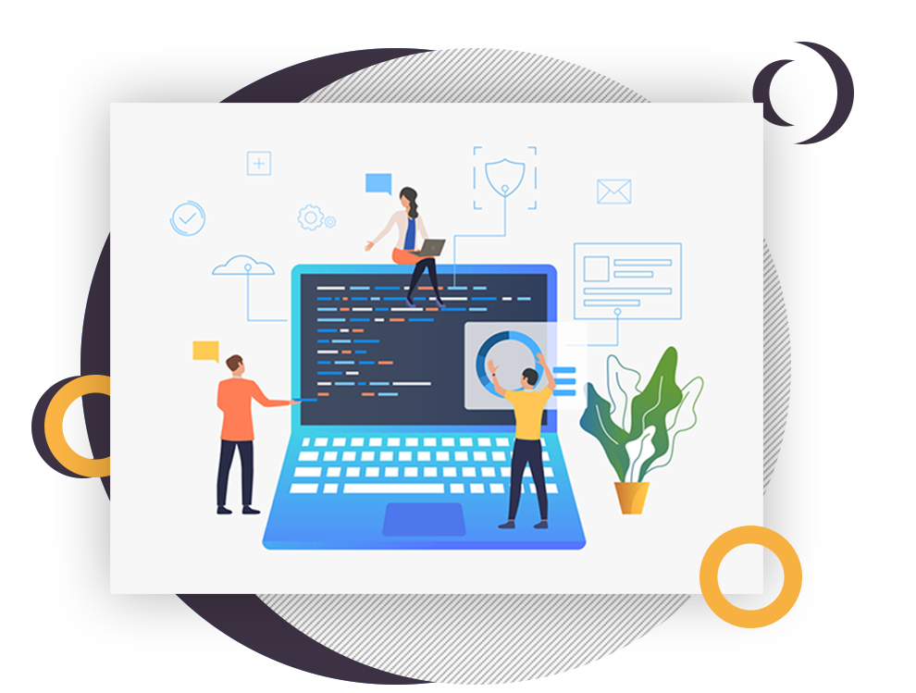

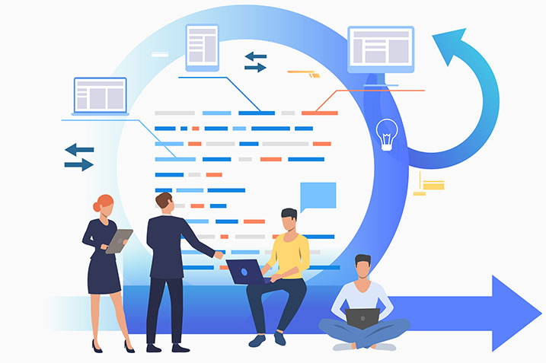

## **About ERP Software**

ERP package is a suite of integrated applications that help trades manage and mechanize various back-office meanings related to knowledge, services, and hominoid resources. It provides a federal database that supports multiple purposes used by different business units. The core goal of ERP software is to advance efficiency, modernize processes, and enable data-driven decision-making across a society. ERP systems typically shelter areas such as finance, human resources, source chain management, engineering, and customer relationship group.

## **Why Choose Us**

* [Efficiency](https://www.techiesgroup.co.in/detailspage/LandingPage/ERP/)
* [Improved Decision-Making](https://www.techiesgroup.co.in/detailspage/LandingPage/ERP/)
* [Enhanced Collaboration](https://www.techiesgroup.co.in/detailspage/LandingPage/ERP/)
* [Scalability](https://www.techiesgroup.co.in/detailspage/LandingPage/ERP/)

**

### **Features**

Applying an ERP software rationalizes business operations by unifying data, enhancing communication, and refining collaboration across departments. It boosts competence by automating procedures, facilitates knowledgeable executive through real-time insights, and ensures controlling compliance, fostering scalability and keenness in the market.

## **How To Works it**

ERP systems participate various business meanings such as finance, HR, industrial, supply chain, and additional into a single stage. They streamline procedures, improve data accuracy, and ease better decision-making across the society.



## **Request A call Back**

Top of Form



Send

Bottom of Form

### **Address**

* 123 Main Street  
  Anytown, USA  
  Zip Code: 12345

### **Links**

* [Home](https://www.techiesgroup.co.in/detailspage/LandingPage/ERP/)
* [About](https://www.techiesgroup.co.in/detailspage/LandingPage/ERP/#about)
* [Work](https://www.techiesgroup.co.in/detailspage/LandingPage/ERP/#work)
* [Contact](https://www.techiesgroup.co.in/detailspage/LandingPage/ERP/#contact)

### **Newsletter**

Top of Form

SUBSCRIBE

Bottom of Form

Event Management System

## Catering & Banquet

* [**HOME**](https://www.techiesgroup.co.in/detailspage/LandingPage/EMS/#wrapper)

* [**ABOUT US**](https://www.techiesgroup.co.in/detailspage/LandingPage/EMS/#aboutus)

* [**SPECIALTIES**](https://www.techiesgroup.co.in/detailspage/LandingPage/EMS/#specialties)

* [**EVENTS GALLERY**](https://www.techiesgroup.co.in/detailspage/LandingPage/EMS/#gallery)



## About Event Management System



### An event management system or event management software program is a digital tool that modernizes the arrangement, organization, and implementation of events. It includes a range of topographies such as event registering, ticketing, venue assortment, scheduling, attendee appointment, and post-event analysis.

#### Event management software features

A truly comprehensive event management system will allow users and organizers to access and manage all aspects of an event, including registration, marketing, engagement, integrations, physical planning and preparation, reporting and analytics, and more.It encompasses a range of features such as event registration, ticketing, venue selection, scheduling, attendee engagement, and post-event analysis. By using event management software, event organizers can simplify their tasks and more efficiently manage logistics and analyze data to enhance future events.

#### Event management platform

An event management system provides hardware and software integrations for campuses, including integrations with HVAC, catering systems, facility management services, and more. These integrations allow event planners to streamline event in virtual, hybrid, and in-person contexts.Effective event manager software should allow users to build repeatable processes and procedures to help maintain event success.With an effective event scheduling software, you can create repeatable steps, save user preferences, and more.



## Our Specialties



### Overall, event management is important because it helps organizations to achieve their goals, create a memorable experience for attendees, improve brand image, generate revenue, and cultivate relationships.

### Drinks



##### Sweet sunrise

The sweet sunrise is an excellent breakfast, brunch, or afternoon drink that skips the liquor of a very popular cocktail."



##### Citrus Fizz

Eggs add texture and flavor to drinks and are commonly used in fizz cocktails. They don't make many appearances in mocktails, so this citrus fizz is a delightful surprise.

### MAIN



##### palak paneer

Palak Paneer is one of the most popular Indian dish made with succulent Paneer cubes (Indian cottage cheese) in a smooth spinach sauce.



##### One sweet appetite

This is the Best Stuffed Peppers Recipe! Dinner is ready in a snap with this hearty beef filled recipe. The perfect filling topped with melted cheese.

### DESSERTS



##### Choco lava cake

Chocolate lava cake is also known as choco lava cake and molten chocolate cake the recipe is very simple and has whole wheat flour and cocoa powder.



##### stawaberry short cake

The shortcakes here are bright. I have always been a fan of lemon ,and they make this recipe really exceptional.



## Online event management system



### **Event management software with ticketing features**

An event ticketing system is a software platform that enables event organizers to sell tickets

### **Online event management system for virtual conferences**

A virtual event, also known as an online event, virtual conference or livestream experience.

### **Event registration and management software**

It defines event registration as the process of organizing attendance for one or more attendees to an experience.

### **Automated event management solutions for trade show**

Create and manage your floor plan while offering exhibitors alike a seamless experience

### **Event management software for educational institutions**

Event Management courses are generally focused on the study of planning events for individuals.

### **Hybrid event management system**

A hybrid event is one that uses a combination of in-person and digital elements, tailored to each audience for optimal experience

### **Event management software with marketing tools**

Event marketing is the advertising of a brand, product or service as part of a wider event..

### **How to choose an event management system**

Successful event planning is often at least partly down to the tools and systems that are used to coordinate .

© COPYRIGHT YOUR WEBSITE  
THEME BY [EVENT MANAGEMENT SYSTEM](http://www.wowthemes.net/)

Health and Safety Management System

### **[Health and Safety Management System](https://www.techiesgroup.co.in/detailspage/LandingPage/HSMS/index.html)**

* [HOME](https://www.techiesgroup.co.in/detailspage/LandingPage/HSMS/#home)
* [ABOUT US](https://www.techiesgroup.co.in/detailspage/LandingPage/HSMS/#about)
* [SERVICES](https://www.techiesgroup.co.in/detailspage/LandingPage/HSMS/#services)
* [GALLERY](https://www.techiesgroup.co.in/detailspage/LandingPage/HSMS/#gallery)
* [CONTACT](https://www.techiesgroup.co.in/detailspage/LandingPage/HSMS/#contact)

# Health and safety monitoring system

Monitoring and reporting are vital parts of a health and safety culture

# Occupational health and safety system

Best health and safety management system software for small businesses

# Health and safety compliance system

Affordable health and safety management solutions for startups

## **About Us**

Safety management software

## **Welcome to Health Lab**

A safety and health management system means the part of the Organisation's management system which covers: the health and safety work organisation and policy in a company. the planning process for accident and ill health prevention.

A Safety Management System provides organisations with a framework to improve employee safety and health, reduce workplace risks and create better, safer working conditions The development and implementation of a comprehensive Safety Management System will support continual improvement and enables an organisation to develop and maintain a strong safety culture.

* 
* 

## **Services**

### HSMS Software How To Choose A Health And Safety Management

A hardware security is a dedicated crypto processor that is specifically designed for the protection of the crypto key lifecycle.

### HSMS Software

Open-source health and safety management system options.A hardware security module (HSM) is a physical device that provides extra security for sensitive data

### Occupational Health And Safety System

How to conduct a health and safety risk assessment using HSMS software.HSM is a metal cutting process that emphasizes rapid speed.

### Safety Management Software

Integrated health and safety management software with employee training.A safety management system that safety performance organization

### Best Practices For Implementing Health And Safety Management System

Customizable health software for different industries.EHS software can be used to track the materials .

‹›

## **Gallery**



### **User-friendly health and safety management tools for educators**



### **Features of a comprehensive health and safety management system**



### **Automated incident management software for HSMS**



### **How to choose a health and safety management system**

## **Contact us**

Top of Form









SEND MESSAGE

Bottom of Form

## Address

#### Address

25 Market Street Hyde Greater Manchester

#### Email

[healthy@gmail.com](https://www.techiesgroup.co.in/detailspage/LandingPage/HSMS/)

#### Phone Number

[12345 68900](https://www.techiesgroup.co.in/detailspage/LandingPage/HSMS/)

## Subscribe

A Health, Safety, and Environment (HSE) management system is a comprehensive framework used by organizations in preventing, mitigating, and eliminating disruptions and losses caused by workplace accidents, risk and hazard exposures, and environmental phenomena.

.

Top of Form



SUBSCRIBE

Bottom of Form

All Rights Reserved. © 2024 [Health and Safety Management System](https://www.techiesgroup.co.in/detailspage/LandingPage/HSMS/)

Fund Management 123 Street, New York, USA 9.00 am - 9.00 pm

FundFusion@gmail.com +44 1234567889

# [FundFusion](https://www.techiesgroup.co.in/detailspage/LandingPage/FMS/index.html)

[Home](https://www.techiesgroup.co.in/detailspage/LandingPage/FMS/index.html)[About](https://www.techiesgroup.co.in/detailspage/LandingPage/FMS/about.html)[Services](https://www.techiesgroup.co.in/detailspage/LandingPage/FMS/service.html)[Features](https://www.techiesgroup.co.in/detailspage/LandingPage/FMS/feature.html)[Contact](https://www.techiesgroup.co.in/detailspage/LandingPage/FMS/contact.html)



# True Financial management system Support For You

[Explore More](https://www.techiesgroup.co.in/detailspage/LandingPage/FMS/index.html)

PreviousNext



Solutions

# Solutions we are provide

AutomatedRealEstateMutualPrivateEquitWealthHedge

Automated Fund Management System

An Automated Fund Management System streamlines investment processes, leveraging algorithms to execute trades, rebalance portfolios, and assess risks autonomously. This software enhances efficiency, reduces human error, and provides real-time insights for effective decision-making. It optimizes fund performance and ensures compliance with regulatory standards, benefiting financial institutions and investors alike.

# 1234

Happy Clients

# 1234

Projects Completed

# 1234

Dedicated Staff

# 1234

Awards Achieved

# Industries



#### Large Enterprises



#### Real Estate



#### Advisors



#### Financial Institutions



#### Startups



#### Large Enterprises



#### Real Estate



#### Advisors



#### Financial Institutions



#### Startups



#### Large Enterprises

# Testimonial

As a financial advisor, I rely on Fund Management Software with risk assessment tools to provide accurate insights to my clients. This software has exceeded my expectations, making my job much easier.



#### John Smith

Financial Advisor

Our hedge fund firm needed a robust Fund Administration Software that could handle complex tasks efficiently. This package not only met but surpassed our expectations, only if seamless processes and complete reporting.



#### Michael Johnson

Hedge Fund Manager

Real Estate Fund Running System structures in this software have significantly improved our operations. It's instinctive and customizable, as long as us with the suppleness we need to manage our real estate savings effectively.



#### Sarah Williams

Real Estate Investor

The Best Fund Organization System package I've used for my startup. It's very user-friendly and has all the topographies I need to manage my reserves efficiently. Highly suggested!



#### Jane Doe

Founder, Small Startup

As a monetary advisor, I rely on Fund Management Software program with risk valuation tools to provide precise insights to my clients. This software program has surpassed my outlooks, making my job much informal.



#### John Smith

Financial Advisor

Our hedgerow fund firm wanted a robust Fund Management Software that might handle multifaceted tasks efficiently. This package not only met but surpassed our outlooks, providing seamless processes and inclusive reporting.



#### Michael Johnson

Hedge Fund Manager

Real Estate Fund Management System structures in this software program have greatly greater our operations. It's instinctive and customizable, as long as us with the litheness we need to accomplish our real estate reserves effectively.



#### Sarah Williams

Real Estate Investor

The Best Fund Running System software program I've rummage-sale for my origination. It's incredibly user-friendly and has all the features I need to manage my funds efficiently. Highly recommended!



#### Jane Doe

Founder, Small Startup

As a financial advisor, I rely on Fund Management Software with risk assessment tools to provide accurate insights to my clients. This software has exceeded my expectations, making my job much easier.



#### John Smith

Financial Advisor

Our hedge fund firm needed a robust Fund Administration Software that could handle complex tasks efficiently. This software not only met but exceeded our expectations, providing seamless operations and comprehensive reporting.



#### Michael Johnson

Hedge Fund Manager

#### Our Office

123 Street, New York, USA

+012 345 67890

FundFusion@gmail.com

#### Services

[Customizable FundImplementationRisk Assessment ToolsAutomated PortfolioFund Performance](https://www.techiesgroup.co.in/detailspage/LandingPage/FMS/service.html)

#### Quick Links

[About Us](https://www.techiesgroup.co.in/detailspage/LandingPage/FMS/about.html)[Contact Us](https://www.techiesgroup.co.in/detailspage/LandingPage/FMS/contact.html)[Our Services](https://www.techiesgroup.co.in/detailspage/LandingPage/FMS/service.html)[Support](https://www.techiesgroup.co.in/detailspage/LandingPage/FMS/index.html)

#### Newsletter

Stay updated with our latest news and updates. Sign up for our newsletter today!

#### Stem

#### Patient Management System

[**Home**](https://www.techiesgroup.co.in/detailspage/LandingPage/PMS/index.html)[**About**](https://www.techiesgroup.co.in/detailspage/LandingPage/PMS/#about)[**Service**](https://www.techiesgroup.co.in/detailspage/LandingPage/PMS/#service)[**Appointment**](https://www.techiesgroup.co.in/detailspage/LandingPage/PMS/#appointment)[**Testimonial**](https://www.techiesgroup.co.in/detailspage/LandingPage/PMS/#testimonial)[**Blog**](https://www.techiesgroup.co.in/detailspage/LandingPage/PMS/#blog)[**Contact**](https://www.techiesgroup.co.in/detailspage/LandingPage/PMS/contact.html)

##### WELCOME TO HEALTHHUB SOLUTIONS

# Best Healthcare Solution In Your City

[**Find Doctor**](https://www.techiesgroup.co.in/detailspage/LandingPage/PMS/) [**Appointment**](https://www.techiesgroup.co.in/detailspage/LandingPage/PMS/)

Find the **best patient management system software for small clinics** with HealthHub Solutions. Discover **affordable patient management solutions for healthcare providers** and more.



##### ABOUT US

# Best Medical Care For Yourself and Your Family

Tempor erat elitr at rebum at at clita aliquyam consetetur. Diam dolor diam ipsum et, tempor voluptua sit consetetur sit. Aliquyam diam amet diam et eos sadipscing labore. Clita erat ipsum et lorem et sit, sed stet no labore lorem sit. Sanctus clita duo justo et tempor consetetur takimata eirmod, dolores takimata consetetur invidunt magna dolores aliquyam dolores dolore. Amet erat amet et magna

###### QualifiedDoctors

###### EmergencyServices

###### AccurateTesting

###### FreeAmbulance

Discover the **best medical care for yourself and your family** at HealthHub Solutions. We offer **qualified doctors, emergency services, accurate testing,** and **free ambulance** services.

##### SERVICES

# Excellent Medical Services

#### Emergency Care

Experience top-notch **emergency care** services at HealthHub Solutions. Lorem ipsum dolor sit amet, consectetur adipiscing elit.

#### Operation & Surgery

Complete **operation and operation** services available.

#### Outdoor Checkup

Suitable **outdoor checkup** facilities for all ages

#### Ambulance Service

Quick **ambulance facilities** available 24/7

#### Medicine & Pharmacy

Available **medicine and pharmacy** services.

#### Blood Testing

Accurate **blood testing** facilities for diagnosis.

##### APPOINTMENT

# Make An Appointment for Your Family

Make a choice today to experience personalized healthcare at Health Hub Solutions. Our devoted team ensures you obtain sympathetic care tailored to your needs. Whether you essential monotonous check-ups or specialized actions, our expert medics are here to deliver you with the best medicinal care. Book your selection now and income the first step to better health.

[**Find Doctor**](https://www.techiesgroup.co.in/detailspage/LandingPage/PMS/) [**Read More**](https://www.techiesgroup.co.in/detailspage/LandingPage/PMS/)

# Book An Appointment

Top of Form











Make An Appointment

Bottom of Form

##### FIND A DOCTOR

# Find Qualified Healthcare Professionals

##### Find a professional that meets your medicinal needs. Our team comprises experts in various sections, ready to deliver excellent care.

Search

##### PATIENT TESTIMONIALS

# What Patients Say About Our Services



The medicinal team if exceptional care. I felt safe and healthy taken care of through my action.

### Jane Smith

###### Teacher



My knowledge at the hospital was brilliant. The doctors attended to my anxieties and providing effective action.

### Michael Johnson

###### Accountant



I am very satisfied with the maintenance I established. The doctors and operate were sympathetic and specialized.

### John Doe

###### Software Engineer



The medicinal team provided excellent care. I felt safe and healthy taken upkeep of through my treatment.

### Jane Smith

###### Teacher



My knowledge at the hospital was excellent. The medics listened to my anxieties and providing effective action.

### Michael Johnson

###### Accountant



I am very satisfied with the care I established. The registrars and staff remained sympathetic and specialized.

### John Doe

###### Software Engineer



The medicinal team if exceptional care. I felt harmless and well occupied care of through my treatment.

### Jane Smith

###### Teacher

##### BLOG POST

# Our Latest Medical Blog Posts



[**Understanding Chronic Pain Management**](https://www.techiesgroup.co.in/detailspage/LandingPage/PMS/)

Chronic discomfort affects millions universal. Learn about real management plans.

John Doe

12345123



[**Nutritional Tips for Boosting Your Immune System**](https://www.techiesgroup.co.in/detailspage/LandingPage/PMS/)

Determine how a composed diet can reinforce your protected organization and improve general health.

John Doe

12345123



[**Mental Health Awareness: Breaking the Stigma**](https://www.techiesgroup.co.in/detailspage/LandingPage/PMS/)

Explore the rank of mental health consciousness and how to provision persons in need.

John Doe

12345123

#### GET IN TOUCH

Have queries or need help? Reach out to us!

455 Broadway, New York, NY 10013, USA

contact@HealthHubSolutions.com

+1 234-567-8901

#### QUICK LINKS

[Home](https://www.techiesgroup.co.in/detailspage/LandingPage/PMS/)[About Us](https://www.techiesgroup.co.in/detailspage/LandingPage/PMS/#about)[Our Services](https://www.techiesgroup.co.in/detailspage/LandingPage/PMS/#service)[Latest Blog](https://www.techiesgroup.co.in/detailspage/LandingPage/PMS/#blog)[Contact Us](https://www.techiesgroup.co.in/detailspage/LandingPage/PMS/contact.html)

#### POPULAR LINKS

[FAQsTestimonialsEventsCareersPrivacy PolicyTerms of Service](https://www.techiesgroup.co.in/detailspage/LandingPage/PMS/)

#### NEWSLETTER

Top of Form

Sign Up

Bottom of Form

###### FOLLOW US

#### Visitor's Management System

# [**VISITEASE**](https://www.techiesgroup.co.in/detailspage/LandingPage/VMS/index.html)

* [HOME](https://www.techiesgroup.co.in/detailspage/LandingPage/VMS/index.html)

* [ABOUT](https://www.techiesgroup.co.in/detailspage/LandingPage/VMS/#about)

* [GALLERY](https://www.techiesgroup.co.in/detailspage/LandingPage/VMS/#gallery)

* [BLOG](https://www.techiesgroup.co.in/detailspage/LandingPage/VMS/#blog)

* [CONTACT](https://www.techiesgroup.co.in/detailspage/LandingPage/VMS/#contact)

## **WELCOME TO OUR VISITOR MANAGEMENT SYSTEM**

Our advanced Visitor Management System streamlines the check-in process, enhances security, and provides a seamless experience for visitors. Whether you need visitor registration software, a visitor check-in system, or a comprehensive visitor tracking system, we have the perfect solution for your needs.

[LEARN MORE](https://www.techiesgroup.co.in/detailspage/LandingPage/VMS/)

###### **ENHANCE YOUR VISITOR EXPERIENCE WITH OUR ADVANCED SOLUTIONS**

Discover in what way our Visitor Organization System can advance security and rationalize visitor communications.

Comfortable to our groundbreaking Visitor Management System

###### **EFFICIENTLY MANAGE VISITOR CHECK-INS AND ENHANCE SECURITY**

Our complete system offers answers like visitor registering package and a visitor check-in organization. Ensure even operations with our guest tracking organization and profit from custom badge production.

Learn how our cloud-based caller management organization can improve your facility's safety and rationalize visitor interactions.

[EXPLORE MORE »](https://www.techiesgroup.co.in/detailspage/LandingPage/VMS/)

###### [**INTEGRATE VISITOR MANAGEMENT SEAMLESSLY**](https://www.techiesgroup.co.in/detailspage/LandingPage/VMS/)

Explore the benefits of using a visitor management system with facial recognition technology for enhanced security.

###### [**CUSTOMIZABLE SOLUTIONS FOR VARIOUS INDUSTRIES**](https://www.techiesgroup.co.in/detailspage/LandingPage/VMS/)

Discover customizable visitor management solutions tailored for corporate offices, healthcare facilities, and schools.

###### [**IMPLEMENT VISITOR MANAGEMENT EFFECTIVELY**](https://www.techiesgroup.co.in/detailspage/LandingPage/VMS/)

Learn how to implement a visitor management system and its benefits for your organization.

###### [**ENHANCE SECURITY WITH OUR VISITOR TRACKING SOFTWARE**](https://www.techiesgroup.co.in/detailspage/LandingPage/VMS/)

Ensure effectual management of companies with our progressive following and nursing structures.

###### **EXPLORE OUR VISITOR MANAGEMENT SYSTEM FEATURES**

Discover how our progressive keys can rationalize your visitor management course.

###### [**EFFICIENT VISITOR CHECK-INS**](https://www.techiesgroup.co.in/detailspage/LandingPage/VMS/)

Enhance efficiency with our streamlined visitor check-in process and real-time monitoring.

###### [**SECURE ACCESS CONTROL**](https://www.techiesgroup.co.in/detailspage/LandingPage/VMS/)

Implement secure access control measures with our visitor management system solutions.

###### [**CUSTOMIZABLE SOLUTIONS**](https://www.techiesgroup.co.in/detailspage/LandingPage/VMS/)

Tailor our visitor management system to fit your specific needs and industry requirements.

###### [**REAL-TIME MONITORING**](https://www.techiesgroup.co.in/detailspage/LandingPage/VMS/)

Monitor visitor activities in real-time and ensure compliance with security protocols.

###### [**INTEGRATED SOLUTIONS**](https://www.techiesgroup.co.in/detailspage/LandingPage/VMS/)

Integrate our visitor management system seamlessly into your existing infrastructure.

###### [**USER-FRIENDLY INTERFACE**](https://www.techiesgroup.co.in/detailspage/LandingPage/VMS/)

Experience an intuitive user interface designed to simplify your visitor management tasks.

###### **DISCOVER ADVANCED VISITOR MANAGEMENT SOLUTIONS**

Explore our comprehensive visitor management system for seamless operations and enhanced security.

[READ MORE »](https://www.techiesgroup.co.in/detailspage/LandingPage/VMS/)

###### **STAY INFORMED WITH OUR LATEST UPDATES**

Explore perceptive trainings and informs on visitor organization systems and manufacturing trends.

[](https://www.techiesgroup.co.in/detailspage/LandingPage/VMS/)

### **ENHANCE VISITOR SECURITY**

* [Admin](https://www.techiesgroup.co.in/detailspage/LandingPage/VMS/)

* [Visitor Security](https://www.techiesgroup.co.in/detailspage/LandingPage/VMS/)

Learn how to reinforce visitor safety with effective organization strategies and advanced knowledges.

[FULL STORY »](https://www.techiesgroup.co.in/detailspage/LandingPage/VMS/)

### **STREAMLINE CHECK-IN PROCESSES**

* [Admin](https://www.techiesgroup.co.in/detailspage/LandingPage/VMS/)

* [Check-In Efficiency](https://www.techiesgroup.co.in/detailspage/LandingPage/VMS/)

Discover instructions to enhance check-in courses and enhance working efficiency for your capability.

[FULL STORY »](https://www.techiesgroup.co.in/detailspage/LandingPage/VMS/)

### **IMPLEMENT CUSTOM SOLUTIONS**

* [Admin](https://www.techiesgroup.co.in/detailspage/LandingPage/VMS/)

* [Custom Solutions](https://www.techiesgroup.co.in/detailspage/LandingPage/VMS/)

Explore in what way customizable visitor organization solutions can be tailored to meet your exact needs.

[FULL STORY »](https://www.techiesgroup.co.in/detailspage/LandingPage/VMS/)

###### **CONTACT US FOR ADVANCED VISITOR MANAGEMENT SOLUTIONS**

Discover how our visitor management system can streamline operations and enhance security.

[GET IN TOUCH »](https://www.techiesgroup.co.in/detailspage/LandingPage/VMS/)

###### **VISITEASE**

Streamlined visitor registration, enhanced security, customizable badge printing, cloud-based convenience, and scalable solutions for efficient visitor management.

* 123 Main Street, London, SW1A 1AA, United Kingdom
* +00 (123) 456 7890
* info@VisitEase.com

###### **USEFULL LINKS**

* [Home](https://www.techiesgroup.co.in/detailspage/LandingPage/VMS/)
* [About](https://www.techiesgroup.co.in/detailspage/LandingPage/VMS/#about)
* [Blog](https://www.techiesgroup.co.in/detailspage/LandingPage/VMS/#blog)
* [Gallery](https://www.techiesgroup.co.in/detailspage/LandingPage/VMS/#gallery)

###### **STAY UPDATED WITH VISITOREASE**

Subscribe to our newsletter for the latest updates.

Top of Form

SUBSCRIBE

Bottom of Form

#### Fleet Management systemgement System

[HOME](https://www.techiesgroup.co.in/detailspage/LandingPage/Fleet%20MS/index.html)[ABOUT](https://www.techiesgroup.co.in/detailspage/LandingPage/Fleet%20MS/#about)[SERVICES](https://www.techiesgroup.co.in/detailspage/LandingPage/Fleet%20MS/#service)[FEATURES](https://www.techiesgroup.co.in/detailspage/LandingPage/Fleet%20MS/#features)[CONTACT](https://www.techiesgroup.co.in/detailspage/LandingPage/Fleet%20MS/#contact)

#### +44 1234567889



##### TRANSPORT & FLEETEASES SOLUTION

# Your Solution for Efficient Fleet Management



##### TRANSPORT & FLEETEASES SOLUTION

# Enhance Your Transport Operations



##### TRANSPORT & FLEETEASES SOLUTION

# Your Solution for Efficient Fleet Management



##### TRANSPORT & FLEETEASES SOLUTION

# Enhance Your Transport Operations



##### TRANSPORT & FLEETEASES SOLUTION

# Your Solution for Efficient Fleet Management



##### TRANSPORT & FLEETEASES SOLUTION

# Enhance Your Transport Operations



###### ABOUT US

# Quick Transport and FleetEases Solutions

At Rapid Transport and FleetEases Answers, we specialize in as long as complete Fleet Management Systems (FMS) tailored for numerous business dimensions and businesses. Our cloud-based car fleet management system suggestions real-time GPS tracking, guaranteeing your fleet's places and statuses are continuously visible. Whether you're a small occupational seeking the best fleet management system software or a logistics business in need of reasonable solutions, we have the correct tools for you.

Our fleet upkeep software helps reduce stoppage and repair costs by safeguarding your automobiles are always in top disorder. With our truck fleet organization software and fleet telematics system, you get a comprehensive overview of your fleet’s presentation. Our answers include fleet communication software, fleet fuel management systems, and fleet list management software, all intended to enhance working efficiency.

Experience the aids of our customizable and climbable fleet organization tools, perfect for public transport and profitable fleets alike. Improve your fleet care with driver conduct monitoring, and optimize your ways with our automatic fleet routing and scheduling software. Quick Transport and Fleet Eases Answers is dedicated to if nearby and combined fleet organization systems that provide to your specific needs.

## 1234

Happy Clients

## 1234

Complete Shipments

## 1234

Customer Reviews

###### OUR SERVICES

# Explore Our Services



#### Fleet Management System Implementation

Our team concentrates in applying the best fleet management system package for small trades, ensuring unified integration and all-out efficiency.



#### Real-Time GPS Fleet Tracking

Utilize our fleet organization system with the actual GPS following to screen your cars' locations and they recover the working visibility in this.



#### Comprehensive Fleet Maintenance Solutions

Retain your fleet running effortlessly with our reasonable fleet maintenance software, calculated to streamline upkeep tasks and diminish downtime.



#### Cloud-Based Fleet Management Platform

Experience the assistances of a cloud-based fleet running system with our feature-rich stage, offering remote user-friendliness and greater data security.



#### Driver Behavior Monitoring and Safety Enhancement

Improve fleet safety by our fleet management system containing driver conduct intensive care, authorizing you to proactively speech risky driving ways and improve complete safety.



#### Tailored Fleet Optimization Solutions

Improve your fleet processes with our customizable swift management software, as long as automated routing and development solutions for better-quality efficiency and cost investments.

# Our Features

##### Real-Time GPS Tracking

Guarantee efficient triangulation and increased refuge with our fleet management organization's real-time GPS following feature.

##### Maintenance Management

Stay on top of vehicle maintenance schedules and reduce downtime with our intuitive fleet maintenance software.

##### Driver Behavior Monitoring

Endorse safer heavy habits besides improve recital with our fleet telematics system's complete driver performance intensive care capabilities.

##### Route Optimization

Make the most of fuel competence and streamline processes by leveraging our fleet steering and expansion software's forward-thinking route optimization features.

##### Cloud-Based Platform

Admittance critical fleet information anytime, anywhere, with our cloud-based fleet organization system, offering matchless flexibility and scalability.

##### Integrated Reporting and Analytics

Brand informed choices and drive business growth by our fleet organization software's healthy reporting and analytics tools, if valuable visions into fleet performance.

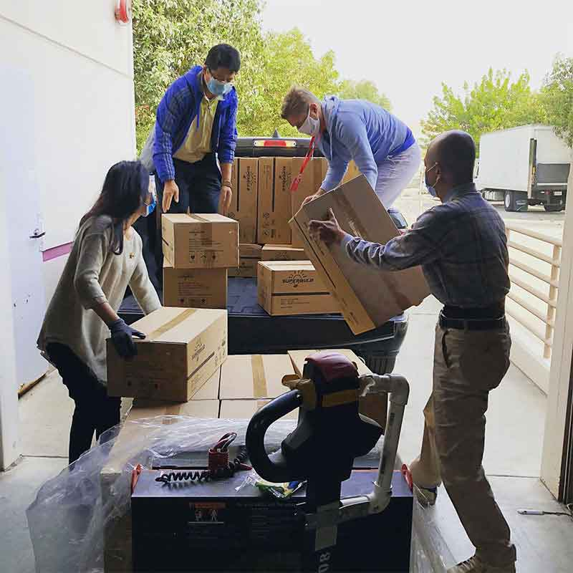

###### TRANSPORT BOOKING

# Book Your Transport Service!

Looking to modernize your fleet processes with our top-notch fleet running solutions? Whether you need automobile tracking, upkeep software, or cloud-based management schemes, we offer the finest solutions tailored for minor businesses and large logistics businesses alike. Book your conveyance service today and knowledge the efficiency of our complete fleet management tools.

###### Call for any query!

### +012 345 6789

Top of Form













Book Now

Bottom of Form

###### OUR TEAM

# Expert Team Members



##### Fleet Management Specialist

Expert in Fleet Management System



##### Fleet MS software Engineer

Specialist in FMS Software Solutions



##### GPS Fleet Tracking Expert

Real-Time GPS Tracking Specialist



##### Fleet Maintenance Specialist

Expert in Fleet Maintenance Software

###### TESTIMONIAL

# Our Clients Say!



##### Jane Smith

Fleet Manager

"Our trucking company has importantly benefited after a complete fleet management system. The actual GPS tracking and automatic fleet management answers have improved our fleet's efficiency."



##### Alex Johnson

Transportation Director

"The swift maintenance package we use has remained a game-changer. It's an inexpensive fleet running solution that keeps our logistics corporation consecutively smoothly. The driver performance monitoring feature is particularly useful."



##### Emily Davis

Operations Head

"We applied an open-source fleet management scheme that offers countless flexibility. It's been faultless for our small business, letting us to track our fleet efficiently and ensure obedience with industry values."



##### John Doe

Logistics Manager

"By means of the best fleet organization system software for small industries has transformed our operations. The cloud-based fleet management system is extremely accessible and has knowingly reduced our costs."



##### Jane Smith

Fleet Manager

"Our trucking company has importantly helped from a complete fleet management scheme. The real-time GPS following and automatic fleet management solutions have enhanced our fleet's efficiency."



##### Alex Johnson

Transportation Director

"The fleet maintenance package we use has remained a game-changer. It's an reasonable fleet management solution that retains our logistics company running smoothly. The driver performance monitoring feature is particularly useful."



##### Emily Davis

Operations Head

"We applied an open-source fleet management system that offers great suppleness. It's been faultless for our small commercial, allowing us to track our fleet efficiently and ensure obedience with industry values."



##### John Doe

Logistics Manager

"Using the best fleet management system software for small trades has altered our operations. The cloud-based fleet management system is incredibly user-friendly and has meaningfully reduced our prices."



##### Jane Smith

Fleet Director

"Our trucking company has greatly benefited from a complete fleet management system. The real-time GPS tracking and automated fleet management solutions have enhanced our fleet's efficiency."



##### Alex Johnson

Transportation Director

"The fleet maintenance package we use has been a game-changer. It's an affordable fleet management solution that keeps our logistics company running smoothly. The driver behavior monitoring feature is particularly useful."

###### GET IN TOUCH

# Contact For Any Query

If you have any questions about our Fleet Management System, including our FMS software, vehicle fleet management system, fleet tracking system, fleet maintenance software, GPS fleet tracking system, or truck fleet management software, please don't hesitate to contact us. We offer comprehensive solutions like fleet telematics systems, fleet dispatch software, fleet fuel management systems, and fleet inventory management software. Our cloud-based fleet management system and fleet performance monitoring system are designed to cater to businesses of all sizes, from small businesses to large logistics companies. Additionally, we provide fleet maintenance management systems, fleet safety management software, fleet routing and scheduling software, fleet compliance management systems, and fleet asset management software. Reach out to learn more about how our top-rated fleet management tools can benefit your commercial fleet or public transportation needs.

Top of Form

Your Name

Your Email

Subject

Message

Send Message

Bottom of Form

#### Address

123 Street, New York, USA

+44 1234567889

FleetEase@gmail.com

#### Services

[Fleet ImplementationReal-Time GPSComprehensive MaintenanceCloud-BasedDriver BehaviorTailored](https://www.techiesgroup.co.in/detailspage/LandingPage/Fleet%20MS/#service)

#### Quick Links

[About Us](https://www.techiesgroup.co.in/detailspage/LandingPage/Fleet%20MS/#about)[Contact Us](https://www.techiesgroup.co.in/detailspage/LandingPage/Fleet%20MS/#contact)[Our Services](https://www.techiesgroup.co.in/detailspage/LandingPage/Fleet%20MS/#service)[Features](https://www.techiesgroup.co.in/detailspage/LandingPage/Fleet%20MS/#features)

#### Newsletter

Dolor amet sit justo amet elitr clita ipsum elitr est.



#### Order Management

* [**Home**](https://www.techiesgroup.co.in/detailspage/LandingPage/OMS/#top)
* [**Men's**](https://www.techiesgroup.co.in/detailspage/LandingPage/OMS/#men)
* [**Women's**](https://www.techiesgroup.co.in/detailspage/LandingPage/OMS/#women)
* [**Kid's**](https://www.techiesgroup.co.in/detailspage/LandingPage/OMS/#kids)
* [**Pages**](javascript:;)
* [**Explore**](https://www.techiesgroup.co.in/detailspage/LandingPage/OMS/#explore)

#### We Are Shopay

*An e-commerce website is one that &allows people to buy and sell physical goods*



#### Women

*Order management software for small businesses*



#### Men

*Order management software for small businesses*



#### Kids

*Retail order management system*



#### Accessories

*Integrated order management system*



## Men's Latest

*E-commerce order management system.*



#### coated white shirt

$90.00



#### blue corn pant

$150.00

#### Classic Spring

$120.00



#### jacket t-shirt

$120.00



#### coated white shirt

$90.00



#### blue corn pant

$150.00

#### Classic Spring

$120.00



#### jacket t-shirt

$120.00



#### coated white shirt

$90.00



#### blue corn pant

$150.00

‹›

## Women's Latest

*Retail order management system*



#### Classic Dress

$45.00



#### Spring Collection

$130.00



#### Classic Spring

$120.00



#### New coart shirt with pants

$85.00



#### Classic Dress

$45.00



#### Spring Collection

$130.00



#### Classic Spring

$120.00



#### New coart shirt with pants

$85.00



#### Classic Dress

$45.00



#### Spring Collection

$130.00

‹›

## Kid's Latest

*Open-source order management system options*



#### Summer Dress

$12.00



#### Classic Kid

$30.00



#### Classic Spring

$120.00



#### Shaddi Collection

$80.00



#### Summer Dress

$12.00



#### Classic Kid

$30.00



#### Classic Spring

$120.00



#### Shaddi Collection

$80.00



#### Summer Dress

$12.00



#### Classic Kid

$30.00

‹›

## Explore Our Products

Customizable order management software for different industries.Top-rated order management tools for wholesale businesses

How to improve order fulfillment using an OMS. - An OMS can also help with filling orders faster while improving accuracy. Most systems offer a two-way sync to make sure order information is passed between your order management system and your ecommerce platform (and/or fulfillment software) while providing you with visibility into the entire process.

Order management system with inventory tracking.The order management process begins when an order is placed and ends when the customer receives their package.

#### Cloud-based order management system advantages for retailers

*Order fulfillment software*





#### Online order management system for remote teams

*Order fulfillment software*



* [25 Market Street Hyde Greater Manchester](https://www.techiesgroup.co.in/detailspage/LandingPage/OMS/)
* [shopay@company.com](https://www.techiesgroup.co.in/detailspage/LandingPage/OMS/)
* [010-010-0998](https://www.techiesgroup.co.in/detailspage/LandingPage/OMS/)

#### Shopping & Categories

* [Men’s Shopping](https://www.techiesgroup.co.in/detailspage/LandingPage/OMS/)
* [Women’s Shopping](https://www.techiesgroup.co.in/detailspage/LandingPage/OMS/)
* [Kid's Shopping](https://www.techiesgroup.co.in/detailspage/LandingPage/OMS/)

#### Useful Links

* [Homepage](https://www.techiesgroup.co.in/detailspage/LandingPage/OMS/)
* [About Us](https://www.techiesgroup.co.in/detailspage/LandingPage/OMS/)
* [Help](https://www.techiesgroup.co.in/detailspage/LandingPage/OMS/)
* [Contact Us](https://www.techiesgroup.co.in/detailspage/LandingPage/OMS/)

#### Help & Information

* [Help](https://www.techiesgroup.co.in/detailspage/LandingPage/OMS/)
* [FAQ's](https://www.techiesgroup.co.in/detailspage/LandingPage/OMS/)
* [Shipping](https://www.techiesgroup.co.in/detailspage/LandingPage/OMS/)
* [Tracking ID](https://www.techiesgroup.co.in/detailspage/LandingPage/OMS/)

Copyright © 2024 Shopay company. All Rights Reserved.

#### Project Management System

# [**PROJECTPULSE**](https://www.techiesgroup.co.in/detailspage/LandingPage/Project%20MS/#header)

* [Home](https://www.techiesgroup.co.in/detailspage/LandingPage/Project%20MS/#intro)
* [About Us](https://www.techiesgroup.co.in/detailspage/LandingPage/Project%20MS/#about)
* [Services](https://www.techiesgroup.co.in/detailspage/LandingPage/Project%20MS/#services)
* [Contact Us](https://www.techiesgroup.co.in/detailspage/LandingPage/Project%20MS/#contact)

## Project management softwarewith collaboration capabilities

[**Get Started**](https://www.techiesgroup.co.in/detailspage/LandingPage/Project%20MS/#about) [**Our Services**](https://www.techiesgroup.co.in/detailspage/LandingPage/Project%20MS/#services)

### **About Us**

Efficiently manage projects with our intuitive software. Streamline tasks, collaborate seamlessly, and achieve success effortlessly.

Streamline project workflows effortlessly with our intuitive software. From task delegation to progress tracking, our platform ensures efficient collaboration and timely delivery. Empower your team to achieve project milestones seamlessly with our innovative tools.

#### [Task Management](https://www.techiesgroup.co.in/detailspage/LandingPage/Project%20MS/)

Organize tasks, assign responsibilities, and track progress to ensure efficient project execution.

#### [Collaboration Tools](https://www.techiesgroup.co.in/detailspage/LandingPage/Project%20MS/)

Facilitate seamless communication and file sharing among team members, enhancing collaboration and productivity.

#### [Reporting and Analytics](https://www.techiesgroup.co.in/detailspage/LandingPage/Project%20MS/)

Generate insightful reports and analyze project metrics to make data-driven decisions and optimize project performance.

#### Easy-to-use project management software for startups.

Finding the right project management software is crucial for startups aiming to streamline operations and boost productivity. One standout option is Project Pulse, designed with startups in mind. Its intuitive interface and comprehensive features make it a go-to choice for teams looking to efficiently manage tasks, deadlines, and resources. With Project Pulse, startups can easily create, assign, and track tasks, fostering collaboration and accountability among team members.

Its customizable dashboards provide real-time insights, empowering startups to make informed decisions and adapt to changing priorities swiftly. From project planning to execution, Project Pulse simplifies the project management process, allowing startups to focus on innovation and growth.

#### Cloud-based project management tools for remote teams

Cloud-based project management tools are indispensable for modern remote teams, providing a streamlined platform for collaboration and organization. These tools, accessible from any location with an internet connection, facilitate seamless communication among team members, regardless of geographical barriers.

By centralizing project-related information and fostering real-time communication, these tools enhance transparency and accountability within the team. Additionally, they offer scalability, enabling teams to adapt to changing project requirements and accommodate growth seamlessly.

With intuitive interfaces and customizable workflows, cloud-based project management tools empower remote teams to collaborate effectively, driving success in projects of any scale.

### **Services**

Your strategic vision rivals the most well-planned projects

#### [Task Management](https://www.techiesgroup.co.in/detailspage/LandingPage/Project%20MS/)

This service allows users to create, assign, and track tasks throughout the project lifecycle.

#### [Schedule Management](https://www.techiesgroup.co.in/detailspage/LandingPage/Project%20MS/)

Project management systems help in creating and managing project schedules.

#### [Resource Management](https://www.techiesgroup.co.in/detailspage/LandingPage/Project%20MS/)

Systems facilitate the allocation and utilization of resources, including personnel, equipment, and materials.

#### [Communication and Collaboration](https://www.techiesgroup.co.in/detailspage/LandingPage/Project%20MS/)

Project management systems often include communication and collaboration tools such as messaging, file sharing, and discussion forums.

#### [Risk Management](https://www.techiesgroup.co.in/detailspage/LandingPage/Project%20MS/)

Project management systems offer tools for identifying, assessing, and mitigating project risks.

#### [Cost Management](https://www.techiesgroup.co.in/detailspage/LandingPage/Project%20MS/)

These systems provide features for creating and managing project budgets, tracking expenses, and monitoring costs against budgeted estimates.

### **PROJECTPULSE**

A comprehensive project management platform tailored specifically for marketing agencies, facilitating streamlined collaboration, task allocation, timeline management, and resource optimization to enhance productivity and deliver successful campaigns efficiently.

#### USEFUL LINKS

* [Home](https://www.techiesgroup.co.in/detailspage/LandingPage/Project%20MS/)
* [About us](https://www.techiesgroup.co.in/detailspage/LandingPage/Project%20MS/)
* [Services](https://www.techiesgroup.co.in/detailspage/LandingPage/Project%20MS/)
* [Terms of service](https://www.techiesgroup.co.in/detailspage/LandingPage/Project%20MS/)
* [Privacy policy](https://www.techiesgroup.co.in/detailspage/LandingPage/Project%20MS/)

#### CONTACT US

A108 Adam Street  
New York, NY 535022  
United States  
**Phone:** +1 5589 55488 55  
**Email:** info@example.com

#### OUR NEWSLETTER

An accessible project management system designed for non-profits, offering cost-effective solutions for organizing tasks, managing resources, tracking progress, and maximizing efficiency in pursuing their charitable missions.

Top of Form



Bottom of Form

© Copyright . All Rights Reserved

#### Human Resource

[HRM Solutions](https://www.techiesgroup.co.in/detailspage/LandingPage/Human_Resource%20MS/index.html)

* [HOME](https://www.techiesgroup.co.in/detailspage/LandingPage/Human_Resource%20MS/index.html)

* [ABOUT](https://www.techiesgroup.co.in/detailspage/LandingPage/Human_Resource%20MS/about.html)

* [SERVICES](https://www.techiesgroup.co.in/detailspage/LandingPage/Human_Resource%20MS/services.html)

* [BLOG](https://www.techiesgroup.co.in/detailspage/LandingPage/Human_Resource%20MS/blog.html)

* [CONTACT](https://www.techiesgroup.co.in/detailspage/LandingPage/Human_Resource%20MS/contact.html)

# **Affordable Human Resource Management solutions for companies**

Cost-effective HR management solutions to simplify processes, boost efficiency, and drive business success. Effortlessly optimize your workforce operations.

### **HR Software for Small Businesses**

Empower your small business with an efficient HRM system tailored to your unique needs.

### **Best HRM Software for Startup**

Unlock the potential of your startup with the top-rated HR management software for seamless operations.

### **Top HRM Tools for Employee Management**

Enhance employee management with our top-rated HRM tools designed to streamline operations

## **About Us**















## **Why Choose Our HR Management System?**

## [**Best HR Management System 2024**](https://www.techiesgroup.co.in/detailspage/LandingPage/Human_Resource%20MS/)

Elevate your startup's potential with our top-tier HRM software, integrating cutting-edge features to streamline HR operations and boost productivity. From onboarding to performance management, our solution offers comprehensive tools tailored to meet the unique needs of startups. Empower your team with intuitive interfaces and customizable options, ensuring smooth processes and maximizing efficiency from day one.

## [**Cloud-Based HR Management Tools**](https://www.techiesgroup.co.in/detailspage/LandingPage/Human_Resource%20MS/)

## [**Top HR Software for Recruitment**](https://www.techiesgroup.co.in/detailspage/LandingPage/Human_Resource%20MS/)

## [**Customizable HR Software**](https://www.techiesgroup.co.in/detailspage/LandingPage/Human_Resource%20MS/)

259NUMBER OF CLIENTS

51NUMBER OF PERSONNEL

2YEARS OF EXPERIENCE

## **The Leadership**

### [EMMA MILLER](https://www.techiesgroup.co.in/detailspage/LandingPage/Human_Resource%20MS/)

[CHIEF TECHNOLOGY OFFICER](https://www.techiesgroup.co.in/detailspage/LandingPage/Human_Resource%20MS/)

[Leading the development of our HR software for small businesses](https://www.techiesgroup.co.in/detailspage/LandingPage/Human_Resource%20MS/)

### [SARAH JOHNSON](https://www.techiesgroup.co.in/detailspage/LandingPage/Human_Resource%20MS/)

[VP OF OPERATIONS](https://www.techiesgroup.co.in/detailspage/LandingPage/Human_Resource%20MS/)

[Overseeing the development of our cloud-based HR management tools for remote teams](https://www.techiesgroup.co.in/detailspage/LandingPage/Human_Resource%20MS/)

### [JOHN DOE](https://www.techiesgroup.co.in/detailspage/LandingPage/Human_Resource%20MS/)

[HEAD OF PRODUCT DEVELOPMENT](https://www.techiesgroup.co.in/detailspage/LandingPage/Human_Resource%20MS/)

[Driving innovation in our Best HR management system 2024 for startups](https://www.techiesgroup.co.in/detailspage/LandingPage/Human_Resource%20MS/)

## **Happy Customers**

“

“With the best HR management system of 2024, we've transformed our startup. The Best HRM software for startups truly empowers our growth.”

Jane Smith, Co-founder of XYZ Tech

“Implementing our employee performance management software has been a game-changer. Affordable HRM solutions for companies like ours have never been more accessible.”

Michael Johnson, HR Director at 123 Industries

“Our HR software for small businesses has streamlined our operations, making Human Resource Management system for small businesses effortless and efficient.”

John Doe, HR Manager at ABC Corporation

“With the best HR management system of 2024, we've transformed our startup. The Best HRM software for startups truly empowers our growth.”

Jane Smith, Co-founder of XYZ Tech

“Implementing our employee performance management software has been a game-changer. Affordable HRM solutions for companies like ours have never been more accessible.”

Michael Johnson, HR Director at 123 Industries

“Our HR software for small businesses has streamlined our operations, making Human Resource Management system for small businesses effortless and efficient.”

John Doe, HR Manager at ABC Corporation

“With the best HR management system of 2024, we've transformed our startup. The Best HRM software for startups truly empowers our growth.”

Jane Smith, Co-founder of XYZ Tech

### **ABOUT**

HR software for small businesses, the Best HR management system 2024, affordable Human Resource Management Sysytem, and comprehensive performance management tools

### **LEARN MORE**

* [How it works?](https://www.techiesgroup.co.in/detailspage/LandingPage/Human_Resource%20MS/)
* [Useful Tools](https://www.techiesgroup.co.in/detailspage/LandingPage/Human_Resource%20MS/)
* [Pricing](https://www.techiesgroup.co.in/detailspage/LandingPage/Human_Resource%20MS/)
* [Sitemap](https://www.techiesgroup.co.in/detailspage/LandingPage/Human_Resource%20MS/)

### **SUPPORT**

* [Abput us](https://www.techiesgroup.co.in/detailspage/LandingPage/Human_Resource%20MS/)
* [Contact Us](https://www.techiesgroup.co.in/detailspage/LandingPage/Human_Resource%20MS/)
* [Help Desk](https://www.techiesgroup.co.in/detailspage/LandingPage/Human_Resource%20MS/)
* [Knowledgebase](https://www.techiesgroup.co.in/detailspage/LandingPage/Human_Resource%20MS/)

### **CONNECT WITH US**

* [+44 1234567889](https://www.techiesgroup.co.in/detailspage/LandingPage/Human_Resource%20MS/)

* [hrms@gmail.com](https://www.techiesgroup.co.in/detailspage/LandingPage/Human_Resource%20MS/)

* [10 Downing Street, London, UK](https://www.techiesgroup.co.in/detailspage/LandingPage/Human_Resource%20MS/)

Copyright ©2024 All rights reserved with by [Human Resources Management System](https://www.techiesgroup.co.in/detailspage/LandingPage/Human_Resource%20MS/index.html)

#### Hotel Management

[ABOUT](https://www.techiesgroup.co.in/detailspage/LandingPage/Hotel%20MS/index.html#about-us)[SERVICES](https://www.techiesgroup.co.in/detailspage/LandingPage/Hotel%20MS/index.html#services)[ROOMS](https://www.techiesgroup.co.in/detailspage/LandingPage/Hotel%20MS/index.html#rooms)

[Contact](https://www.techiesgroup.co.in/detailspage/LandingPage/Hotel%20MS/contact.html)



###### LUXURY LIVING

# Cloud-based hotel management software for small hotels

[OUR ROOMS](https://www.techiesgroup.co.in/detailspage/LandingPage/Hotel%20MS/index.html) [BOOK A ROOM](https://www.techiesgroup.co.in/detailspage/LandingPage/Hotel%20MS/index.html)

PreviousNext









SUBMIT

###### ABOUT US

# Welcome to HOTEL MANAGEMENT SYSTEM

Discover seamless hospitality management with our innovative Hotel Management System. Streamline bookings, manage guest interactions, and optimize operations effortlessly. Elevate guest experiences and boost efficiency with our user-friendly platform. Explore the future of hospitality management today.

## 1234

Rooms

## 1234

Staffs

## 1234

Clients

[EXPLORE MORE](https://www.techiesgroup.co.in/detailspage/LandingPage/Hotel%20MS/index.html)









###### OUR ROOMS

# Explore Our ROOMS

$100/Night

##### Junior Suite

3 Bed2 BathWifi

These rooms are the most basic offering in the hotel, providing essential amenities like a bed, a desk, and a private bathroom.

[VIEW DETAILBOOK NOW](https://www.techiesgroup.co.in/detailspage/LandingPage/Hotel%20MS/index.html)

$100/Night

##### Executive Suite

3 Bed2 BathWifi

These rooms are suitable for guests seeking a higher level of comfort and luxury during their stay.

[VIEW DETAILBOOK NOW](https://www.techiesgroup.co.in/detailspage/LandingPage/Hotel%20MS/index.html)

$100/Night

##### Super Deluxe

3 Bed2 BathWifi

They often feature luxurious amenities such as Jacuzzis, private balconies, and panoramic different views.

[VIEW DETAILBOOK NOW](https://www.techiesgroup.co.in/detailspage/LandingPage/Hotel%20MS/index.html)

###### LUXURY LIVING

# User-friendly hotel management system for boutique hotels

Effortlessly manage bookings, guests, and operations with our intuitive hotel management system. Designed for user-friendly navigation, it streamlines tasks for staff and enhances guest satisfaction. Elevate your hospitality standards effortlessly.

[OUR ROOMS](https://www.techiesgroup.co.in/detailspage/LandingPage/Hotel%20MS/index.html) [BOOK A ROOM](https://www.techiesgroup.co.in/detailspage/LandingPage/Hotel%20MS/index.html)

###### OUR SERVICES

# Explore Our SERVICES

##### [Rooms & Appartment](https://www.techiesgroup.co.in/detailspage/LandingPage/Hotel%20MS/index.html)

[Facilitate easy booking and reservation processes for guests, including online reservations.](https://www.techiesgroup.co.in/detailspage/LandingPage/Hotel%20MS/index.html)

##### [Food & Restaurant](https://www.techiesgroup.co.in/detailspage/LandingPage/Hotel%20MS/index.html)

[The Food and Restaurant Services module in the Hotel Management System is designed to streamline and enhance the dining experience for guests.](https://www.techiesgroup.co.in/detailspage/LandingPage/Hotel%20MS/index.html)

##### [Spa & Fitness](https://www.techiesgroup.co.in/detailspage/LandingPage/Hotel%20MS/index.html)

[The Spa & Fitness services module provides guests with a comprehensive wellness experience.](https://www.techiesgroup.co.in/detailspage/LandingPage/Hotel%20MS/index.html)

##### [Sports & Gaming](https://www.techiesgroup.co.in/detailspage/LandingPage/Hotel%20MS/index.html)

[This comprehensive service offering includes a variety of recreational and competitive activities.](https://www.techiesgroup.co.in/detailspage/LandingPage/Hotel%20MS/index.html)

##### [Event & Party](https://www.techiesgroup.co.in/detailspage/LandingPage/Hotel%20MS/index.html)

[Our system ensures every event is executed flawlessly, leaving a lasting impression on all attendees.](https://www.techiesgroup.co.in/detailspage/LandingPage/Hotel%20MS/index.html)

##### [GYM & Yoga](https://www.techiesgroup.co.in/detailspage/LandingPage/Hotel%20MS/index.html)

[Our Gym and Yoga services module empowers your hotel to provide guests with comprehensive fitness.](https://www.techiesgroup.co.in/detailspage/LandingPage/Hotel%20MS/index.html)

#### Subscribe Our NEWSLETTER

SUBMIT

# [HMS](https://www.techiesgroup.co.in/detailspage/LandingPage/Hotel%20MS/index.html)

###### CONTACT

123 Main Street Anytown, NY 12345 USA

+012 345 67890

hotel@gmail.com

###### COMPANY

[About UsContact UsPrivacy PolicyTerms & ConditionSupport](https://www.techiesgroup.co.in/detailspage/LandingPage/Hotel%20MS/index.html)

###### SERVICES

[Food & RestaurantSpa & FitnessSports & GamingEvent & PartyGYM & Yoga](https://www.techiesgroup.co.in/detailspage/LandingPage/Hotel%20MS/index.html)

[Home](https://www.techiesgroup.co.in/detailspage/LandingPage/Hotel%20MS/index.html) [Cookies](https://www.techiesgroup.co.in/detailspage/LandingPage/Hotel%20MS/index.html) [Help](https://www.techiesgroup.co.in/detailspage/LandingPage/Hotel%20MS/index.html) [FQAs](https://www.techiesgroup.co.in/detailspage/LandingPage/Hotel%20MS/index.html)

#### School Management System

[Home](https://www.techiesgroup.co.in/detailspage/LandingPage/Scholl%20MS/)[About Us](https://www.techiesgroup.co.in/detailspage/LandingPage/Scholl%20MS/#about-us)[Features](https://www.techiesgroup.co.in/detailspage/LandingPage/Scholl%20MS/#classes)[Contact Us](https://www.techiesgroup.co.in/detailspage/LandingPage/Scholl%20MS/#contact)



# Best School management software for small school

School management systems provide skills such as student registration, class documents, grades, analytical grades for students, and other assessment elements.



# Affordable School Management System for Primary School

Our affordable educational ERP software offers a comprehensive solution for managing all aspects of your institution. With its robust architecture, our ERP software can be customized to meet your specific requirements.



# Best School management software for small school

School management systems provide skills such as student registration, class documents, grades, analytical grades for students, and other assessment elements.



# Affordable School Management System for Primary School

Our affordable educational ERP software offers a comprehensive solution for managing all aspects of your institution. With its robust architecture, our ERP software can be customized to meet your specific requirements.



# Best School management software for small school

School management systems provide skills such as student registration, class documents, grades, analytical grades for students, and other assessment elements.



# Affordable School Management System for Primary School

Our affordable educational ERP software offers a comprehensive solution for managing all aspects of your institution. With its robust architecture, our ERP software can be customized to meet your specific requirements.

# School Information System

The majority of such solutions are focused not only on resolving or further improving a wide range of practical administrative issues and internal processes, but also on supporting and promoting schools’ goals and objectives.

### School fees management system

A fee management system is used as task management software that automates collecting fees.

### online school management system

Entab is one of the most preferred school management software, especially for experiential learning.

### School attendence System

The attendance management system is a tool that keeps track of student attendance.

### School Timetable Software

TimeTabler is a fast and reliable computer program used by schools & colleges in over 80 countries.

# Cloud Based School management System Benefits

Educational institutions are adopting technology in the digital age to improve overall efficiency and streamline operations. The School Management System (SMS) is one such innovative solution that offers numerous advantages over conventional administrative procedures. A cloud-based school management system can be a great investment for any institution, It is the best, easiest, and most cost effective solution for administration. Technology has changed the way we do almost everything in our lives and education is no exception. School management systems that were once physical and paper-based, like grade books(result computation) and attendance records, are now digital.









# School Admission Software

An admission management system is a solution that helps to manage student admissions and related activities in colleges, schools, universities, and training institutes.

# How to implement a school management system

School management systems (SMS) are software applications that help schools to streamline their operations and improve efficiency.



### Affordable school management system for primary schools



### Features of an effective school management system



### Customizable school management system for private schools

### Get In Touch

123 High Street Cambridge

+012 345 9076

school@example.com

### Quick Links

[About UsContact UsOur ServicesPrivacy PolicyTerms & Condition](https://www.techiesgroup.co.in/detailspage/LandingPage/Scholl%20MS/)

#### Sales Management System

* [**Home**](https://www.techiesgroup.co.in/detailspage/LandingPage/Sales%20MS/)
* [**About**](https://www.techiesgroup.co.in/detailspage/LandingPage/Sales%20MS/#about)
* [**Service**](https://www.techiesgroup.co.in/detailspage/LandingPage/Sales%20MS/#service)
* [**Contact**](https://www.techiesgroup.co.in/detailspage/LandingPage/Sales%20MS/#contact)

# Sales Management System

Affordable sales management solutions for startups  
Sales performance management software for improved sales tracking  
Features of a comprehensive sales management system



# SMS software Best sales management system software for small businesses



#### Online sales management system

Customizable sales management software for different industries



#### Sales tracking software

Sales performance management software for improved sales tracking



#### Sales automation software

Features of a comprehensive sales management system



#### Sales performance management system

Customizable sales management software for different industries

## Automated sales management solutions for sales pipeline management

Sales automation uses software to eliminate repetitive, manual tasks and automates them to allow you and your sales team to focus more on closing sales and getting paid  
With sales automation tools, you can: Automate follow-ups. Manage your sales pipeline.

#### Enterprise sales management system

The enterprise sales process typically involves complex, high-value products or services that require a deep understanding of the client's business to effectively sell.  
These products or services often need to be customized to meet the unique needs of the client.





Sales force automation software

Sales force automation software automates many of these administrative duties  
so sellers can spend less time clicking  
around a CRM system and more time working with customers.



Sales force automation (SFA) is a tool or software platform that any of the daily tasks expected of sales teams.



SFA technology reduces sales teams' workloads by automating non-revenue generating tasks such as data entry and writing emails.



Sales automation is software functionality that automates the repetitive tasks that are key to building simple and profitable customer journeys.

# Sales and inventory management software

Inventory management software is a software system for tracking inventory levels, orders, sales and deliveries.



### Sales management system for sales forecasting



### Sales management system for eCommerce businesses



### Automated sales management solutions for sales pipeline management



Quick Links

* [Home](https://www.techiesgroup.co.in/detailspage/LandingPage/Sales%20MS/#!)
* [About](https://www.techiesgroup.co.in/detailspage/LandingPage/Sales%20MS/#!)
* [Service](https://www.techiesgroup.co.in/detailspage/LandingPage/Sales%20MS/#!)
* [Contact](https://www.techiesgroup.co.in/detailspage/LandingPage/Sales%20MS/#!)

Legal stuff

* [Disclaimer](https://www.techiesgroup.co.in/detailspage/LandingPage/Sales%20MS/#!)
* [Financing](https://www.techiesgroup.co.in/detailspage/LandingPage/Sales%20MS/#!)
* [Privacy Policy](https://www.techiesgroup.co.in/detailspage/LandingPage/Sales%20MS/#!)
* [Terms of Service](https://www.techiesgroup.co.in/detailspage/LandingPage/Sales%20MS/#!)

Sales management system implementation guide

Top of Form

Bottom of Form

© 2024 saleMarketingTeam

#### Donation management System

# Best Charity donation management system software for small nonprofits

[DONATE NOW](https://www.techiesgroup.co.in/detailspage/LandingPage/DMS/#donate)

### Online donation management software

# Service

Choosing the right donation management system for your charity is crucial for efficient operations and donor engagement. Here's a comprehensive guide to help you make the right choice

[[](https://www.techiesgroup.co.in/detailspage/LandingPage/DMS/)](https://www.techiesgroup.co.in/detailspage/LandingPage/DMS/" \t "_blank)

## [Benefits of using a cloud-based donation management system](https://www.techiesgroup.co.in/detailspage/LandingPage/DMS/)

Highlight the advantages of cloud-based donation management systems, such as accessibility, scalability, and security

[[](https://www.techiesgroup.co.in/detailspage/LandingPage/DMS/)](https://www.techiesgroup.co.in/detailspage/LandingPage/DMS/" \t "_blank)

## [Donation management system with donor tracking features](https://www.techiesgroup.co.in/detailspage/LandingPage/DMS/)

Develop or offer a system that includes robust donor tracking features to help nonprofits effectively manage their donor relationships.

[[](https://www.techiesgroup.co.in/detailspage/LandingPage/DMS/)](https://www.techiesgroup.co.in/detailspage/LandingPage/DMS/" \t "_blank)

## [Affordable donation solutions for churches](https://www.techiesgroup.co.in/detailspage/LandingPage/DMS/)

Provide cost-effective donation management solutions tailored specifically for churches and religious organizations.

[[](https://www.techiesgroup.co.in/detailspage/LandingPage/DMS/)](https://www.techiesgroup.co.in/detailspage/LandingPage/DMS/" \t "_blank)

## [Cloud-based donation management system advantages for NGOs](https://www.techiesgroup.co.in/detailspage/LandingPage/DMS/)

Highlight the assistances of cloud-based donation management systems for NGOs, including flexibility, its cost-effectiveness, and remote user-friendliness.

[[](https://www.techiesgroup.co.in/detailspage/LandingPage/DMS/)](https://www.techiesgroup.co.in/detailspage/LandingPage/DMS/" \t "_blank)

## [Donation tracking software for fundraising events](https://www.techiesgroup.co.in/detailspage/LandingPage/DMS/)

Grow software exactly designed to track aids and manage fund-raise events, providing features such as ticketing, attendee organization, and gift tracking.

[[](https://www.techiesgroup.co.in/detailspage/LandingPage/DMS/)](https://www.techiesgroup.co.in/detailspage/LandingPage/DMS/" \t "_blank)

## [Best donation management system software for small nonprofits](https://www.techiesgroup.co.in/detailspage/LandingPage/DMS/)

Offer a particular software solution custom-made to the needs and budget restraints of small not-for-profit organizations.



# Welcome to Our Donation Management

Our business is enthusiastic to providing brilliant donation organization answers for nonprofits of all sizes. We proposal a range of services, counting cloud-based donation management systems, donor following features, and automatic donation processing. Our answers are designed to be reasonable for small nonprofits, churches, and educational institutions. We also provide consulting on choosing the right scheme for aids and NGOs, ensuring they advantage from robust journalism, analytics, and CRM integration. Our goal is to help governments improve donor meeting, manage recurring aids, and streamline fund-raise events effectively.

# Features of a comprehensive donation management system

Offer a complete donation management system with structures such as donor management, journalism, analytics, and addition with customer relationship management (CRM) tools.

[[](https://www.techiesgroup.co.in/detailspage/LandingPage/DMS/)](https://www.techiesgroup.co.in/detailspage/LandingPage/DMS/" \t "_blank)

#### [Online donation management system for remote fundraising teams](https://www.techiesgroup.co.in/detailspage/LandingPage/DMS/" \t "_blank)

[Provide an online donation management system tailored for remote fundraising teams, allowing for collaboration, real-time updates, and remote access to donation data.](https://www.techiesgroup.co.in/detailspage/LandingPage/DMS/" \t "_blank)

[[](https://www.techiesgroup.co.in/detailspage/LandingPage/DMS/)](https://www.techiesgroup.co.in/detailspage/LandingPage/DMS/" \t "_blank)

#### [Automated donation management solutions for donation processing](https://www.techiesgroup.co.in/detailspage/LandingPage/DMS/" \t "_blank)

[Develop or offer automated donation management solutions to streamline the donation processing workflow, reducing manual effort and increasing efficiency.](https://www.techiesgroup.co.in/detailspage/LandingPage/DMS/" \t "_blank)

[[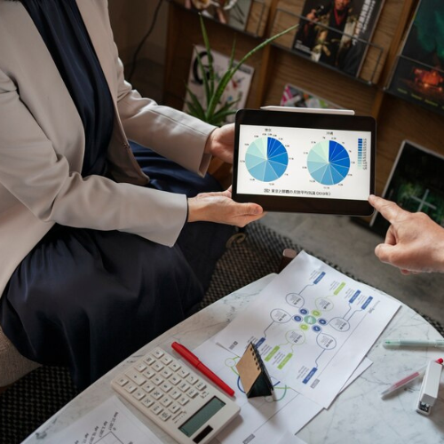](https://www.techiesgroup.co.in/detailspage/LandingPage/DMS/)](https://www.techiesgroup.co.in/detailspage/LandingPage/DMS/" \t "_blank)

#### [Integrated donation management system with reporting and analytics](https://www.techiesgroup.co.in/detailspage/LandingPage/DMS/" \t "_blank)

[Offer a donation management system that integrates reporting and analytics tools to provide insights into donor behavior, campaign performance, and fundraising effectiveness.](https://www.techiesgroup.co.in/detailspage/LandingPage/DMS/" \t "_blank)

[[](https://www.techiesgroup.co.in/detailspage/LandingPage/DMS/)](https://www.techiesgroup.co.in/detailspage/LandingPage/DMS/" \t "_blank)

#### [Donation management system for educational institutions](https://www.techiesgroup.co.in/detailspage/LandingPage/DMS/" \t "_blank)

[Provide a donation management system tailored for educational institutions, offering features such as alumni engagement, scholarship management, and fundraising campaign tracking.](https://www.techiesgroup.co.in/detailspage/LandingPage/DMS/" \t "_blank)

[[](https://www.techiesgroup.co.in/detailspage/LandingPage/DMS/)](https://www.techiesgroup.co.in/detailspage/LandingPage/DMS/" \t "_blank)

#### [Customizable donation management software for different types of nonprofits](https://www.techiesgroup.co.in/detailspage/LandingPage/DMS/" \t "_blank)

[Offer customizable donation management software tailored for diverse nonprofits, ensuring alignment with unique campaign needs, donor engagement strategies, and reporting requirements.](https://www.techiesgroup.co.in/detailspage/LandingPage/DMS/" \t "_blank)

[[](https://www.techiesgroup.co.in/detailspage/LandingPage/DMS/)](https://www.techiesgroup.co.in/detailspage/LandingPage/DMS/" \t "_blank)

#### [Automated donation management software](https://www.techiesgroup.co.in/detailspage/LandingPage/DMS/" \t "_blank)

[Develop or offer automated donation management software to automate tasks such as donation processing, acknowledgment emails, and reporting.](https://www.techiesgroup.co.in/detailspage/LandingPage/DMS/" \t "_blank)

[[](https://www.techiesgroup.co.in/detailspage/LandingPage/DMS/)](https://www.techiesgroup.co.in/detailspage/LandingPage/DMS/" \t "_blank)

#### [Donation management system for recurring donations and pledges](https://www.techiesgroup.co.in/detailspage/LandingPage/DMS/" \t "_blank)

[Offer a donation management system that supports recurring donations and pledges, allowing nonprofits to efficiently manage ongoing contributions from donors.](https://www.techiesgroup.co.in/detailspage/LandingPage/DMS/" \t "_blank)

[[](https://www.techiesgroup.co.in/detailspage/LandingPage/DMS/)](https://www.techiesgroup.co.in/detailspage/LandingPage/DMS/" \t "_blank)

#### [User-friendly donation management tools for nonprofit organizations](https://www.techiesgroup.co.in/detailspage/LandingPage/DMS/" \t "_blank)

[Develop intuitive and user-friendly donation management tools designed specifically for nonprofit organizations to simplify the donation process and improve donor engagement.](https://www.techiesgroup.co.in/detailspage/LandingPage/DMS/" \t "_blank)

# Donate Now

Support our mission with your generous donations. Every contribution helps us make a difference.

#### Divided Evenly

Ensuring all donations are distributed evenly across our various programs and initiatives.

#### Transparency All the Way

We maintain full transparency with our donors, providing regular updates and detailed reports.

#### Trustworthy

Trust is at the core of our operations. We guarantee that your donations are used ethically and effectively.

Top of Form



Project you want to donate

* **Project you want to donate**
* Education Initiatives
* Healthcare Programs
* Community Development





DONATE

Bottom of Form

We Accept: 

#### About Donation Link

Donation Link is dedicated to supporting various charitable causes through an efficient and transparent donation management system. Our mission is to connect generous donors with those in need, ensuring that every contribution makes a significant impact.

#### Quick Links

* [**HOME**](https://www.techiesgroup.co.in/detailspage/LandingPage/DMS/#home)
* [**SERVICE**](https://www.techiesgroup.co.in/detailspage/LandingPage/DMS/#service)
* [**ABOUT**](https://www.techiesgroup.co.in/detailspage/LandingPage/DMS/#about)
* [**DONATE**](https://www.techiesgroup.co.in/detailspage/LandingPage/DMS/#donate)

#### Contact Us

* 123 Donation Street, Nonprofit City, NP 12345
* +1 234 567 890
* info@donationlink.org

Copyright ©2024 All rights reserved | by [Donation Link](https://www.techiesgroup.co.in/detailspage/LandingPage/DMS/)

#### Vendor Management System

# anVendor Management Software System

Dealing with multiple vendors for different needs is not so easy, for this we have to leverage on a vendor management tool that helps drive more value out of vendor relationships. By installing this Vendor Management Software OEM companies can digitally



## Leverage Vendor Management Software & go beyond existing capabilities

Switch from Manual to Digitized Vendor Management and track supplies & payables ,.

* Switch from Manual to Digitized Vendor Management and track supplies & payables
* Centralize vendor master data & increase transparency at all levels
* Manage procurement & keep track of adherence to agreements and quality compliance

Automate vendor workflow process to meet procurement needs & drive efficiency.

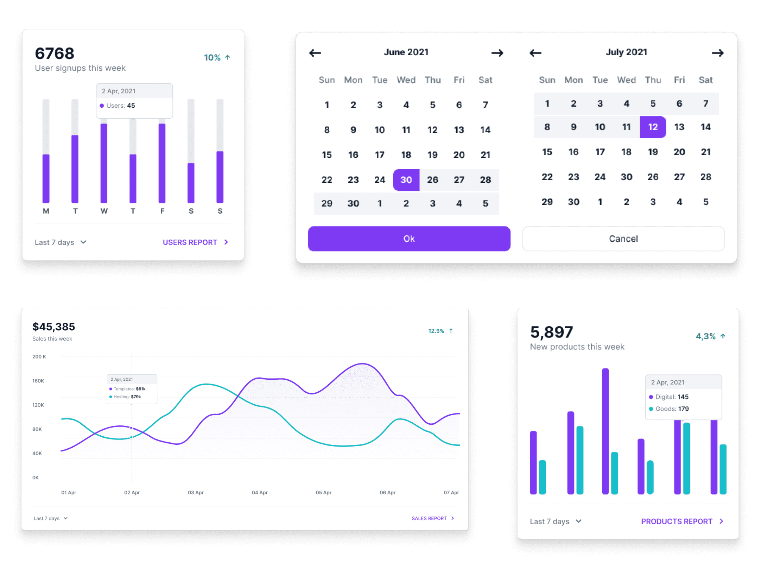



## Web-based Vendor Management Portal for Digitization & Automation

Vendora, the web-based Digital Vendor Management Platform.

* enables organizations to simplify & streamline purchase processes beyond ERP
* Here you can evaluate and onboard suppliers,
* Development workflow
* analyze vendor performance using score cards,
* MIS reports and streamline purchases as a whole.

enables organizations to simplify & streamline purchase processes beyond ERP. Here you can evaluate and onboard suppliers, maintain all types of master data.

Vendora-Features

## Redefine & Digitize your Vendor Management Operations

Buyers can intimate the forecast to vendors and get confirmation..

[Explore Legality Guide](https://www.techiesgroup.co.in/detailspage/LandingPage/Vendor%20MS/)

[Visit the Trust Center](https://www.techiesgroup.co.in/detailspage/LandingPage/Vendor%20MS/)

### 32,000+

Vendors

### 135,000+

PO

### 160,000+

ASN

### 140,000+

Invoices

"Advanced DIGITAL Platform for Vendor Management."



Micheal Gough

CEO at Google

## Advanced DIGITAL Platform for Vendor Management

### Automate manual task

Landwind is an open-source library of interactive components built on top of Tailwind CSS including buttons, dropdowns, modals, navbars, and more.

### Ensure Quality compliance

### Decrease in spend cost

### What about browser support?

## What our Client's says about us

"I would say that the whole modules in this product precisely automated my procurement & supply chain functional flow and I no longer need to worry about tracking my vendor's various supply chain functions. Vendora helped us to Track the vendor performance by various attributes to track the vendor efficiency. Various reports in the buyer and vendor dashboard display is a heads up to act accordingly.

### COMPANY

* [About](https://www.techiesgroup.co.in/detailspage/LandingPage/Vendor%20MS/)
* [Careers](https://www.techiesgroup.co.in/detailspage/LandingPage/Vendor%20MS/)
* [Brand Center](https://www.techiesgroup.co.in/detailspage/LandingPage/Vendor%20MS/)
* [Blog](https://www.techiesgroup.co.in/detailspage/LandingPage/Vendor%20MS/)

### HELP CENTER

* [Discord Server](https://www.techiesgroup.co.in/detailspage/LandingPage/Vendor%20MS/)
* [Twitter](https://www.techiesgroup.co.in/detailspage/LandingPage/Vendor%20MS/)
* [Facebook](https://www.techiesgroup.co.in/detailspage/LandingPage/Vendor%20MS/)
* [Contact Us](https://www.techiesgroup.co.in/detailspage/LandingPage/Vendor%20MS/)

### LEGAL

* [Privacy Policy](https://www.techiesgroup.co.in/detailspage/LandingPage/Vendor%20MS/)
* [Licensing](https://www.techiesgroup.co.in/detailspage/LandingPage/Vendor%20MS/)
* [Terms](https://www.techiesgroup.co.in/detailspage/LandingPage/Vendor%20MS/)

### COMPANY

* [About](https://www.techiesgroup.co.in/detailspage/LandingPage/Vendor%20MS/)
* [Careers](https://www.techiesgroup.co.in/detailspage/LandingPage/Vendor%20MS/)
* [Brand Center](https://www.techiesgroup.co.in/detailspage/LandingPage/Vendor%20MS/)
* [Blog](https://www.techiesgroup.co.in/detailspage/LandingPage/Vendor%20MS/)
* [iOS](https://www.techiesgroup.co.in/detailspage/LandingPage/Vendor%20MS/)
* [Android](https://www.techiesgroup.co.in/detailspage/LandingPage/Vendor%20MS/)
* [Windows](https://www.techiesgroup.co.in/detailspage/LandingPage/Vendor%20MS/)
* [MacOS](https://www.techiesgroup.co.in/detailspage/LandingPage/Vendor%20MS/)

#### Finanicial Management

# FINANCIAL MANAGEMENT SYSTEM

The earliest accounting records were found among the 7,000-year-old ruins of ancient Mesopotamia. This predates the invention of the wheel by over 3,000 years and speaks to the historical and cultural importance of trade and commerce in the evolution of human society.A financial management system is the software and processes used to manage income, expenses, and assets in an organisation.

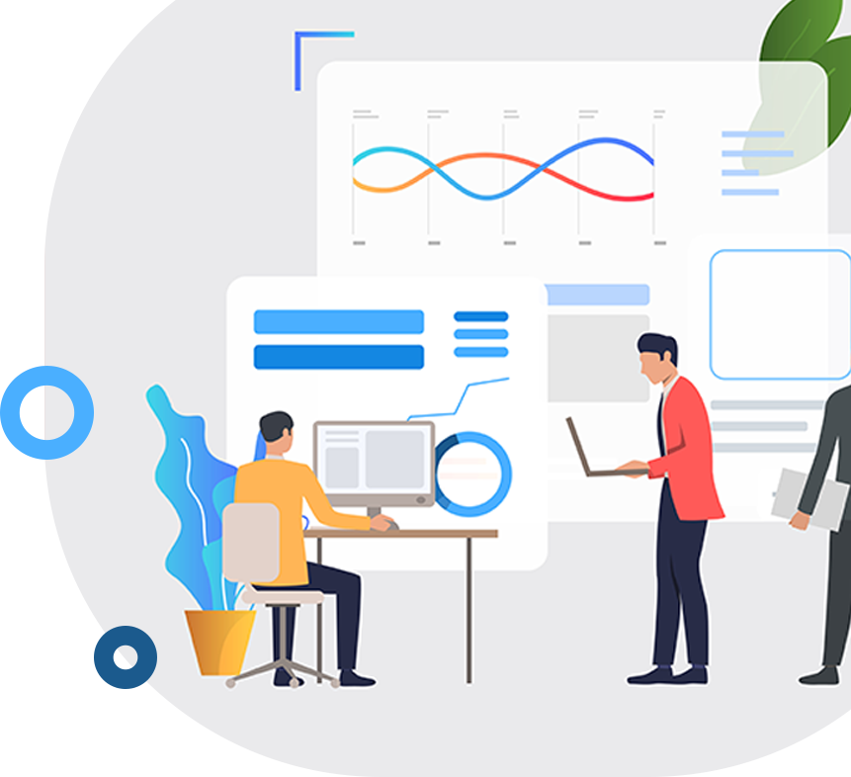

# WELCOME BEST FINANCIAL MANAGEMENT SYSTEM

A financial management system is the software and processes used to manage income, expenses, and assets in an organization. In addition to supporting daily financial operations, the purpose of a financial management system is to maximize profits and ensure long-term enterprise sustainability.



# FINANCIAL MANAGEMENT SYSTEM FOR SMALL BUSINESS BUDGETING

A financial budget offers a strategic overview of how a business manages cash flow, assets, expenses, and income.



### **CLOUD FINANCIAL MANAGEMENT SYSTEM**

Cloud Financial Management is the process of identifying, measuring, monitoring, and optimizing cloud costs.



### **FINANCIAL MANAGEMENT SYSTEM FEATURES**

Financial management involves strategic planning, directing, and controlling financial resources



### **ENTERPRISE FINANCIAL MANAGEMENT SYSTEM**

Financial management software can be part of a company's enterprise resource planning (ERP) system



### **FINANCIAL MANAGEMENT SYSTEM IMPLEMENTATION**

Financial plan implementation is the process of putting into action the strategies and steps outlined in a financial plan



### 1000+

**Years of Business**



### 20000+

**Projects Delivered**



### 10000+

**Satisfied Customers**



### 1500+

**Services**

# FINANCIAL MANAGEMENT SYSTEM FOR ASSET MANAGEMENT

A financial management system is the software and processes used to manage income, expenses, and assets in an organization







## **Financial Management System Integration**





## **Open Source Financial Management System**

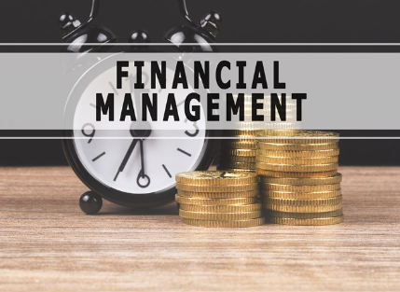



## **Financial Management with RealTime Reporting**





## **Cloud Financial Management System**

#### About Financial

10 Downing Street Westminster London

+01 9876587690

finance@gmail.com

#### About Financial

The purpose of a financial management system is to maximize profits and ensure long-term enterprise sustainability.

#### Instagram













#### Newsletter



[SUBSCRIBE](https://www.techiesgroup.co.in/detailspage/LandingPage/Financial%20MS/)

* [](https://www.techiesgroup.co.in/detailspage/LandingPage/Financial%20MS/)
* [](https://www.techiesgroup.co.in/detailspage/LandingPage/Financial%20MS/)
* [](https://www.techiesgroup.co.in/detailspage/LandingPage/Financial%20MS/)
* [](https://www.techiesgroup.co.in/detailspage/LandingPage/Financial%20MS/)

Copyright 2019 All Right Reserved By [Financial Management Software](https://html.design/)

#### Inventory Management System

#### A

[HOME](https://www.techiesgroup.co.in/detailspage/LandingPage/IMS/)[ABOUT](https://www.techiesgroup.co.in/detailspage/LandingPage/IMS/#about-us)[SERVICE](https://www.techiesgroup.co.in/detailspage/LandingPage/IMS/#service)

[Contact](https://www.techiesgroup.co.in/detailspage/LandingPage/IMS/#contact)



##### WELCOME TO INVENEASE

# Inventory management system features comparison

Like a well-organized warehouse, you bring order to my chaos

##### WELCOME TO INVENEASE

# Asset tracking system benefits for manufacturing

You're the perfect stock level to my demand forecast.



##### WELCOME TO INVENEASE

# Inventory management software integration with accounting

Just like JIT inventory, you arrive exactly when needed, making life easier.



##### WELCOME TO INVENEASE

# Inventory management system features comparison

Like a well-organized warehouse, you bring order to my chaos

##### WELCOME TO INVENEASE

# Asset tracking system benefits for manufacturing

You're the perfect stock level to my demand forecast.



##### WELCOME TO INVENEASE

# Inventory management software integration with accounting

Just like JIT inventory, you arrive exactly when needed, making life easier.



##### WELCOME TO INVENEASE

# Inventory management system features comparison

Like a well-organized warehouse, you bring order to my chaos

# 01

##### Inventory Tracking

# 02

##### Order Management

# 03

##### Inventory Optimization

# 04

##### Reporting and Analytics



# About Us

At InvenEase, we believe in continuous improvement and strive to stay ahead of the curve by incorporating the latest technologies and industry best practices into our platform. We are committed to delivering reliable, user-friendly, and scalable solutions that meet the evolving needs of our customers.

# Our Services

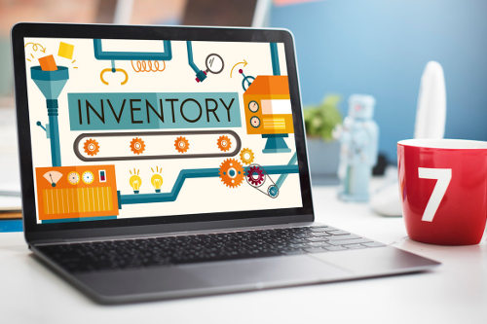

#### Inventory Tracking

This is the core function, allowing businesses to track the movement of inventory items in real-time.



#### Order Management

This ensures accurate order processing and timely delivery to customers.

#### Forecasting and Planning

This helps businesses optimize their inventory levels, reduce excess stock, and avoid stockouts.



#### Inventory Optimization

This ensures that they maintain the right amount of stock to meet demand without overstocking or understocking.



#### Reporting and Analytics

These insights help businesses make informed decisions and identify areas for improvement.



#### Integration with Other Systems

This streamlines data flow across different departments and ensures consistency in information.

# Why Choose Us

When selecting an inventory management system, there are numerous factors to consider, but here are four key reasons why choosing us would be advantageous

Quality

##### Services

Custom

##### Requirements

System

##### Integration

Customer

##### Support



#### Address

456 Oak Avenue Springfield, IL 62701 USA

(212) 555-7890

inventory@gmail.com

#### Services

[Inventory TrackingOrder ManagementForecasting And PlanningInventory OptimizationIntegration With Other Systems](https://www.techiesgroup.co.in/detailspage/LandingPage/IMS/)

#### Quick Links

[About UsContact UsOur ServicesTerms & ConditionSupport](https://www.techiesgroup.co.in/detailspage/LandingPage/IMS/)

#### Newsletter

Dolor amet sit justo amet elitr clita ipsum elitr est.

SignUp

© [InvenEase](https://www.techiesgroup.co.in/detailspage/LandingPage/IMS/), All Right Reserved.

#### Content Management System

* [Home](https://www.techiesgroup.co.in/detailspage/LandingPage/Content%20MS/)
* [About](https://www.techiesgroup.co.in/detailspage/LandingPage/Content%20MS/#about)
* [Services](https://www.techiesgroup.co.in/detailspage/LandingPage/Content%20MS/#services)
* [Contact](https://www.techiesgroup.co.in/detailspage/LandingPage/Content%20MS/#contact)



# CMS Software

Are you a content management system? Because you organize my chaotic life.



# CMS Platform

You're like a content management system, bringing order to my world.



# CMS Solutions

Your presence, like a content management system, brings clarity and organization.

* 1
* 2
* 3

## Implementing a Content Management System for better content organization

* About



#### Now! you manage to keepmy content perfectly organized and my heart fully updated.

A Content Management System (CMS) is a software application used to create, manage, and modify digital content.

CMS platforms offer tools for publishing, editing, and organizing content such as text, images, and videos.

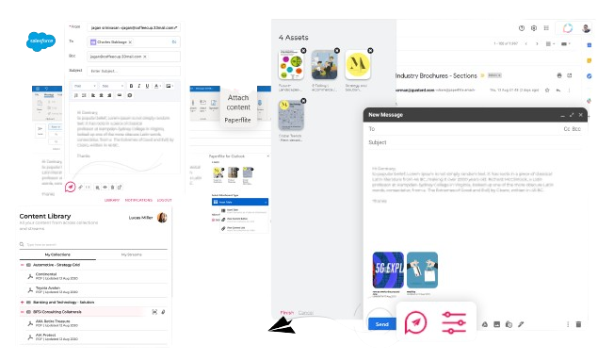

## You organize my chaos beautifully.

Content distribution in a content management system involves disseminating various media types across multiple platforms. This process ensures content reaches target audiences efficiently, utilizing strategies like social media sharing, email campaigns, syndication, and SEO optimization.

## Services

[](https://www.techiesgroup.co.in/detailspage/LandingPage/Content%20MS/product-detail.html)

##### [Content Creation and Editing](https://www.techiesgroup.co.in/detailspage/LandingPage/Content%20MS/product-detail.html)

[](https://www.techiesgroup.co.in/detailspage/LandingPage/Content%20MS/product-detail.html)

##### [Content Organization and Management](https://www.techiesgroup.co.in/detailspage/LandingPage/Content%20MS/product-detail.html)

[](https://www.techiesgroup.co.in/detailspage/LandingPage/Content%20MS/product-detail.html)

##### [Content Publishing and Versioning](https://www.techiesgroup.co.in/detailspage/LandingPage/Content%20MS/product-detail.html)

#### [Content](https://www.techiesgroup.co.in/detailspage/LandingPage/Content%20MS/index.html)Forge

**TechieShubhdeep**

Designed by [Techies](https://www.tooplate.com/)

##### Sitemap

* [About](https://www.techiesgroup.co.in/detailspage/LandingPage/Content%20MS/about.html)
* [Services](https://www.techiesgroup.co.in/detailspage/LandingPage/Content%20MS/)
* [Privacy policy](https://www.techiesgroup.co.in/detailspage/LandingPage/Content%20MS/)
* [FAQs](https://www.techiesgroup.co.in/detailspage/LandingPage/Content%20MS/)
* [Contact](https://www.techiesgroup.co.in/detailspage/LandingPage/Content%20MS/)

#### Contract Management System

* [**Home**](https://www.techiesgroup.co.in/detailspage/LandingPage/Contract%20MS/index.html)
* [**About Us**](https://www.techiesgroup.co.in/detailspage/LandingPage/Contract%20MS/#about-us)
* [**Our Services**](https://www.techiesgroup.co.in/detailspage/LandingPage/Contract%20MS/#services)
* [**Contact**](https://www.techiesgroup.co.in/detailspage/LandingPage/Contract%20MS/#contact)

# Contract Management System

## **Achieve contract visibility and compliance with advanced reporting features. Electronic signatures streamline the contract approval process.**

# Contract Management System

## **Automated reminders and notifications keep you ahead of deadlines. Enjoy enhanced document security and easy access with a top-tier CMS.**

# Contract Management System

## **A contract management system ensures seamless organization of all agreements. With automated workflows, managing contracts becomes a breeze.**

# Contract Management System

## **Achieve contract visibility and compliance with advanced reporting features. Electronic signatures streamline the contract approval process.**

# Contract Management System

## **Automated reminders and notifications keep you ahead of deadlines. Enjoy enhanced document security and easy access with a top-tier CMS.**

# Contract Management System

## **A contract management system ensures seamless organization of all agreements. With automated workflows, managing contracts becomes a breeze.**

# Contract Management System

## **Achieve contract visibility and compliance with advanced reporting features. Electronic signatures streamline the contract approval process.**

#### ABOUT US

## **Welcome to Contract Management System**

*A contract management system (CMS) is a software solution designed to streamline and automate.*

A contract management system is a centralized digital platform designed to streamline the entire contract lifecycle. It automates contract creation, negotiation, execution, and analysis processes, improving efficiency and reducing errors. Features typically include customizable templates, version control, electronic signatures, and alerts for key dates.

[Learn More](https://www.techiesgroup.co.in/detailspage/LandingPage/Contract%20MS/)





#### WHO WE ARE

## **Contract Management System**

*The contract management system serves as a centralized platform for these stakeholders to collaborate, communicate, and effectively manage the organization's contracts.*

In a contract management system, "we" typically refers to the organization or entity utilizing the system to manage its contracts. This includes various stakeholders within the organization such as contract managers, legal teams, procurement professionals, finance departments, and executives.

[Learn More](https://www.techiesgroup.co.in/detailspage/LandingPage/Contract%20MS/)

**1200**

### Complated Projects

**3210**

### Happy Clients

**3781**

### Customer Services

**4300**

### Answered Questions

### **Our Service**

Our Service unlimited solutions to all your business needs. in the installation package we prepare search engine optimization, social media support, we provide corporate identity and graphic design services.



### Contract Creation and Authorings

This service involves the creation, drafting, and authoring of contracts.Users can generate contracts using templates, clauses.



### Contract Repository and Storage

It comprises features such as text indexing, categorization, and hunt functionalities to safeguard easy retrieval of agreements.

### Contract Lifecycle Management (CLM)

CLM includes the entire lifecycle of a agreement, from beginning and compromise to implementation, regeneration, and termination.



### Compliance Monitoring

This facility involves tracking key contract signs, deadlines, and duties to ensure compliance with votive terms and circumstances.



Contract tracking and compliance monitoring help organizations mitigate risks, avoid penalties, and maintain strong relationships with stakeholders by ensuring that contractual obligations are met in a timely manner.

Advanced systems may offer secure cloud-based storage with access control mechanisms to maintain confidentiality and compliance with data protection regulations.

### **Pages**

* [Home](https://www.techiesgroup.co.in/detailspage/LandingPage/Contract%20MS/)
* [Blog](https://www.techiesgroup.co.in/detailspage/LandingPage/Contract%20MS/)
* [About](https://www.techiesgroup.co.in/detailspage/LandingPage/Contract%20MS/)
* [Faq](https://www.techiesgroup.co.in/detailspage/LandingPage/Contract%20MS/)
* [Contact](https://www.techiesgroup.co.in/detailspage/LandingPage/Contract%20MS/)

### **Subscribe**

It includes features such as document indexing, categorization, and search functionalities to ensure easy retrieval of contracts when needed.

Top of Form



Bottom of Form

Design By : [TechieShubhdeep](https://html.design/)

#### Knowledge Management

* [Home](https://www.techiesgroup.co.in/detailspage/LandingPage/Knowledge%20MS/)

* [Get](https://www.techiesgroup.co.in/detailspage/LandingPage/Knowledge%20MS/#get)

* [Blog](https://www.techiesgroup.co.in/detailspage/LandingPage/Knowledge%20MS/#blog)

* [Contact](https://www.techiesgroup.co.in/detailspage/LandingPage/Knowledge%20MS/#contact)

# **We Help You to Learn New Things**

# **The Roots of Education are Bitter, But the Fruit is Sweet**

# **The Great Aim of Education is not Knowledge, But Action**

# **We Help You to Learn New Things**

# **The Roots of Education are Bitter, But the Fruit is Sweet**

1. [1](https://www.techiesgroup.co.in/detailspage/LandingPage/Knowledge%20MS/)
2. [2](https://www.techiesgroup.co.in/detailspage/LandingPage/Knowledge%20MS/)
3. [3](https://www.techiesgroup.co.in/detailspage/LandingPage/Knowledge%20MS/)

## **GET KNOWLEDGE OF...**

technology-based system designed to help organizations capture, organize, store, retrieve, and share knowledge

### [**Business**](https://www.techiesgroup.co.in/detailspage/LandingPage/Knowledge%20MS/)

A business description is a detailed account of a company's operations, goals, and unique characteristics.

### [**Health & Psychology**](https://www.techiesgroup.co.in/detailspage/LandingPage/Knowledge%20MS/)

Health psychology is a specialized field within psychology focused on understanding how biological, psychological.

### [**Accounting**](https://www.techiesgroup.co.in/detailspage/LandingPage/Knowledge%20MS/)

Accounting is the systematic process of recording, classifying, summarizing, and interpreting financial information.

### [**Science & Technology**](https://www.techiesgroup.co.in/detailspage/LandingPage/Knowledge%20MS/)

Science is the systematic pursuit of knowledge about the natural world through observation and experimentation.

### [**Art & Media**](https://www.techiesgroup.co.in/detailspage/LandingPage/Knowledge%20MS/)

Art and media encompass a broad range of creative expressions and communication methods that reflect, shape.

### [**Real Estate**](https://www.techiesgroup.co.in/detailspage/LandingPage/Knowledge%20MS/)

The spacious living area is perfect for relaxing with loved ones or entertaining guests.

### [**Language**](https://www.techiesgroup.co.in/detailspage/LandingPage/Knowledge%20MS/)

It could encompass various aspects of language, such as phonetics, syntax, semantics, pragmatics.

### [**Web & Programming**](https://www.techiesgroup.co.in/detailspage/LandingPage/Knowledge%20MS/)

Web programming involves the creation and maintenance of websites and web applications using programming languages.

2802Foreign Followers

3145Students Enrolled

4279Classes Complete

918Certified Teachers

## **BLOG & EVENTS**

A knowledge management system (KMS) is a software platform or framework designed to facilitate

### [**The Pillars of Effective Knowledge Management**](https://www.techiesgroup.co.in/detailspage/LandingPage/Knowledge%20MS/)

KMS starts with the identification and capture of knowledge from various sources within the organization.

### [**Understanding Knowledge Management Systems**](https://www.techiesgroup.co.in/detailspage/LandingPage/Knowledge%20MS/)

Knowledge Management System is a framework designed to capture, organize, and distribute knowledge within an organization.

### [**Unlocking Organizational Potential**](https://www.techiesgroup.co.in/detailspage/LandingPage/Knowledge%20MS/)

Knowledge Management Systems are multifaceted platforms designed to facilitate the seamless flow of information.

### ABOUT KNOWLEDGE MANAGEMENT

KMS provide mechanisms for capturing both explicit and tacit knowledge.

### LEARNING

* [Course](https://www.techiesgroup.co.in/detailspage/LandingPage/Knowledge%20MS/)
* [Blog](https://www.techiesgroup.co.in/detailspage/LandingPage/Knowledge%20MS/)
* [Contact](https://www.techiesgroup.co.in/detailspage/LandingPage/Knowledge%20MS/)
* [Terms](https://www.techiesgroup.co.in/detailspage/LandingPage/Knowledge%20MS/)
* [Meetups](https://www.techiesgroup.co.in/detailspage/LandingPage/Knowledge%20MS/)

### LEARN & GROW

* [Blog](https://www.techiesgroup.co.in/detailspage/LandingPage/Knowledge%20MS/)
* [Privacy](https://www.techiesgroup.co.in/detailspage/LandingPage/Knowledge%20MS/)
* [Testimonials](https://www.techiesgroup.co.in/detailspage/LandingPage/Knowledge%20MS/)
* [Handbook](https://www.techiesgroup.co.in/detailspage/LandingPage/Knowledge%20MS/)
* [Held Desk](https://www.techiesgroup.co.in/detailspage/LandingPage/Knowledge%20MS/)

### ENGAGE US

* [Marketing](https://www.techiesgroup.co.in/detailspage/LandingPage/Knowledge%20MS/)
* [Visual Assistant](https://www.techiesgroup.co.in/detailspage/LandingPage/Knowledge%20MS/)
* [System Analysis](https://www.techiesgroup.co.in/detailspage/LandingPage/Knowledge%20MS/)
* [Advertise](https://www.techiesgroup.co.in/detailspage/LandingPage/Knowledge%20MS/)

### LEGAL

* [Find Designers](https://www.techiesgroup.co.in/detailspage/LandingPage/Knowledge%20MS/)
* [Find Developers](https://www.techiesgroup.co.in/detailspage/LandingPage/Knowledge%20MS/)
* [Teams](https://www.techiesgroup.co.in/detailspage/LandingPage/Knowledge%20MS/)
* [Advertise](https://www.techiesgroup.co.in/detailspage/LandingPage/Knowledge%20MS/)
* [API](https://www.techiesgroup.co.in/detailspage/LandingPage/Knowledge%20MS/)

#### Pet Care Management System

[Home](https://www.techiesgroup.co.in/detailspage/LandingPage/PET_care%20MS/)[About](https://www.techiesgroup.co.in/detailspage/LandingPage/PET_care%20MS/#about)[Service](https://www.techiesgroup.co.in/detailspage/LandingPage/PET_care%20MS/#services)[Contact](https://www.techiesgroup.co.in/detailspage/LandingPage/PET_care%20MS/#contact)



### Best Pet Services

# **Keep Your Pet Happy**

##### Your pet's happiness, our priority. Simplify pet care with PetEase

#### Going for a vacation?

# **Book For Your Pet**

Want to keep your pet care on point? Our system is the cat's meow for organizing everything from vet visits to play dates!

##### Pet Boarding

Set reminders for vaccinations, medication refills, and vet appointments.

##### Pet Feeding

Plan and manage pet diets, including dietary restrictions.

##### Pet Grooming

Pet grooming is the practice of animal’s hygiene and physical appearance.

##### Pet Tranning

The experience for pet trainers, pet owners, and the pets themselves

#### About Us

# **Boarding & Daycare**

##### Organize various aspects of pet care

A pet care management system helps pet owners stay organized, informed, and proactive about their pet's health and well-being.

##### Best In Industry

##### Emergency Services

##### 24/7 Customer Support







#### Our Services

# **Pet Services**

### Pet Boarding

Pet boarding is a service provided by facilities such as kennels, catteries, and pet hotels where owners can temporarily.

### Pet Feeding

Pet feeding involves providing food and water to domestic animals to ensure their nutritional needs are met for optimal health.

### Pet Grooming

Pet grooming is the process of enhancing the appearance and hygiene of domestic animals, typically dogs and cats.

### Per Training

Pet training is the process of teaching animals, typically domesticated pets like dogs, cats, birds, even more exotic animals

### Pet Exercise

Pet exercise involves engaging your furry friend in physical activities to promote their health and well-being.

### Pet Treatment

Pet treatment encompasses the care and nurturing provided to domesticated animals to ensure their physical, emotional.



#### Why Choose Us?

# **Special Care On Pets**

Pet care businesses to organize and manage their operations efficiently. This includes scheduling appointments, managing pet records, and tracking services provided.

##### Best In Industry

##### Emergency Services

##### Special Care

##### Customer Support

# PetEase

Pet care management system can lead to increased customer satisfaction by providing a streamlined and professional experience for pet owners and ensuring that their pets receive the best possible care.

##### Get In Touch

9876 Maple Lane Bayside, NY 11361

(415) 555-9876

petcare@gmail.com

##### Popular Links

[HomeAbout UsOur ServicesContact Us](https://www.techiesgroup.co.in/detailspage/LandingPage/PET_care%20MS/)

##### Newsletter

Top of Form



Submit Now

Bottom of Form

#### Lab Information Management System

# LIMS

**AI-DRIVEN LIMS SOLUTIONS**

[PreviousNext](https://www.techiesgroup.co.in/detailspage/LandingPage/Lab%20MS/index.html#carouselHacked)

## ABOUT US

#### "LIMS with electronic laboratory notebook (ELN) integration"



# E

### **Environment Lab**

Laboratory informatics management systems play a vital role in ensuring smooth data management, workflow optimization, and accurate analysis.



# L

### **Top LIMS for pharmaceutical labs**

Laboratory informatics and discuss the myriad ways it can enhance efficiency, accuracy, and innovation in scientific research.



# C

### **Cloud-based LIMS clinical research**

The foundation for successful modern laboratories is a comprehensive lab operations management plan.

## OUR SERVICES

#### LIMS for enhancing laboratory efficiency and accuracy



### **HeartBeat Test**



### **Brain MRI**



### **knee problem**



### **X-ray**

## OUR LIMS

#### User-friendly LIMS for academic research laboratories



### **"LIMS software for sample tracking and management".**

### **How to integrate LIMS with ERP systems**





### **Features of an advanced LIMS system**

### **How to choose the right LIMS for your laboratory**





### **LIMS compliance management features**

### **LIMS electronic laboratory integration**



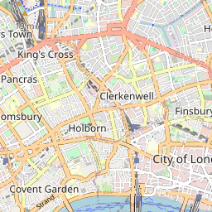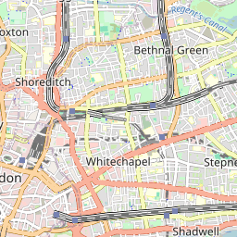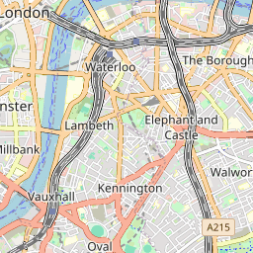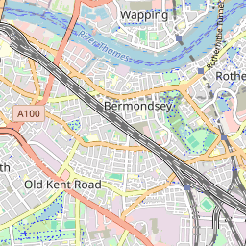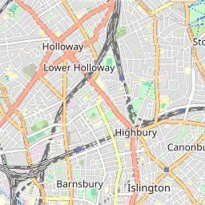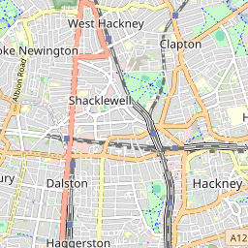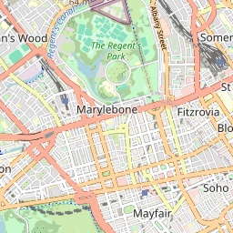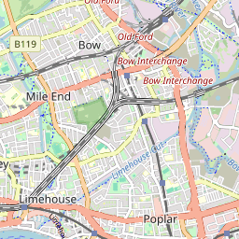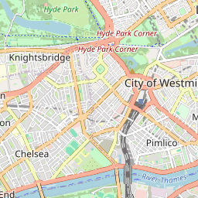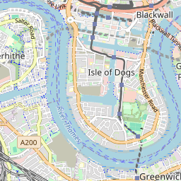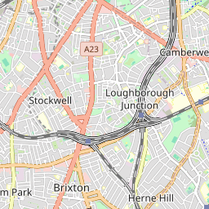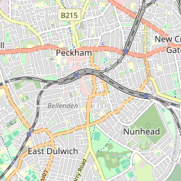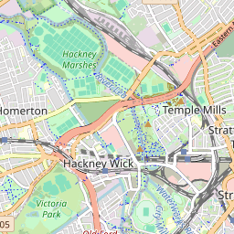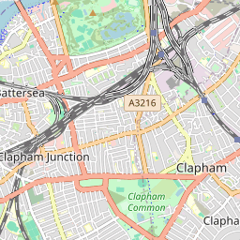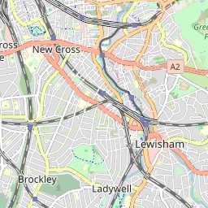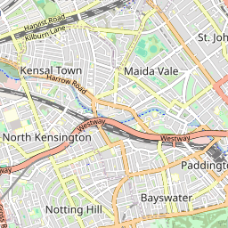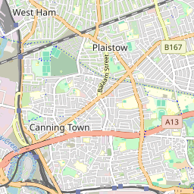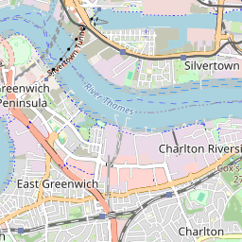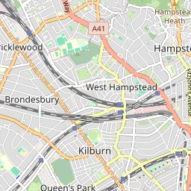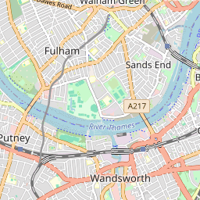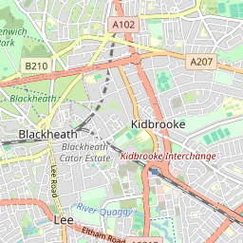

A pretty CSS3 popup.  
Easily customizable.

[×](https://www.techiesgroup.co.in/detailspage/LandingPage/Lab%20MS/index.html#close)

[+−](https://www.techiesgroup.co.in/detailspage/LandingPage/Lab%20MS/index.html)

[Leaflet](https://leafletjs.com/) | © OpenStreetMap contributors

## CONTACT US

### CONTACT INFORMATION

* **Monday - Friday:** 9:30 AM to 6:30 PM
* **Address: 123 High Street Cambridge**
* **Phone:** 07123 456789
* **Email:** Labs@doctor.com

### LEAVE US A MESSAGE

Top of Form

   

Bottom of Form

©LIMS All right reserved

#### System

#### Attendance management system:-

* [Home](https://www.techiesgroup.co.in/detailspage/LandingPage/AMS/)
* [About](https://www.techiesgroup.co.in/detailspage/LandingPage/AMS/#about)
* [Services](https://www.techiesgroup.co.in/detailspage/LandingPage/AMS/#service)
* [Contact](https://www.techiesgroup.co.in/detailspage/LandingPage/AMS/#contact)

Top of Form

Bottom of Form

Previous



#### Welcome To AccuAttend

## Attendance system, you've got charm.



#### Welcome To AccuAttend

## Clocking in, you're timelessly captivating.



#### Welcome To AccuAttend

## Attendance system, you've got charm.



#### Welcome To AccuAttend

## Clocking in, you're timelessly captivating.

Next

### **Attendance Tracking**

The core functionality of any attendance management system is to accurately track attendance for individuals or groups.

### **Automated Alerts**

Automated alerts enhance the system's efficiency by notifying administrators or supervisors of important events or deviations.

### **Reporting and Analytics**

Attendance management systems often include robust reporting and analytics capabilities to derive valuable insights.

## ABOUT US

The Attendance Management System (AMS) is a comprehensive solution designed to streamline and automate the process of tracking and managing employee or student attendance. It provides an efficient, accurate, and user-friendly platform for organizations of all sizes to monitor attendance patterns, ensure compliance, and enhance productivity.

* User Management
* Integration Capabilities
* Comprehensive Reporting
* Real-time Monitoring
* Compliance and Security

The Attendance Management System is an essential tool for modern organizations looking to enhance their operational efficiency, ensure compliance, and foster a productive work environment.



## OUR FEATURES

Here are key features of an Attendance Management System

#### Automated Attendance Tracking

Utilizes fingerprint, facial recognition, or retina scans to automatically log attendance.

#### Leave Management

Allows employees or students to apply for leave and managers to approve or reject requests through the system.

#### Shift and Schedule Management

Automatically calculates overtime based on attendance data and shift timings.

[READ MORE](https://www.techiesgroup.co.in/detailspage/LandingPage/AMS/)

#### Reporting and Analytics

Provides insights and trends to help manage workforce or student attendance more effectively.

#### Mobile Accessibility

Allows users to log attendance, apply for leave, and view attendance records through a mobile app.

#### Integration Capabilities

Seamlessly integrates with HR and payroll systems to ensure accurate data flow and payroll processing.

## SERVICES

An attendance management system is a valuable tool for any organization looking to efficiently manage attendance, optimize workforce productivity, and ensure compliance with relevant policies and regulations.

[](https://www.techiesgroup.co.in/detailspage/LandingPage/AMS/)

#### [Absence Management](https://www.techiesgroup.co.in/detailspage/LandingPage/AMS/)

Monitoring and reporting of absenteeism, Alerts and notifications for excessive absences or tardiness,Alerts and notifications for excessive absences or tardiness.

#### [Integration with Payroll Systems](https://www.techiesgroup.co.in/detailspage/LandingPage/AMS/)

Seamless integration with payroll systems for accurate and timely salary calculations based on attendance data,Seamless integration with payroll systems for accurate and timely salary.

[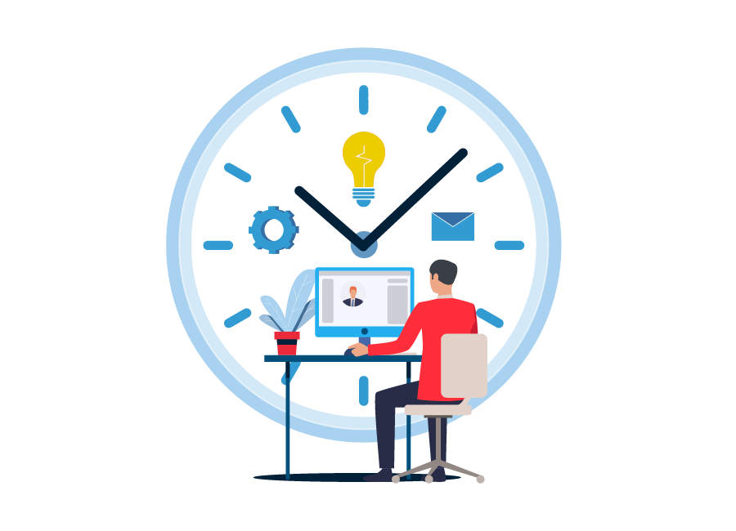](https://www.techiesgroup.co.in/detailspage/LandingPage/AMS/)

#### [Reporting and Analytics](https://www.techiesgroup.co.in/detailspage/LandingPage/AMS/)

Generation of comprehensive reports on attendance patterns, overtime, leave balances, and more. Advanced analytics to identify trends and insights for better workforce management.

[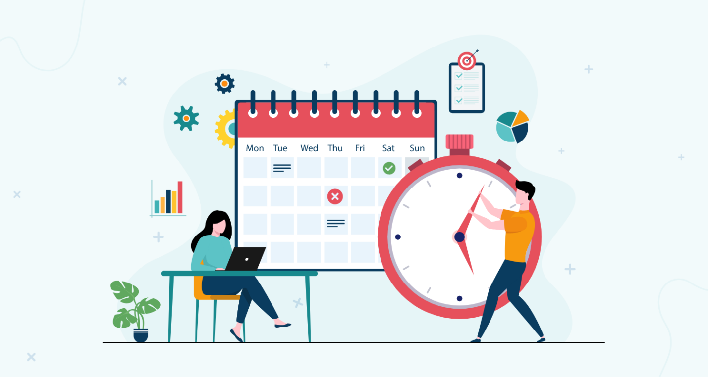](https://www.techiesgroup.co.in/detailspage/LandingPage/AMS/)

#### [Attendance Tracking](https://www.techiesgroup.co.in/detailspage/LandingPage/AMS/)

Real-time recording of attendance using various methods such as biometric devices, RFID cards, mobile apps, or web-based platforms,Automated clock-in and clock-out tracking.

[](https://www.techiesgroup.co.in/detailspage/LandingPage/AMS/)

#### [Leave Management](https://www.techiesgroup.co.in/detailspage/LandingPage/AMS/)

Request and approval workflows for different types of leave (sick leave, vacation, etc.), Integration with attendance records to ensure accurate leave balances and payroll processing.

[](https://www.techiesgroup.co.in/detailspage/LandingPage/AMS/)

#### [Scheduling and Shift Management](https://www.techiesgroup.co.in/detailspage/LandingPage/AMS/)

Creation and management of work schedules, Shift swapping, shift bidding, and automated scheduling features,Shift swapping, shift bidding, and automated scheduling features.

[](https://www.techiesgroup.co.in/detailspage/LandingPage/AMS/)

#### [Absence Management](https://www.techiesgroup.co.in/detailspage/LandingPage/AMS/)

Monitoring and reporting of absenteeism, Alerts and notifications for excessive absences or tardiness,Alerts and notifications for excessive absences or tardiness.

#### [Integration with Payroll Systems](https://www.techiesgroup.co.in/detailspage/LandingPage/AMS/)

Seamless integration with payroll systems for accurate and timely salary calculations based on attendance data,Seamless integration with payroll systems for accurate and timely salary.

[](https://www.techiesgroup.co.in/detailspage/LandingPage/AMS/)

#### [Reporting and Analytics](https://www.techiesgroup.co.in/detailspage/LandingPage/AMS/)

Generation of comprehensive reports on attendance patterns, overtime, leave balances, and more. Advanced analytics to identify trends and insights for better workforce management.

[](https://www.techiesgroup.co.in/detailspage/LandingPage/AMS/)

#### [Attendance Tracking](https://www.techiesgroup.co.in/detailspage/LandingPage/AMS/)

Real-time recording of attendance using various methods such as biometric devices, RFID cards, mobile apps, or web-based platforms,Automated clock-in and clock-out tracking.

[](https://www.techiesgroup.co.in/detailspage/LandingPage/AMS/)

#### [Leave Management](https://www.techiesgroup.co.in/detailspage/LandingPage/AMS/)

Request and approval workflows for different types of leave (sick leave, vacation, etc.), Integration with attendance records to ensure accurate leave balances and payroll processing.

[](https://www.techiesgroup.co.in/detailspage/LandingPage/AMS/)

#### [Scheduling and Shift Management](https://www.techiesgroup.co.in/detailspage/LandingPage/AMS/)

Creation and management of work schedules, Shift swapping, shift bidding, and automated scheduling features,Shift swapping, shift bidding, and automated scheduling features.

## FROM BLOG

A digital solution designed to automate and simplify attendance tracking. In this blog post.

[](https://www.techiesgroup.co.in/detailspage/LandingPage/AMS/)

### [**Attendance Management Systems are Revolutionizing HR**](https://www.techiesgroup.co.in/detailspage/LandingPage/AMS/)

As organizations evolve in the digital age, traditional HR practices are rapidly being replaced by more efficient and automated solutions. One such advancement is the (AMS).

[READ MORE](https://www.techiesgroup.co.in/detailspage/LandingPage/AMS/)

[](https://www.techiesgroup.co.in/detailspage/LandingPage/AMS/)

### [**Boosting Employee Morale and Efficiency**](https://www.techiesgroup.co.in/detailspage/LandingPage/AMS/)

Employee morale and efficiency are critical components of any successful organization. Surprisingly, something as simple as an Attendance Management System (AMS) can have a profound impact on both. In this blog.

[READ MORE](https://www.techiesgroup.co.in/detailspage/LandingPage/AMS/)

[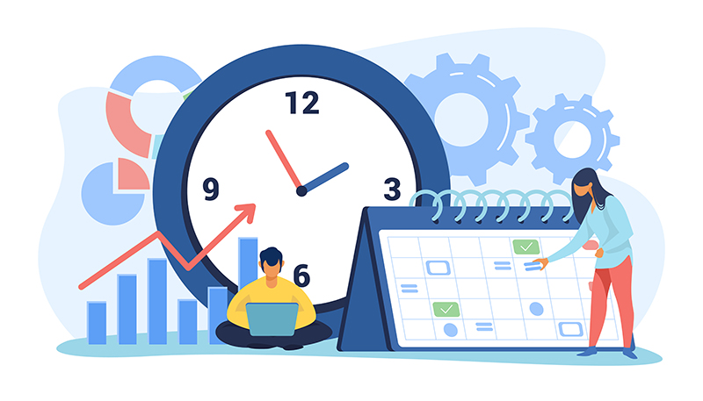](https://www.techiesgroup.co.in/detailspage/LandingPage/AMS/)

### [**Navigating Remote Work Challenges**](https://www.techiesgroup.co.in/detailspage/LandingPage/AMS/)

The shift towards remote work has presented both opportunities and challenges for organizations worldwide. One significant challenge is tracking employee attendance and ensuring accountability in a remote environment.

[READ MORE](https://www.techiesgroup.co.in/detailspage/LandingPage/AMS/)

#### INFORMATION

* [About Us](https://www.techiesgroup.co.in/detailspage/LandingPage/AMS/)
* [Features](https://www.techiesgroup.co.in/detailspage/LandingPage/AMS/)
* [Service](https://www.techiesgroup.co.in/detailspage/LandingPage/AMS/)
* [Event](https://www.techiesgroup.co.in/detailspage/LandingPage/AMS/)
* [Sitemap](https://www.techiesgroup.co.in/detailspage/LandingPage/AMS/)
* [Term Of Use](https://www.techiesgroup.co.in/detailspage/LandingPage/AMS/)

#### STUDENT HELP

* [Get Started](https://www.techiesgroup.co.in/detailspage/LandingPage/AMS/)
* [My Questions](https://www.techiesgroup.co.in/detailspage/LandingPage/AMS/)
* [Download Files](https://www.techiesgroup.co.in/detailspage/LandingPage/AMS/)
* [Latest Course](https://www.techiesgroup.co.in/detailspage/LandingPage/AMS/)
* [Academic News](https://www.techiesgroup.co.in/detailspage/LandingPage/AMS/)

#### NEWS LETTER

Get latest update, news & academic offers

Top of Form

 Subscribe!

Bottom of Form

#### CONTACT

123 Main Street Anytown, CA 90210 United States

Phone: +1 (555) 123-4567

www.attendance@gmail.com

Task Management System:-

[**TaskGram.**](https://www.techiesgroup.co.in/detailspage/LandingPage/Task%20MS/index.html)

* [Home](https://www.techiesgroup.co.in/detailspage/LandingPage/Task%20MS/)
* [About](https://www.techiesgroup.co.in/detailspage/LandingPage/Task%20MS/#about)
* [Why](https://www.techiesgroup.co.in/detailspage/LandingPage/Task%20MS/#why)
* [Contact](https://www.techiesgroup.co.in/detailspage/LandingPage/Task%20MS/#contact)

# **Online Task Manage System**

Task management software for personal productivity

[More Info](https://www.techiesgroup.co.in/detailspage/LandingPage/Task%20MS/)

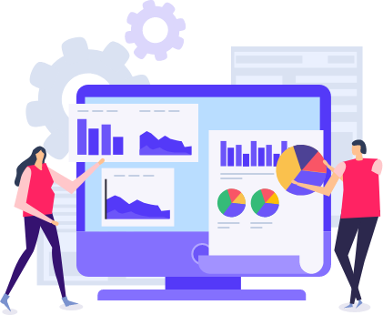

##### **Task Creation and Assignment**

Create tasks and assign them to individuals or teams.

##### **Task Tracking and Status Updates**

Track the progress of tasks from start to completion.

##### **Notifications and Reminders**

Sends notifications and reminders to users about upcoming deadlines and task updates.



## Top-rated Task Management tools for team productivity

Tasks can be organized hierarchically or categorically, allowing users to group related tasks together for easier management and tracking.

## Task management system with time tracking features.

These systems typically provide a centralized platform where users can create, assign, monitor, and update tasks



WHY CHOOSE US

## Task management software for enterprises

##### **Organization**

This organization saves time and reduces the risk of forgetting important tasks.

##### **Efficiency**

This increases productivity by providing a clear overview of tasks, deadlines, and progress.

##### **Collaboration**

This fosters collaboration, ensures everyone is on the same page, and promotes accountability.

OUR BLOG

## Read our latest News

Sam Newman

[23 Apr 2020](https://www.techiesgroup.co.in/detailspage/LandingPage/Task%20MS/)

Understanding the Basics of Task Management

Rachel

[29 Apr 2024](https://www.techiesgroup.co.in/detailspage/LandingPage/Task%20MS/)

Effective Time Management

Carla

[23 May 2024](https://www.techiesgroup.co.in/detailspage/LandingPage/Task%20MS/)

Choosing the Right Task Management Tools

Mike

[30 May 2024](https://www.techiesgroup.co.in/detailspage/LandingPage/Task%20MS/)

Maintaining Work-Life Balance

### TaskGram.

A task management system helps streamline your tasks.

[task@gmail.com](https://www.techiesgroup.co.in/detailspage/LandingPage/Task%20MS/)

[(123) 456-7890](https://www.techiesgroup.co.in/detailspage/LandingPage/Task%20MS/)

##### Quick Links

* [How it works](https://www.techiesgroup.co.in/detailspage/LandingPage/Task%20MS/)
* [Security](https://www.techiesgroup.co.in/detailspage/LandingPage/Task%20MS/)
* [Pricing](https://www.techiesgroup.co.in/detailspage/LandingPage/Task%20MS/)
* [Resources](https://www.techiesgroup.co.in/detailspage/LandingPage/Task%20MS/)
* [Report a Bug](https://www.techiesgroup.co.in/detailspage/LandingPage/Task%20MS/)

##### About Us

* [About Us](https://www.techiesgroup.co.in/detailspage/LandingPage/Task%20MS/)
* [Jobs](https://www.techiesgroup.co.in/detailspage/LandingPage/Task%20MS/)
* [Our Teams](https://www.techiesgroup.co.in/detailspage/LandingPage/Task%20MS/)
* [Testimonials](https://www.techiesgroup.co.in/detailspage/LandingPage/Task%20MS/)
* [News & Press](https://www.techiesgroup.co.in/detailspage/LandingPage/Task%20MS/)

##### Subscribe

Top of Form



Bottom of Form

[Privacy](https://www.techiesgroup.co.in/detailspage/LandingPage/Task%20MS/)

[Contact Us](https://www.techiesgroup.co.in/detailspage/LandingPage/Task%20MS/)

Water management system :-

[UK , United state americaCall : +01 1234567890ukn@gmail.com](https://www.techiesgroup.co.in/detailspage/LandingPage/WMS/)

[**Water**](https://www.techiesgroup.co.in/detailspage/LandingPage/WMS/index.html)

* [HOME(CURRENT)](https://www.techiesgroup.co.in/detailspage/LandingPage/WMS/index.html)

# WATER MANAGEMENT

The Water Management program works with communities to harvest and store rainwater for direct use, and/or replenish groundwater by building

[Read moreGet A Quote](https://www.techiesgroup.co.in/detailspage/LandingPage/WMS/)

# WATER MANAGEMENT

The Water Management program works with communities to harvest and store rainwater for direct use, and/or replenish groundwater by building

[Read moreGet A Quote](https://www.techiesgroup.co.in/detailspage/LandingPage/WMS/)

# WATER MANAGEMENT

The Water Management program works with communities to harvest and store rainwater for direct use, and/or replenish groundwater by building

[Read moreGet A Quote](https://www.techiesgroup.co.in/detailspage/LandingPage/WMS/)



## WHY DO WE NEED WATER MANAGEMENT?

India has about 18 percent of the world’s population and only 4 percent of the world’s water resources. It is severely water-stressed, thereby making water management a national priority. India uses about 230 cubic kilometers of groundwater annually, which is more than a quarter of the global total, making it the world’s largest user of groundwater. About 90 percent of the groundwater extracted is used for irrigation and over 60 percent of the irrigated land in India is supported primarily by groundwater supplies. For an agrarian country like India, water is a key driving force of agriculture and has a direct bearing on its productivity and sustainability.

[READ MORE](https://www.techiesgroup.co.in/detailspage/LandingPage/WMS/)

## WATCH OUR WORK ON “WATER MANAGEMENT"

###### WHY DO WE NEED WATER MANAGEMENT?

India has about 18 percent of the world’s population and only 4 percent of the world’s water resources. It is severely water-stressed, thereby making water management a national priority. India uses about 230 cubic kilometers of groundwater annually,

[Read More](https://www.techiesgroup.co.in/detailspage/LandingPage/WMS/)

###### WATER RESOURCE AUGMENTATION

The Water Management program focuses on replenishing depleted underground aquifers and augmenting groundwater primarily with rainwater harvesting. This improves the availability and quality of groundwater in the long run, and provides water security to rural households.

[Read More](https://www.techiesgroup.co.in/detailspage/LandingPage/WMS/)

###### ROOFTOP RAINWATER HARVESTING

The Water Management program promotes installation of rooftop rainwater harvesting systems in public buildings such as schools and institutional buildings that collect rainwater and store it over-ground for later consumption. The water is passed through an appropriate filtering process.

[Read More](https://www.techiesgroup.co.in/detailspage/LandingPage/WMS/)

## WATER-CONSCIOUS COMMUNITIES



#### household water treatment

In India, just 8% of the groundwater extracted is meant for drinking purposes, while the majority, around 12%, is utilized for industrial needs. The Composite Water Management Index, a report by NITI Aayog, has raised concerns about India’s water crisis, highlighting that over 600 million individuals are currently grappling with severe water shortages.

[PreviousNext](https://www.techiesgroup.co.in/detailspage/LandingPage/WMS/#carouselExampleControls)



## GET IN TOUCH

Top of Form







SEND

Bottom of Form

## OUR TEAM

A water management system encompasses various practices, technologies, and policies aimed at efficiently and sustainably managing water resources. Here's a description of different components typically involved.



##### **Martin Anderson**

###### **supervisor**



##### **Denny Butler**

###### **supervisor**



##### **Nathan Mcpherson**

###### **supervisor**

[View All](https://www.techiesgroup.co.in/detailspage/LandingPage/WMS/)

[**WMS**](https://www.techiesgroup.co.in/detailspage/LandingPage/WMS/index.html)

In India, just 8% of the groundwater extracted is meant for drinking purposes, while the majority

##### **Contact Us**

[Water management System Call : +01 1234567890 ukn@gmail.com](https://www.techiesgroup.co.in/detailspage/LandingPage/WMS/)

##### **Save Water**

Top of Form

 SUBSCRIBE

Bottom of Form

Expense Management System:-

## [**ExpenseMaster**](https://www.techiesgroup.co.in/detailspage/LandingPage/Expense%20MS/index.html)

* [Home](https://www.techiesgroup.co.in/detailspage/LandingPage/Expense%20MS/#home-section)

* [About Us](https://www.techiesgroup.co.in/detailspage/LandingPage/Expense%20MS/#about-section)

* [Services](https://www.techiesgroup.co.in/detailspage/LandingPage/Expense%20MS/#services-section)

* [Contact](https://www.techiesgroup.co.in/detailspage/LandingPage/Expense%20MS/#contact-section)

# EXPENSE TRACKING SOFTWARE

Expense management software with real-time reporting features. Top expense management tools for freelancers and consultants.

[Get In Touch](https://www.techiesgroup.co.in/detailspage/LandingPage/Expense%20MS/)

# BUSINESS EXPENSE MANAGEMENT

Expense tracking app for Android and iOS with receipt scanning. Expense management system integration with accounting software.

[Get In Touch](https://www.techiesgroup.co.in/detailspage/LandingPage/Expense%20MS/)

# EXPENSE MANAGEMENT SOFTWARE

Best cloud-based expense management system for small businesses. How to automate expense tracking for remote teams.

[Get In Touch](https://www.techiesgroup.co.in/detailspage/LandingPage/Expense%20MS/)

# EXPENSE TRACKING SOFTWARE

Expense management software with real-time reporting features. Top expense management tools for freelancers and consultants.

[Get In Touch](https://www.techiesgroup.co.in/detailspage/LandingPage/Expense%20MS/)

# BUSINESS EXPENSE MANAGEMENT

Expense tracking app for Android and iOS with receipt scanning. Expense management system integration with accounting software.

[Get In Touch](https://www.techiesgroup.co.in/detailspage/LandingPage/Expense%20MS/)

# EXPENSE MANAGEMENT SOFTWARE

Best cloud-based expense management system for small businesses. How to automate expense tracking for remote teams.

[Get In Touch](https://www.techiesgroup.co.in/detailspage/LandingPage/Expense%20MS/)

# EXPENSE TRACKING SOFTWARE

Expense management software with real-time reporting features. Top expense management tools for freelancers and consultants.

[Get In Touch](https://www.techiesgroup.co.in/detailspage/LandingPage/Expense%20MS/)

## About Us

Get best expense management software. Track expenses, automate, integrate with accounting, real-time reporting



### **Expense Management System**

Expense management software is crucial for businesses of all sizes. Finding the best cloud-based expense management system for small businesses can streamline financial processes and save valuable time. With features like real-time reporting, businesses can track expenses efficiently.

Automating expense tracking for remote teams is essential for modern businesses. By leveraging expense tracking software, businesses can ensure accuracy and transparency in financial transactions. Online expense management tools cater to freelancers and consultants, offering flexibility and convenience.



### **Streamlining Business Finances**

Managing business expenses seamlessly requires integration with accounting software. Expense reimbursement software simplifies the process for startups, providing benefits such as easy tracking and reimbursement. Cloud-based expense management solutions are ideal for managing travel expenses effectively.

Choosing the right expense management solution for your business is crucial. Consider factors like pricing, features, and scalability when comparing expense tracking apps. For enterprise use, comprehensive expense management system pricing comparisons can guide decision-making.

## Expense Management Team

Best cloud-based expense management system for small businesses. How to automate expense tracking for remote teams. Expense management software with real-time reporting features. Top expense management tools for freelancers and consultants. Expense tracking app for Android and iOS with receipt scanning.



### **Kaiara Spencer**

ACCOUNTANT



### **Dave Simpson**

BANK TELLER



### **Ben Thompson**

BANK TELLER

## Expense Management System Features

Expense management software with real-time reporting features. Best cloud-based expense management system for small businesses. How to automate expense tracking for remote teams.















## Cloud-Based Accessibility

Experience the convenience of our cloud-based expense management system, ideal for small businesses. Access your expense data securely from any device with an internet connection, ensuring seamless expense tracking for your remote teams.

## Automated Expense Tracking

Streamline your expense tracking process with our automated solution. Say goodbye to manual data entry and tedious receipt management. Our software automates expense tracking for remote teams, saving time and reducing errors in your financial records.

## Real-Time Reporting

Our expense management software offers real-time reporting features, enabling you to track expenses as they occur. Gain insights into spending patterns instantly, empowering better financial decision-making for your small business.

## Cloud-Based Accessibility

Experience the convenience of our cloud-based expense management system, ideal for small businesses. Access your expense data securely from any device with an internet connection, ensuring seamless expense tracking for your remote teams.

## Automated Expense Tracking

Streamline your expense tracking process with our automated solution. Say goodbye to manual data entry and tedious receipt management. Our software automates expense tracking for remote teams, saving time and reducing errors in your financial records.

## Real-Time Reporting

Our expense management software offers real-time reporting features, enabling you to track expenses as they occur. Gain insights into spending patterns instantly, empowering better financial decision-making for your small business.

## Cloud-Based Accessibility

Experience the convenience of our cloud-based expense management system, ideal for small businesses. Access your expense data securely from any device with an internet connection, ensuring seamless expense tracking for your remote teams.

## Our Services

### **Cloud-Based Expense Management System Setup**

Simplify expense tracking for your small business with our best-in-class cloud-based expense management system. Enjoy real-time reporting features and seamless integration with accounting software for efficient financial management.

### **Automated Expense Tracking for Remote Team**

Take the hassle out of expense tracking for your remote teams with our automated system. From receipt scanning to real-time expense reports, our platform ensures accuracy and efficiency, allowing your team to focus on what matters most.

### **Expense Management Software Integration Services**

Optimize your business operations by integrating your expense management system with accounting software. Our expert services ensure a smooth transition, allowing for streamlined expense tracking and financial reporting.

### **Online Expense Management Solutions for Freelancers and Consultants**

Manage your finances more effectively with our top online expense management tools. Designed specifically for freelancers and consultants, our platform offers easy expense tracking and comprehensive reporting features to help you stay organized and in control.

### **Expense Tracking App Development for Android and iOS**

Stay on top of your expenses wherever you are with our custom expense tracking app for Android and iOS. Featuring receipt scanning capabilities and intuitive user interface, our app makes it easy to manage your finances on the move.

### **Expense Management System Consulting for Startups**

Make informed decisions about your expense management system with our consulting services tailored for startups. Discover the benefits of using online expense management tools and find the perfect solution to suit your business needs and budget.

## Our Testimonial

*“Freelancers and consultants often struggle with managing expenses. With the top expense management tools available, it's become much easier for me.”*



Robert Spears

*“Having an expense tracking app with receipt scanning capabilities has been a game-changer for me. It's made managing my expenses much more efficient.”*



Bruce Rogers

*“As a small business owner, finding the best cloud-based expense management system was crucial for me. I'm glad I found a solution that meets all my needs.”*



John Smith

*“Managing expenses for remote teams used to be a hassle until we automated our expense tracking. Now, we can focus more on our work.”*



Christine Aguilar

*“Freelancers and consultants often struggle with managing expenses. With the top expense management tools available, it's become much easier for me.”*



Robert Spears

*“Having an expense tracking app with receipt scanning capabilities has been a game-changer for me. It's made managing my expenses much more efficient.”*



Bruce Rogers

*“As a small business owner, finding the best cloud-based expense management system was crucial for me. I'm glad I found a solution that meets all my needs.”*



John Smith

*“Managing expenses for remote teams used to be a hassle until we automated our expense tracking. Now, we can focus more on our work.”*



Christine Aguilar

## Frequently Ask Questions

### **What is the best cloud-based expense management system for small businesses?**

The best cloud-based expense management system for small businesses is one that offers scalability, real-time reporting, and easy integration with accounting software. Our system provides all these features to streamline your expense tracking.

### **How can I automate expense tracking for remote teams?**

You can automate expense tracking for remote teams by using our expense management software, which offers features like receipt scanning, automatic categorization, and integration with various payment platforms.

### **What are the benefits of using an online expense management system for startups?**

An online expense management system for startups helps in reducing manual errors, saving time on data entry, providing real-time financial insights, and ensuring compliance with company policies.

### **How does expense management software help in managing travel expenses?**

Expense management software helps manage travel expenses by allowing users to submit travel receipts on the go, automatically categorizing expenses, and integrating with travel booking tools to streamline the entire process.

### **Can I integrate the expense management system with my accounting software?**

Yes, our expense management system seamlessly integrates with popular accounting software to ensure your financial data is accurate and up-to-date, reducing manual entry and errors.

### **What features should I look for in an expense tracking app for Android and iOS?**

Look for features such as receipt scanning, real-time expense reporting, automatic categorization, and the ability to sync with other financial tools. Our app offers all these features and more for both Android and iOS.

### **How do I choose the right expense management solution for my business?**

Choose an expense management solution that fits your business size, integrates with your existing systems, offers real-time reporting, and provides features that cater to your specific needs. Our solution offers customizable options for businesses of all sizes.

### **How does the expense management system pricing compare for enterprise use??**

Our expense management system offers competitive pricing for enterprise use, with scalable plans that provide advanced features like bulk expense processing, detailed analytics, and dedicated support to meet the needs of large organizations.



### **Top expense management tools for freelancers and consultants**

Discover the best cloud-based expense management system for small businesses. Explore how to automate expense tracking for remote teams with ease.

### **Expense management software for managing travel expenses**

Utilize expense tracking software with real-time reporting features. Learn about the benefits of using an online expense management system for startups and how it integrates with accounting software.

## Contact Us

123 Baker Street, London, Greater London, NW1 6XE, United Kingdom

[+44 1234567889](https://www.techiesgroup.co.in/detailspage/LandingPage/Expense%20MS/)

[Expensemaster@gmail.com](https://www.techiesgroup.co.in/detailspage/LandingPage/Expense%20MS/)

Top of Form

## **Contact Form**

First Name

Last Name

Email

Subject

Message



Bottom of Form

## **About Us**

We provide the best cloud-based expense management system with real-time reporting and accounting integration.

## **Quick Links**

* [About Us](https://www.techiesgroup.co.in/detailspage/LandingPage/Expense%20MS/#about-section)
* [Services](https://www.techiesgroup.co.in/detailspage/LandingPage/Expense%20MS/#services-section)
* [Testimonials](https://www.techiesgroup.co.in/detailspage/LandingPage/Expense%20MS/#testimonials-section)
* [Contact Us](https://www.techiesgroup.co.in/detailspage/LandingPage/Expense%20MS/#contact-section)

## **Follow Us**

## **Subscribe Newsletter**

Top of Form



Send

Bottom of Form

Copyright © 2024 All rights reserved | by [ExpenseMaster](https://www.techiesgroup.co.in/detailspage/LandingPage/Expense%20MS/index.html" \t "_blank)

Resource Management System:-

[Call : +44 20 7123 4567Email : resources@gmail.com49 Featherstone Street, United State](https://www.techiesgroup.co.in/detailspage/LandingPage/Resource%20MS/)

[**Resource Management System**](https://www.techiesgroup.co.in/detailspage/LandingPage/Resource%20MS/index.html)

* [HOME](https://www.techiesgroup.co.in/detailspage/LandingPage/Resource%20MS/index.html)
* [SERVICES](https://www.techiesgroup.co.in/detailspage/LandingPage/Resource%20MS/#service)
* [ABOUT](https://www.techiesgroup.co.in/detailspage/LandingPage/Resource%20MS/#about)
* [CONTACT US](https://www.techiesgroup.co.in/detailspage/LandingPage/Resource%20MS/#contact)

Top of Form

Bottom of Form



# RESOURCE MANAGEMENT SOFTWARE FOR SMALL BUSINESSES

Cloud-based resource management system advantages for enterprises

# RESOURCE MANAGEMENT SYSTEM WITH SCHEDULING FEATURES

Customizable resource management software for different industries

## Our Services

Resource Management System (RMS) is a tool, which is designed for the efficient management of key airport resources



##### RESOURCE MANAGEMENT SYSTEM IMPLEMENTATION GUIDE

The art of resource management has now become a critical cornerstone for organizational success.



##### RESOURCE TRACKING SOFTWARE

Resource tracking involves monitoring the work that individual resources complete over the course of a project



##### RESOURCE MANAGEMENT TOOLS

Resource management tools help project managers use their time well to ensure teams work effectively together to complete projects on time and within budget.

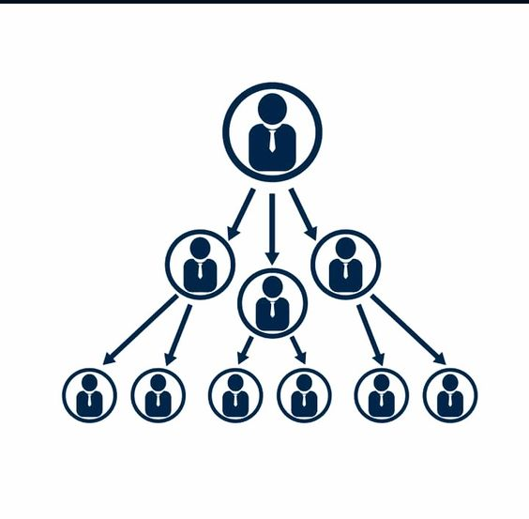

##### EMPLOYEE RESOURCE MANAGEMENT SYSTEM

the ERM is designed not only to facilitate the work of human resources, but also to facilitate interaction with employees

## About Us

Most modern business projects require a range of different resources to reach completion. And perhaps the most vital of those resources are the human resources. Full-time, part-time, and contracted employees are the lifeblood of most business organizations, connecting with customers, accomplishing specialized tasks, and contributing to strategic decisions. Unfortunately, employees, along with their time and ability, are finite resources. And at any given moment, any individual employee can only be in one place, working on one task, and applying his or her skills in a way that furthers one project. Other finite resources, such as equipment, workspace, and capital, are likewise limited by availability.





A ‘resource’ is any cost that can pertain to the effort of completing a project. A form of project management, resource management considers all different kinds of resources, including tangible resources (such as materials, equipment, and budgets), intangible resources (such as time and skill), and human resources. Resource management involves taking inventory of available resources, scheduling or rescheduling start and end dates for resource use, managing resource-related conflicts or dependencies, monitoring resource usage and need over time, and using data-backed insight to make adjustments where needed.

## CONTACT US

Top of Form







SEND

Bottom of Form

Keyboard shortcuts

Map data ©2024 Google

[Terms](https://www.google.com/intl/en-US_US/help/terms_maps.html)

[Report a map error](https://www.google.com/maps/@40.712775,-74.005973,18z/data=!10m1!1e1!12b1?source=apiv3&rapsrc=apiv3)

This page can't load Google Maps correctly.

|  |  |
| --- | --- |
| [Do you own this website?](http://g.co/dev/maps-no-account) | OK |

#### 49 Featherstone Street

[United State Call +44 20 7123 4567 resource@gmail.com](https://www.techiesgroup.co.in/detailspage/LandingPage/Resource%20MS/)

#### Info

The HRMS prioritizes convenience. When a user enters information, the HR platform reflects these changes in real time. Furthermore, an HRMS enables self-service so people can input information without having to rely on HR to do it for them.

#### Links

[Home](https://www.techiesgroup.co.in/detailspage/LandingPage/Resource%20MS/index.html)[About](https://www.techiesgroup.co.in/detailspage/LandingPage/Resource%20MS/#about)[Services](https://www.techiesgroup.co.in/detailspage/LandingPage/Resource%20MS/#service)[Contact Us](https://www.techiesgroup.co.in/detailspage/LandingPage/Resource%20MS/#contact)

#### Subscribe

Top of Form

 Subscribe

Bottom of Form

© 2024 All Rights Reserved By [Resource management System](https://html.design/)

Library Management System:-

[10 Downing Street Westminster LondonCall : +01 011 44 20 7123 4567libarian@gmail.com](https://www.techiesgroup.co.in/detailspage/LandingPage/LMS/)

[**Library management system**](https://www.techiesgroup.co.in/detailspage/LandingPage/LMS/index.html)

* [HOME(CURRENT)](https://www.techiesgroup.co.in/detailspage/LandingPage/LMS/index.html)
* [ABOUT](https://www.techiesgroup.co.in/detailspage/LandingPage/LMS/#about)
* [SERVICES](https://www.techiesgroup.co.in/detailspage/LandingPage/LMS/#service)
* [FEATURES](https://www.techiesgroup.co.in/detailspage/LandingPage/LMS/#features)
* [CONTACT US](https://www.techiesgroup.co.in/detailspage/LandingPage/LMS/#contact)

# "Cloud-based library automation for easy cataloging and circulation"

"Top features to look for in an academic library management system"

[PreviousNext](https://www.techiesgroup.co.in/detailspage/LandingPage/LMS/#customCarousel1)

## Our Services

"Library management system customization options for unique requirements"



##### Integrated library system

"How to automate book tracking with library management software"



##### Library automation software

"Choosing the right library management system for your institution"



##### Academic library management system

A library management system is software that is designed to manage all the functions of a library. It helps librarian to maintain the database of new books



##### Best library software

An integrated library management system (LMS) is ERP software that helps in simplifying the daily operations of the library.



##### Library catalog software

The library catalogue is a form of bibliographic database that describes information resources available in a specific library, or in a library network



##### Library automation software

"Choosing the best library management system for special libraries"



##### Integrated library system

"How to automate book tracking with library management software"



##### Library automation software

"Choosing the right library management system for your institution"



##### Academic library management system

A library management system is software that is designed to manage all the functions of a library. It helps librarian to maintain the database of new books



##### Best library software

An integrated library management system (LMS) is ERP software that helps in simplifying the daily operations of the library.



##### Library catalog software

The library catalogue is a form of bibliographic database that describes information resources available in a specific library, or in a library network



##### Library automation software

"Choosing the best library management system for special libraries"

## About Us

The purpose of a library management system is to operate a library with efficiency and at reduced costs. The system being entirely automated streamlines all the tasks involved in operations of the library. The activities of book purchasing, cataloging, indexing, circulation recording and stock checking are done by the software. Such software eliminates the need for repetitive manual work and minimizes the chances of errors. The library management system software helps in reducing operational costs. Managing a library manually is labor intensive and an immense amount of paperwork is involved. An automated system reduces the need for manpower and stationery. This leads to lower operational costs. The system saves time for both the user and the librarian. With just a click the user can search for the books available in the library. The librarian can answer queries with ease regarding the availability of books. Adding, removing or editing the database is a simple process. Adding new members or cancelling existing memberships can be done with ease.



## Our Digital library management system

A library management system is software that is designed to manage all the functions of a library. It helps librarian to maintain the database of new books and the books that are borrowed by members along with their due dates. This system completely automates all your library's activities.



##### **"LibraryEase"**



##### **School library management system**



##### **Library catalog software**



## Get In Touch

Top of Form







Select Service

* **Select Service**
* Service 1
* Service 2
* Service 3



SEND

Bottom of Form

[**Libary system**](https://www.techiesgroup.co.in/detailspage/LandingPage/LMS/index.html)

[Location+01 1234567890](https://www.techiesgroup.co.in/detailspage/LandingPage/LMS/)

Library Software is software used to manage the whole database of a library. This system helps in keeping record of all the items like books, DVDs, CDs, and Magazines etc. in a library.

##### NEWSLETTER

Top of Form

 Subscribe

Bottom of Form

##### SERVICES

A Library has collection of thousands of books and management of so many books is a huge responsibility. The digital library management system is a user - friendly software designed for the smooth functioning of library management system.

##### USEFUL LINKS

* [Home](https://www.techiesgroup.co.in/detailspage/LandingPage/LMS/index.html)
* [About](https://www.techiesgroup.co.in/detailspage/LandingPage/LMS/#about)
* [Services](https://www.techiesgroup.co.in/detailspage/LandingPage/LMS/service.html)
* [Contact Us](https://www.techiesgroup.co.in/detailspage/LandingPage/LMS/#contact)

© 2024 All Rights Reserved By [Libary Management system](https://html.design/)

Enviornmental Management System:-

[](https://www.techiesgroup.co.in/detailspage/LandingPage/Env%20MS/index.html)

* [Home](https://www.techiesgroup.co.in/detailspage/LandingPage/Env%20MS/index.html)

* [About](https://www.techiesgroup.co.in/detailspage/LandingPage/Env%20MS/#about)

* [Services](https://www.techiesgroup.co.in/detailspage/LandingPage/Env%20MS/#service)

* [Compliance Solutions](https://www.techiesgroup.co.in/detailspage/LandingPage/Env%20MS/#projects)

* [Contact](https://www.techiesgroup.co.in/detailspage/LandingPage/Env%20MS/#contact)

[Make A Compliance](https://www.techiesgroup.co.in/detailspage/LandingPage/Env%20MS/#complance)

# **Environmental Management Systems**

Implementing sustainable management systems in manufacturing for a greener future

# **Environmental Compliance**

Top features of environmental compliance management systems to protect our planet

# **Environmental Monitoring**

Automated environmental audit software for regulatory compliance

* 1
* 2
* 3

ABOUT

## **Leading in Environmental Management Systems**

Our environmental compliance software ensures top features for effective management. We focus on sustainability management systems to assess environmental impacts and drive corporate sustainability.

From automated environmental monitoring software to comprehensive environmental risk management tools, we help businesses implement sustainable management systems efficiently. Choose the right EMS software for your organization and track environmental performance for greener business practices.

BENEFITS OF ENVIRONMENTAL MANAGEMENT SYSTEMS

## **Optimizing Environmental Performance**

Environmental management systems (EMS) are crucial for businesses to ensure compliance with regulations and minimize their ecological footprint. Here are some key advantages

* - Enhanced environmental compliance
* - Improved resource efficiency
* - Cost savings
* - Enhanced corporate reputation
* - Risk mitigation



## **Services**

Environmental compliance software solutions to ensure compliance with environmental laws, track requirements, and manage audits.



### [Environmental Compliance Software Solutions](https://www.techiesgroup.co.in/detailspage/LandingPage/Env%20MS/)

Software to ensure compliance with environmental laws, track requirements, and manage audits.



### [Cloud-Based Environmental Management Systems](https://www.techiesgroup.co.in/detailspage/LandingPage/Env%20MS/)

Manage environmental impact from anywhere with real-time data, analysis, and reporting in the cloud.



### [Sustainability Management and Impact Assessment Tools](https://www.techiesgroup.co.in/detailspage/LandingPage/Env%20MS/)

Tools for assessing environmental impact, tracking sustainability metrics, and managing initiatives.



### [Automated Environmental Monitoring and Audit Software](https://www.techiesgroup.co.in/detailspage/LandingPage/Env%20MS/)

Automated solutions for tracking environmental data and conducting audits to ensure compliance.



### [Environmental Risk and Performance Management](https://www.techiesgroup.co.in/detailspage/LandingPage/Env%20MS/)

Tools for assessing and mitigating environmental risks, incident management, and performance tracking.



### [EMS Implementation and ROI Analysis](https://www.techiesgroup.co.in/detailspage/LandingPage/Env%20MS/)

Assistance with selecting and implementing EMS software, along with cost and ROI analysis.

## **Compliance Solutions**

Environmental compliance software ensures that your organization adheres to regulations efficiently. Top features of environmental compliance management systems include real-time monitoring and reporting, ensuring you stay ahead of compliance requirements.



### [**Top Features of Environmental Compliance Management Systems**](https://www.techiesgroup.co.in/detailspage/LandingPage/Env%20MS/blog_details.html)

Discover the essential features that make environmental compliance software a vital tool for businesses aiming to meet regulatory standards and improve sustainability practices.



### [**Environmental Performance Tracking for Green Business Practices**](https://www.techiesgroup.co.in/detailspage/LandingPage/Env%20MS/blog_details.html)

Understand how tracking environmental performance can help your business adopt greener practices, reduce waste, and improve overall sustainability.

## **Environmental Compliance Management System**

Fill out the form below to learn more about our Environmental Compliance Management System, request a demo, or get in touch with our experts.

Top of Form

Full Name

Email Address

Phone Number

Company Name

Message

Submit

Bottom of Form

[[](https://maps.google.com/maps?ll=-31.197,150.744&z=9&t=m&hl=en-US&gl=US&mapclient=apiv3)](https://maps.google.com/maps?ll=-31.197,150.744&z=9&t=m&hl=en-US&gl=US&mapclient=apiv3" \o "Open this area in Google Maps (opens a new window)" \t "_blank)

Map data ©2019 Google

Map data ©2019 Google

[Terms of Use](https://www.google.com/intl/en-US_US/help/terms_maps.html)

[Report a map error](https://www.google.com/maps/@-31.197,150.744,9z/data=!10m1!1e1!12b1?source=apiv3&rapsrc=apiv3)

This page can't load Google Maps correctly.

|  |  |
| --- | --- |
| [Do you own this website?](https://developers.google.com/maps/documentation/javascript/error-messages?utm_source=maps_js&utm_medium=degraded&utm_campaign=billing#api-key-and-billing-errors) | OK |

## Get in Touch

Top of Form







SEND

Bottom of Form

### **123 Baker Street,**

London, UK

### **+44 1234567889**

Mon to Fri 9am to 6pm

### **environmental@gmail.com**

Send us your query anytime!

[](https://www.techiesgroup.co.in/detailspage/LandingPage/Env%20MS/index.html)

The automated process starts as soon as the system begins monitoring environmental data.

  Risk Management System

# [**RISK MANAGEMENT SYSTEM**](https://www.techiesgroup.co.in/detailspage/LandingPage/Risk%20MS/index.html)

* [Home](https://www.techiesgroup.co.in/detailspage/LandingPage/Risk%20MS/#hero)
* [About](https://www.techiesgroup.co.in/detailspage/LandingPage/Risk%20MS/#aboutus)
* [Team](https://www.techiesgroup.co.in/detailspage/LandingPage/Risk%20MS/#team)
* [Contact](https://www.techiesgroup.co.in/detailspage/LandingPage/Risk%20MS/#contact)

# Risk Management System

## **An integrated practice that helps business identify, evaluate, measure, and mitigate risks**

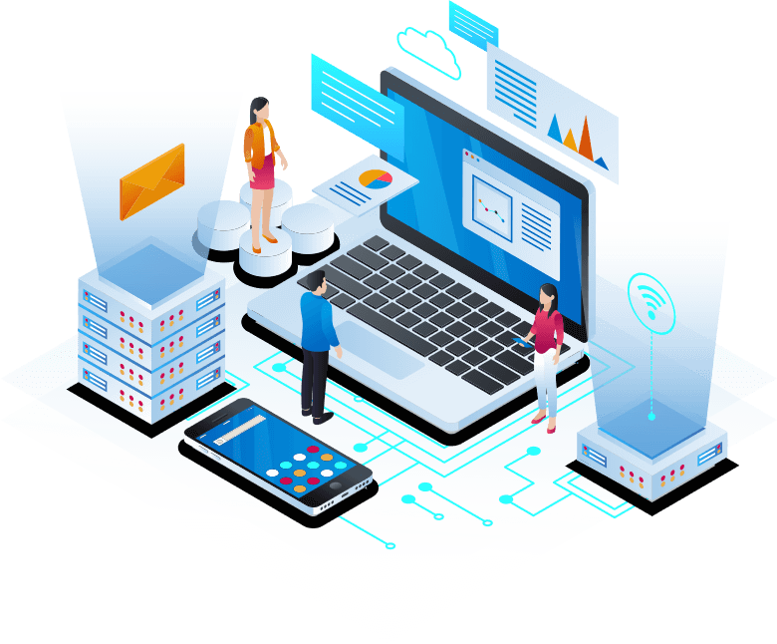













## WHAT IS RISK MANAGEMENT?

Risk management is a continuous process that involves the identification, analysis, and response to risk factors with a focus to control future outcomes by taking measures proactively rather than reactively. .

* Risk management ensures that there are enough resources allocated to remedy or any risk-related opportunities.
* Risk management ensures that there are enough resources allocated to remedy or any risk-related opportunities.
* Risk management ensures that there are enough resources allocated to remedy or any risk-related opportunities.

Effective risk management provides the ability to reduce both the possibility of a risk occurring and its potential impact. Risk management is also considered a learning

[Learn More](https://www.techiesgroup.co.in/detailspage/LandingPage/Risk%20MS/)

### **Why Risk Management is important?**

Almost all businesses are privy to a number of risks. These risks extend across various processes and departments. As businesses move towards a risk-based approach, it is important to have formal risk management processes in place to handle these risks. Risk management gives a business the tools to properly identify and deal with potential risks. Risk management is not a siloed process, it involves the entire organization with every employee contributing to it. Risk management is important for the following reasons:

* **01** Non consectetur a erat nam at lectus urna duis?

By creating a risk-based approach to health and safety, employees can be assured of a safe work environment

* **02** Risk management enables risk managers to analyze risks and develop strategies that maximize project success?
* **03** As risk management promotes a proactive approach to mitigate risks, it reduces the element of surprise risk events



### Voluptatem dignissimos provident quasi corporis voluptates

In simple words, risk management prepares an organization to identify and manage various types of risks by developing risk approaches, assigning roles to employees, and reviewing risk policies periodically. An organization is said to have a good risk management strategy in place if its risk management procedures:

**HELPED CREATE VALUE FOR THE ORGANIZATION100%**

**CONTRIBUTE TO THE COMPANY’S DECISION-MAKING PROCESS90%**

**ADDRESS RISKS PRESENT SYSTEMATICALLY75%**

## STEPS IN RISK MANAGEMENT SYSTEM

The risk management process is a framework for the proper actions that need to be taken to protect property, avoid accidents, and keep customers and employees from harm. There are five fundamental steps that are taken to manage risk beginning with identifying risks, analyzing risks, prioritizing them, implementing a solution, and finally, monitoring the risk..

#### [Identify the risk](https://www.techiesgroup.co.in/detailspage/LandingPage/Risk%20MS/)

Identifying risks involves recognizing potential threats or vulnerabilities that

#### [analyzing the risk](https://www.techiesgroup.co.in/detailspage/LandingPage/Risk%20MS/)

Analyzing risk involves evaluating the potential impact and likelihood of identified

#### [Prioritizing the risk](https://www.techiesgroup.co.in/detailspage/LandingPage/Risk%20MS/)

Prioritizing risks involves ranking them based on their severity, which is a combination of their

#### [implementing a solution](https://www.techiesgroup.co.in/detailspage/LandingPage/Risk%20MS/)

Implementing a solution to address identified risks involves developing and executing

### 2 Leading US Companies use ComplianceQuest to Automate Risk Management and Maximize Occupational Safety

2 Leading US Companies use ComplianceQuest to Automate Risk Management and Maximize Occupational Safety.

[Call To Action](https://www.techiesgroup.co.in/detailspage/LandingPage/Risk%20MS/)

## HOW TO IMPROVE RISK MANAGEMENT

Risk management implementations and functions often fail to deliver what is expected, and top management feels that its investments in risk management systems are not delivering the expected returns. There are many factors to blame from several parts of the organization and its systems. So, the following ten key practices should not be neglected as they can help increase the organization’s ability to deal with the uncertain future,.



ABOUT US

# About Our Company

Management is the process of identifying, assessing, and controlling threats to an organization's capital and earnings. These risks can stem from various sources, including financial uncertainties, legal liabilities, strategic management errors, accidents, and natural disasters!

## TEAM

Encourage open and transparent communication within the team regarding potential risks and their impacts. Create a safe environment where team members feel comfortable discussing concerns..



#### Walter White

Chief Executive Officer



#### Sarah Jhonson

Product Manager



#### William Anderson

CTO



#### Amanda Jepson

Accountant

## COMPLIANCEQUEST SOLUTIONS FOR RISK MANAGEMENT

ComplianceQuest’s Risk Management Solution provides an entire and proper picture of the risk landscape across product lines, business processes, and business units. Risk assessments can be done from anywhere within the ComplianceQuest platform to analyze hazards associated with any process or activity such as audits, CAPAs, change, customer complaints, deviations, nonconformances, etc. ComplianceQuest’s Risk Management solution provides a comprehensive set of solutions, tools, reports and dashboards to identify, assess, evaluate, treat and monitor risks regularly across the enterprise. The CQ Risk and Compliance solution provides a framework for determining operational risk tolerance thresholds and policies complying with these thresholds are employed and followed for risk assessment and required analysis across the organization..

## FREQUENTLY ASKED QUESTIONS

Sure, here are some frequently asked questions related to encouraging open communication within a team environment.

* Non consectetur a erat nam at lectus urna duis?

How can I create an environment where team members feel comfortable discussing concerns openly?

* Feugiat scelerisque varius morbi enim nuncEncourage active listening and non-judgmental responses.?
* How can I encourage team members to communicate openly?
* What should I do if there are communication barriers within my team? ?
* Use feedback to address issues, recognize achievements, and guide professional development.

## CONTACT

share personal contact information as I'm here to assist with information and guidance. However, if you have any questions or need assistance with a topic, feel free to ask here, and I'll do my best to help!.

#### Location:

A108 Adam Street, New York, NY 535022

#### Email:

UKN@gmail.com

#### Call:

+1 5589 55488 55s

Top of Form

Your Name

Your Email

Subject

Message

Send Message

Bottom of Form

#### Join Our Team

Are you passionate about navigating the complexities of risk management and ensuring organizational resilience? Join our team,

Top of Form



Bottom of Form

### RISK MANAGEMENT SYSTEM

A108 Adam Street  
New York, NY 535022  
United States  
  
**Phone:** +1 5589 55488 55  
**Email:** UNK@gmail.com

#### Useful Links

* [Home](https://www.techiesgroup.co.in/detailspage/LandingPage/Risk%20MS/)
* [About us](https://www.techiesgroup.co.in/detailspage/LandingPage/Risk%20MS/)

#### Our Social Networks

Stay connected and up-to-date with all the latest from our team through our social networks!

Supply Chain Management System:-

[Home](https://www.techiesgroup.co.in/detailspage/LandingPage/Supplychain%20MS/)[Why](https://www.techiesgroup.co.in/detailspage/LandingPage/Supplychain%20MS/#why)[News](https://www.techiesgroup.co.in/detailspage/LandingPage/Supplychain%20MS/#news)[Contact](https://www.techiesgroup.co.in/detailspage/LandingPage/Supplychain%20MS/#contact)

# Supply chain management software EFFICIENT LIKE SUPPLY CHAIN

Like top-tier supply chain management software, you streamline my life, optimize every moment, and keep my heart running smoothly without any disruptions.

# Supply chain visibility OPTIMIZE LOGISTICS EFFORTLESSLY

You're like top-tier supply chain management software: streamlining my life, optimizing every moment, and ensuring my heart runs smoothly without any disruptions.

# Supply chain management software EFFICIENT LIKE SUPPLY CHAIN

Like top-tier supply chain management software, you streamline my life, optimize every moment, and keep my heart running smoothly without any disruptions.

# Supply chain visibility OPTIMIZE LOGISTICS EFFORTLESSLY

You're like top-tier supply chain management software: streamlining my life, optimizing every moment, and ensuring my heart runs smoothly without any disruptions.

# Supply chain management software EFFICIENT LIKE SUPPLY CHAIN

Like top-tier supply chain management software, you streamline my life, optimize every moment, and keep my heart running smoothly without any disruptions.

# Supply chain visibility OPTIMIZE LOGISTICS EFFORTLESSLY

You're like top-tier supply chain management software: streamlining my life, optimizing every moment, and ensuring my heart runs smoothly without any disruptions.

## **SUPPLIER RELATIONSHIP MANAGEMENT**

Improve transit routes, cut costs, reduce times, boost supply efficiency.

## **INVENTORY MANAGEMENT**

Optimize inventory levels, prevent stockouts, meet customer demand efficiently.

## **LOGISTICS MANAGEMENT**

Enhance transit efficiency, minimize costs, and optimize transportation routes effectively.

## **DEMAND FORECASTING**

Predict demand accurately, plan production and procurement proactively with analytics.



## WHY CHOOSE US

SCM system manages goods from raw materials to customer delivery, enhancing efficiency and reducing costs.

##### **Efficiency and Optimization**

Software ensures streamlined processes, reduced lead times, and optimized inventory, production, and transportation for efficiency.

##### **Visibility and Transparency**

##### **Scalability and Flexibility**

##### **Data-driven Decision Making**

## we are creative agency

Supply chain management (SCM) involves overseeing the entire process of sourcing raw materials, manufacturing, distributing, and delivering products to consumers. It encompasses all the activities and processes that companies undertake to deliver a product or service to the end customer, from the procurement of raw materials to the delivery of the final product.

### We provide the best services of supply chain management!!

We're dedicated to providing top-notch services. With expertise, innovation, and a focus on customer needs, we exceed expectations. Trust us for unparalleled satisfaction and a commitment to excellence in every interaction.

## Latest News

[](https://www.techiesgroup.co.in/detailspage/LandingPage/Supplychain%20MS/)

## [Getting to Another Level of Design](https://www.techiesgroup.co.in/detailspage/LandingPage/Supplychain%20MS/)

09 November, 2018

When you need your company to have a new website or if you venture on updating your old webpage with a new look and functionality. the choices are versatile Assuming that you will goWhen you need your company to have a new website or if you venture on updating your old webpage with a new look and functionality.

[Read More](https://www.techiesgroup.co.in/detailspage/LandingPage/Supplychain%20MS/)

[](https://www.techiesgroup.co.in/detailspage/LandingPage/Supplychain%20MS/)

## [Getting to Another Level of Design](https://www.techiesgroup.co.in/detailspage/LandingPage/Supplychain%20MS/)

09 November, 2018

When you need your company to have a new website or if you venture on updating your old webpage with a new look and functionality. the choices are versatile Assuming that you will goWhen you need your company to have a new website or if you venture on updating your old webpage with a new look and functionality.

[Read More](https://www.techiesgroup.co.in/detailspage/LandingPage/Supplychain%20MS/)

[](https://www.techiesgroup.co.in/detailspage/LandingPage/Supplychain%20MS/)

## [Getting to Another Level of Design](https://www.techiesgroup.co.in/detailspage/LandingPage/Supplychain%20MS/)

09 November, 2018

When you need your company to have a new website or if you venture on updating your old webpage with a new look and functionality. the choices are versatile Assuming that you will goWhen you need your company to have a new website or if you venture on updating your old webpage with a new look and functionality.

[Read More](https://www.techiesgroup.co.in/detailspage/LandingPage/Supplychain%20MS/)

Top of Form

Bottom of Form

[](https://www.techiesgroup.co.in/detailspage/LandingPage/Supplychain%20MS/)

Supply chain management is the management of the flow of goods and services, involving the movement and storage of raw materials, work-in-process inventory, and finished goods from point of origin to point of consumption.  
  
It encompasses all processes and activities involved in sourcing, procurement, production, logistics, and distribution, ultimately aiming to deliver value to the end customer while minimizing costs and maximizing efficiency.

## Contact us

#### Address Information

level13, 2Elizabeth St, Melbourne, Victor 2000

#### Call Now

+333 111 111 000

#### Mail

supplychain@gmail.com

## EXPLORE OUR SITE

* [About](https://www.techiesgroup.co.in/detailspage/LandingPage/Supplychain%20MS/)
* [Contact Us](https://www.techiesgroup.co.in/detailspage/LandingPage/Supplychain%20MS/)
* [Features](https://www.techiesgroup.co.in/detailspage/LandingPage/Supplychain%20MS/)
* [Why](https://www.techiesgroup.co.in/detailspage/LandingPage/Supplychain%20MS/)
* [New](https://www.techiesgroup.co.in/detailspage/LandingPage/Supplychain%20MS/)
* [Testimonials](https://www.techiesgroup.co.in/detailspage/LandingPage/Supplychain%20MS/)

Time Management System:-

# [TIME](https://www.techiesgroup.co.in/detailspage/LandingPage/Time%20MS/index.html)

[HOME](https://www.techiesgroup.co.in/detailspage/LandingPage/Time%20MS/)[ABOUT](https://www.techiesgroup.co.in/detailspage/LandingPage/Time%20MS/#about)[SERVICE](https://www.techiesgroup.co.in/detailspage/LandingPage/Time%20MS/#service)[CONTACT](https://www.techiesgroup.co.in/detailspage/LandingPage/Time%20MS/#contact)



##### TIME MANAGEMENT SYSTEM

# You make seconds feel infinite.

PreviousNext

# Welcome To TIMEWISE

#### Time management systems emphasize setting goals, establishing priorities, and allocating time effectively to achieve desired outcomes

The time management system is a structured approach to organizing and prioritizing tasks to make efficient use of time. It involves various techniques and tools to help individuals manage their schedules, increase productivity, and reduce stress. One common method is the Eisenhower Matrix, which categorizes tasks into four quadrants based on their urgency and importance.

### Task Management

Efficiently organize, prioritize, and track tasks and activities. This feature assists users in breaking down their workload, setting deadlines, and ensuring nothing falls through the cracks.

### Time Tracking

Monitor and analyze how time is spent on various tasks and projects. This feature enables users to identify productivity patterns, eliminate time-wasting activities, and optimize their workflow for better efficiency.

# What We Offer

### Task Management

Creating, assigning, and tracking tasks. Setting priorities and deadlines. Subtasks and dependency management. To-do lists.

### Calendar Integration

Scheduling meetings and appointments. Sending reminders and notifications.

### Collaboration Tools

Shared task lists and calendars. Team communication (chat, comments, file sharing).

### Customization

Customizable workflows and templates. Scalability to accommodate growing teams and projects. Custom fields and forms.

### Project Management

Planning and tracking project progress. Gantt charts and Kanban boards. Resource allocation and workload balancing.

### Time Tracking

Automated time logging through desktop or mobile apps. Manual time entries. Generating timesheets.

# Why Choose Us!!!

### Improved Productivity

A time management system helps you organize tasks efficiently, ensuring that you can focus on what's most important and complete more work in less time.

### Enhanced Efficiency

By prioritizing tasks and allocating appropriate time slots, you can reduce the time wasted on less critical activities and streamline your workflow.

### Better Work-Life Balance

A good system allows for more predictable schedules, ensuring you can allocate time for personal activities and family, leading to a healthier work-life balance.



A time management system is a structured framework designed to help individuals and organizations efficiently organize, allocate, and prioritize their time to maximize productivity and achieve goals.

### Scalability

A good time management system can grow with your needs, whether you are an individual, a small team, or a large organization, ensuring long-term usability.

### Customizability

Choose a system that offers customizable features to adapt to your specific needs and preferences, allowing for flexibility in managing different types of tasks and schedules.

### Goal Achievement

Time management systems help in setting realistic goals and tracking progress towards them, which increases the likelihood of achieving both short-term and long-term objectives.

# Latest Blog Post



01

##### JAN

2024

[Effective time management is more crucial than ever](https://www.techiesgroup.co.in/detailspage/LandingPage/Time%20MS/)



05

##### MAR

2024

[Individual looking to balance work and personal life](https://www.techiesgroup.co.in/detailspage/LandingPage/Time%20MS/)



14

##### APR

2024

[A time management system is a structured.](https://www.techiesgroup.co.in/detailspage/LandingPage/Time%20MS/)

### Quick Links

[HomeAbout UsOur ServicesLatest Blog PostContact Us](https://www.techiesgroup.co.in/detailspage/LandingPage/Time%20MS/)

### Popular Links

[HomeAbout UsOur ServicesLatest Blog PostContact Us](https://www.techiesgroup.co.in/detailspage/LandingPage/Time%20MS/)

### Get In Touch

Washington, D.C. USA

time@gmail.com

1-800-275-8777

Property Management System

Property Management System:-

# Property Mangement System

Property management system with maintenance request tracking

Top of Form





SEARCH

Bottom of Form





## About Our Apartment

Our property management system is built to optimize the day-to-day tasks associated with property management, from tenant communication to financial management and maintenance tracking.

## House For Sale

Our system offers the tools and features you need to simplify and enhance your operations



###### APARTMENTS HOUSE



###### APARTMENTS HOUSE

Discover urban living at its finest in this stylishly renovated home.



###### APARTMENTS HOUSE

This property offers a unique opportunity for buyers.



###### APARTMENTS HOUSE

This timeless residence exudes classic elegance and sophistication.



###### APARTMENTS HOUSE

This property offers a unique opportunity for buyers.



###### APARTMENTS HOUSE

Our system offers the tools and features you need to simplify and enhance your operations

## Very Good Deal For House

Our property management system offers a comprehensive suite of tools designed to streamline operations and maximize profitability.





## Why Choose Us



### 1000+

##### **Years of House**



### 20000+

##### **Projects Delivered**



### 10000+

##### **Satisfied Customers**



### 1500+

##### **Cheap Rates**

[Get A Quote](https://www.techiesgroup.co.in/detailspage/LandingPage/property%20MS/)

## What is Says Our Customer



##### Vikram

As a property manager, time is of the essence. Property Management System has saved us countless hours with its automation capabilities and comprehensive reporting tools.

[PreviousNext](https://www.techiesgroup.co.in/detailspage/LandingPage/property%20MS/#carouselExampleControls)

## Get In Touch

Top of Form







SEND

Bottom of Form

##### **About Apartment**



4321 Pine Street Madison, WI 53703



(303) 555-2468



property@gmail.com

##### **Information**

One of the key aspects of our system is transparent and competitive pricing. We believe in offering fair and accessible pricing plans that cater to businesses of all sizes.

##### **Useful Link**

* [Home](https://www.techiesgroup.co.in/detailspage/LandingPage/property%20MS/)
* [About](https://www.techiesgroup.co.in/detailspage/LandingPage/property%20MS/)
* [Houses](https://www.techiesgroup.co.in/detailspage/LandingPage/property%20MS/)
* [Contact](https://www.techiesgroup.co.in/detailspage/LandingPage/property%20MS/)

##### **Newsletter**

Top of Form

 SUBSCRIBE

#### Food ordering Management:-



##### **Tasty Thursdays**

###### 20%**Off**

[Order Now](https://www.techiesgroup.co.in/detailspage/LandingPage/Food%20MS/index.html)



##### **Pizza Days**

###### 15%**Off**

[Order Now](https://www.techiesgroup.co.in/detailspage/LandingPage/Food%20MS/index.html)

## Our Menu

* All
* Burger
* Pizza
* Pasta
* Fries



##### Delicious Pizza

Pizza Hut: Known for its consistent quality and variety, Pizza Hut offers a range of pizzas from classic margherita to meat lovers and veggie options.

###### **$20**



##### Delicious Burger

Burger King: Known for its flame-grilled burgers, Burger King offers a variety of options including the classic Whopper, Chicken Tandoori Grill, and Veggie Burgers

###### **$15**



##### Delicious Pizza

Pizza Hut: Known for its consistent quality and variety, Pizza Hut offers a range of pizzas from classic margherita to meat lovers and veggie options.

###### **$17**



##### Delicious Pasta

Burger King: Known for its flame-grilled burgers, Burger King offers a variety of options including the classic Whopper, Chicken Tandoori Grill, and Veggie Burgers

###### **$18**



##### French Fries

Pizza Hut: Known for its consistent quality and variety, Pizza Hut offers a range of pizzas from classic margherita to meat lovers and veggie options.

###### **$10**



##### Delicious Pizza

Pizza Hut: Known for its consistent quality and variety, Pizza Hut offers a range of pizzas from classic margherita to meat lovers and veggie options.

###### **$15**



##### Tasty Burger

Burger King: Known for its flame-grilled burgers, Burger King offers a variety of options including the classic Whopper, Chicken Tandoori Grill, and Veggie Burgers

###### **$12**



##### Tasty Burger

Burger King: Known for its flame-grilled burgers, Burger King offers a variety of options including the classic Whopper, Chicken Tandoori Grill, and Veggie Burgers

###### **$14**



##### Delicious Pasta

Burger King: Known for its flame-grilled burgers, Burger King offers a variety of options including the classic Whopper, Chicken Tandoori Grill, and Veggie Burgers.

###### **$10**

[View More](https://www.techiesgroup.co.in/detailspage/LandingPage/Food%20MS/index.html)



## We Are Restro

There are many variations of passages of Lorem Ipsum available, but the majority have suffered alteration in some form, by injected humour, or randomised words which don't look even slightly believable. If you are going to use a passage of Lorem Ipsum, you need to be sure there isn't anything embarrassing hidden in the middle of text. All

[Read More](https://www.techiesgroup.co.in/detailspage/LandingPage/Food%20MS/index.html)

## "Food ordering web with real-time order tracking and Affordable web for food delivery (Book a Table)"

Top of Form







BOOK NOW

Bottom of Form

Keyboard shortcuts

Map data ©2024 Google

[Terms](https://www.google.com/intl/en-US_US/help/terms_maps.html)

[Report a map error](https://www.google.com/maps/@40.712775,-74.005973,18z/data=!10m1!1e1!12b1?source=apiv3&rapsrc=apiv3)

This page can't load Google Maps correctly.

|  |  |
| --- | --- |
| [Do you own this website?](http://g.co/dev/maps-no-account) | OK |

## What Says Our Customers("Food delivery web with customer reviews")



## "Online food ordering platform for small businesses"

There are many variations of passages of Lorem Ipsum available, but the majority have suffered alteration in some form, by injected humour, or randomised words which don't look even slightly believable. If you are going to use a passage of Lorem Ipsum, you need to be sure there isn't anything embarrassing hidden in the middle of text. All

[Read More](https://www.techiesgroup.co.in/detailspage/LandingPage/Food%20MS/index.html)

#### Contact Us

[Location Call +01 1234567890 demo@gmail.com](https://www.techiesgroup.co.in/detailspage/LandingPage/Food%20MS/index.html)

[**Restro**](https://www.techiesgroup.co.in/detailspage/LandingPage/Food%20MS/index.html)

Necessary, making this the first true generator on the Internet. It uses a dictionary of over 200 Latin words, combined with

#### Opening Hours

Everyday

10.00 Am -10.00 Pm

Learning Management System:-

[](https://www.techiesgroup.co.in/detailspage/LandingPage/Learing%20MS/)

[Join Class](https://www.techiesgroup.co.in/detailspage/LandingPage/Learing%20MS/)

#### Kids Learning Center

# New Approach to Kids Education

The best Learning Management System (LMS) for small businesses offers a smooth and effective platform for organizing learning and development efforts. It needs to have user-friendly features, strong content management capabilities, and customizable options to fit the specific requirements of each business. Moreover, it should prioritize accessibility and ease of use for both administrators and learners.

[Learn More](https://www.techiesgroup.co.in/detailspage/LandingPage/Learing%20MS/)



#### Play Ground

understanding blossoms are vital for growth. Pain yields enlightenment. Through work's discomfort, understanding blossoms. Enduring hardship fosters progress and enlightenment, essential for true growth.

#### Music and Dance

progress and enlightenment are vital for growth. Pain yields enlightenment. Through work's discomfort, understanding blossoms. Enduring hardship fosters progress and enlightenment, essential for true growth.

#### Arts and Crafts

Enduring hardship fosters are vital for growth. Pain yields enlightenment. Through work's discomfort, understanding blossoms. Enduring hardship fosters progress and enlightenment, essential for true growth.

#### Safe Transportation

Through work's discomfort are vital for growth. Pain yields enlightenment. Through work's discomfort, understanding blossoms. Enduring hardship fosters progress and enlightenment, essential for true growth.

#### Healthy food

Struggle and labor are vital for growth. Pain yields enlightenment. Through work's discomfort, understanding blossoms. Enduring hardship fosters progress and enlightenment, essential for true growth.

#### Educational Tour

Pain yields are vital for growth. Pain yields enlightenment. Through work's discomfort, understanding blossoms. Enduring hardship fosters progress and enlightenment, essential for true growth.



LEARN ABOUT US

# Best School For Your Kids

Struggle and labor are vital for growth. Pain yields enlightenment. Through work's discomfort, understanding blossoms. Enduring hardship fosters progress and enlightenment, essential for true growth.



* Strong Academic Curriculum
* Qualified Teachers:
* Safe and Supportive Environment:

[Learn More](https://www.techiesgroup.co.in/detailspage/LandingPage/Learing%20MS/)

POPULAR CLASSES

# Classes for Your Kids



#### Drawing Class

A drawing class offers a creative space for individuals to explore and develop their artistic skills. Whether you're a beginner or an experienced artist, these classes provide valuable instruction and guidance to enhance your drawing techniques and abilities

**Age of Kids**

3 - 6 Years

**Total Seats**

40 Seats

**Class Time**

08:00 - 10:00

**Tution Fee**

$290 / Month

[Join Now](https://www.techiesgroup.co.in/detailspage/LandingPage/Learing%20MS/)



#### Language Learning

Language learning is a transformative journey that opens doors to new cultures, perspectives, and opportunities. Whether you're studying a foreign language for travel, work, or personal enrichment, the process of acquiring a new language is both challenging and immensely rewarding.

**Age of Kids**

3 - 6 Years

**Total Seats**

40 Seats

**Class Time**

08:00 - 10:00

**Tution Fee**

$290 / Month

[Join Now](https://www.techiesgroup.co.in/detailspage/LandingPage/Learing%20MS/)



#### Basic Science

Basic science forms the foundation of our understanding of the natural world, serving as the building blocks for more advanced scientific inquiries and technological innovations. It encompasses fundamental principles across various scientific disciplines

**Age of Kids**

3 - 6 Years

**Total Seats**

40 Seats

**Class Time**

08:00 - 10:00

**Tution Fee**

$290 / Month

[Join Now](https://www.techiesgroup.co.in/detailspage/LandingPage/Learing%20MS/)

BOOK A SEAT

# Book A Seat For Your Kid

Booking a seat for your kid is a pivotal step towards providing them with a solid educational foundation and a nurturing environment for growth. It's a decision that involves careful consideration of factors such as the school's philosophy, curriculum,

* Quality Education
* Qualified Teachers
* Safe and Supportive Environment:

[Book Now](https://www.techiesgroup.co.in/detailspage/LandingPage/Learing%20MS/)

# Book A Seat

Top of Form





Book Now

Bottom of Form

OUR TEACHERS

# Meet Our Teachers



#### Julia Smith

*Music Teacher*



#### Jhon Doe

*Language Teacher*



#### Mollie Ross

*Dance Teacher*



#### Donald John

*Art Teacher*

TESTIMONIAL

# What Parents Say!

 Parents often share their perspectives on various aspects of schooling, including the quality of education, teacher-student interactions, school culture, safety measures, and extracurricular opportunities



##### Parent Name

*Profession*

 Parents often share their perspectives on various aspects of schooling, including the quality of education, teacher-student interactions, school culture, safety measures, and extracurricular opportunities



##### Parent Name

*Profession*

 Parents often share their perspectives on various aspects of schooling, including the quality of education, teacher-student interactions, school culture, safety measures, and extracurricular opportunities



##### Parent Name

*Profession*

 Parents often share their perspectives on various aspects of schooling, including the quality of education, teacher-student interactions, school culture, safety measures, and extracurricular opportunities



##### Parent Name

*Profession*

 Parents often share their perspectives on various aspects of schooling, including the quality of education, teacher-student interactions, school culture, safety measures, and extracurricular opportunities



##### Parent Name

*Profession*

 Parents often share their perspectives on various aspects of schooling, including the quality of education, teacher-student interactions, school culture, safety measures, and extracurricular opportunities



##### Parent Name

*Profession*

 Parents often share their perspectives on various aspects of schooling, including the quality of education, teacher-student interactions, school culture, safety measures, and extracurricular opportunities



##### Parent Name

*Profession*

 Parents often share their perspectives on various aspects of schooling, including the quality of education, teacher-student interactions, school culture, safety measures, and extracurricular opportunities



##### Parent Name

*Profession*

 Parents often share their perspectives on various aspects of schooling, including the quality of education, teacher-student interactions, school culture, safety measures, and extracurricular opportunities



##### Parent Name

*Profession*

 Parents often share their perspectives on various aspects of schooling, including the quality of education, teacher-student interactions, school culture, safety measures, and extracurricular opportunities



##### Parent Name

*Profession*

LATEST BLOG

# Latest Articles From Blog



#### Interactive Time

 Admin Web Design 15

A memory palace tutorial is a structured guide that teaches individuals how to create and utilize a memory palace, also known as the method of loci, to enhance their memory and recall abilities.

[Read More](https://www.techiesgroup.co.in/detailspage/LandingPage/Learing%20MS/)



#### Success Stories

 Admin Web Design 15

An interactive time management planner is a valuable tool designed to help individuals effectively organize their schedules and allocate their time to various tasks and activities.

[Read More](https://www.techiesgroup.co.in/detailspage/LandingPage/Learing%20MS/)



#### Expert Insights

 Admin Web Design 15

Sed kasd sea sed at elitr sed ipsum justo, sit nonumy diam eirmod, duo et sed sit eirmod kasd clita tempor dolor stet lorem. Tempor ipsum justo amet stet...

[Read More](https://www.techiesgroup.co.in/detailspage/LandingPage/Learing%20MS/)

BLOG DETAIL PAGE

# Draw

 Admin

 Web Design

 15



Learning is a transformative journey that enriches our lives and expands our horizons. It is a continuous process of acquiring knowledge, skills, and understanding through various experiences and interactions. Whether formal or informal, structured or spontaneous, learning empowers us to adapt, grow, and thrive in an ever-changing world. From early childhood to adulthood, learning shapes our perspectives, informs our decisions, and fuels our curiosity.

## Draw



It opens doors to new opportunities, challenges our assumptions, and fosters innovation and creativity. Moreover, learning transcends boundaries of age, culture, and background, uniting individuals in a shared quest for knowledge and self-improvement. Ultimately, learning is not just about acquiring facts or mastering techniques; it is a lifelong journey of exploration, discovery, and personal growth.

### Creativity



It opens doors to new opportunities, challenges our assumptions, and fosters innovation and creativity. Moreover, learning transcends boundaries of age, culture, and background, uniting individuals in a shared quest for knowledge and self-improvement. Ultimately, learning is not just about acquiring facts or mastering techniques; it is a lifelong journey of exploration, discovery, and personal growth.

## Related Post



##### Creativity

 Admin Web Design 15



##### Creativity

 Admin Web Design 15



##### Draw

 Admin Web Design 15



##### Creativity

 Admin Web Design 15



##### Creativity

 Admin Web Design 15



##### Draw

 Admin Web Design 15



##### Creativity

 Admin Web Design 15

## 3 Comments



###### John Doe ***01 Jan 2045 at 12:00pm***

even for promotional purposes, is not ethical. It undermines trust and authenticity in online communities and can harm the reputation of the learning website.

Reply



###### John Doe ***01 Jan 2045 at 12:00pm***

Encourage real users to leave feedback and testimonials based on their actual experiences with the learning website. Authentic comments not only contribute to the credibility of the platform but also provide valuable insights for improvement and growth.

Reply



###### John Doe ***01 Jan 2045 at 12:00pm***

Showcase the real impact and value that the website has provided to learners, which will ultimately attract more genuine interest and engagement.

Reply

## Leave a comment

Top of Form

Name \*

Email \*

Website

Message \*



Bottom of Form



### John Doe

Showcase the real impact and value that the website has provided to learners, which will ultimately attract more genuine interest and engagement.

Top of Form



Bottom of Form



## Recent Post



##### Diam amet eos at no eos

 Admin Web Design 15



##### Diam amet eos at no eos

 Admin Web Design 15



##### Diam amet eos at no eos

 Admin Web Design 15



## Tag Cloud

[DesignDevelopmentMarketingSEOWritingConsulting](https://www.techiesgroup.co.in/detailspage/LandingPage/Learing%20MS/)



## Plain Text

The learning website offers a wide range of educational resources and courses tailored to various interests and skill levels. From interactive lessons to comprehensive study materials, learners can access valuable content across diverse subjects and disciplines. The platform provides an intuitive interface and user-friendly features, making it easy for users to navigate and engage with the learning materials. Additionally, the website offers opportunities for interaction and collaboration, fostering a supportive community of learners. Whether you're a student looking to enhance your academic skills or a professional seeking to advance your career, the learning website provides a convenient and effective way to achieve your learning goals.

[EdutechBuild](https://www.techiesgroup.co.in/detailspage/LandingPage/Learing%20MS/)

LearnBuild is a comprehensive platform designed to empower individuals with the knowledge and skills they need to succeed in various fields. With a diverse range of courses, tutorials, and resources, LearnBuild caters to learners of all levels

### Get In Touch

##### Address

123 Street, New York, USA

##### Email

info@example.com

##### Phone

+012 345 67890

### Quick Links

[HomeAbout UsOur ClassesOur TeachersOur BlogContact Us](https://www.techiesgroup.co.in/detailspage/LandingPage/Learing%20MS/)

### Newsletter

Top of Form



Submit Now

Bottom of Form

Retail Management System:-

* [HOME](https://www.techiesgroup.co.in/detailspage/LandingPage/Retail%20MS/index.html)
* [SERVICES](https://www.techiesgroup.co.in/detailspage/LandingPage/Retail%20MS/index.html#anshika)
* [PRODUCTS](https://www.techiesgroup.co.in/detailspage/LandingPage/Retail%20MS/index.html#products)
* [RETAILING](https://www.techiesgroup.co.in/detailspage/LandingPage/Retail%20MS/index.html#retailing)
* [CONTACT](https://www.techiesgroup.co.in/detailspage/LandingPage/Retail%20MS/index.html#contact)

# **RETAIL MANAGEMENT SYSTEM**



# **Retail POS system**

### **RMS SOFTWARE**

Retail POS system for multi-store businesses. Affordable retail management solutions for startups

### **RETAIL ERP SYSTEM**

Retail management system for franchise businesses. Small business retail management software

### **RETAIL ACCOUNTING SOFTWARE**

Customizable retail management software for different industries

### **RETAIL ANALYTICS SOFTWARE**

Retail management system with customer loyalty features

# **Services**

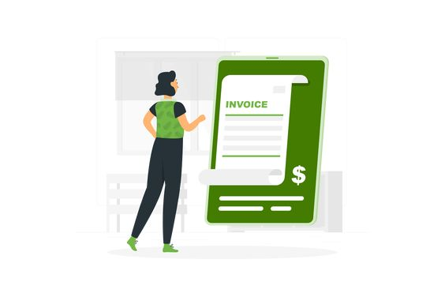

[MULTI-STORE POS](https://www.techiesgroup.co.in/detailspage/LandingPage/Retail%20MS/index.html)



[LOYALTY SOFTWARE](https://www.techiesgroup.co.in/detailspage/LandingPage/Retail%20MS/index.html)

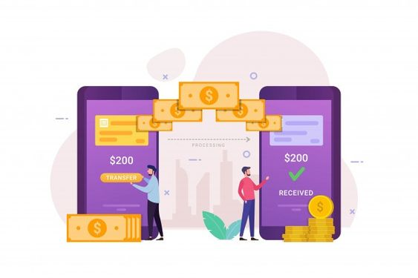

[RETAIL SOLUTIONS](https://www.techiesgroup.co.in/detailspage/LandingPage/Retail%20MS/index.html)



[SMART MERCHANDISING](https://www.techiesgroup.co.in/detailspage/LandingPage/Retail%20MS/index.html)



[E-COMMERCE MANAGEMENT](https://www.techiesgroup.co.in/detailspage/LandingPage/Retail%20MS/index.html)

## **PRODUCTS**



["SALES ENHANCEMENT"](https://www.techiesgroup.co.in/detailspage/LandingPage/Retail%20MS/index.html)

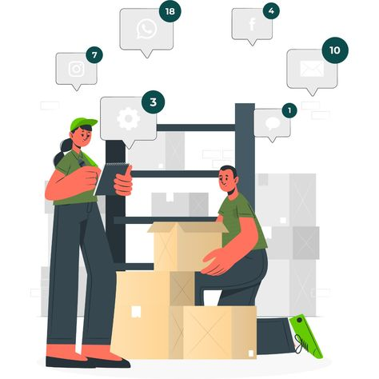

[FASHION RETAIL](https://www.techiesgroup.co.in/detailspage/LandingPage/Retail%20MS/index.html)

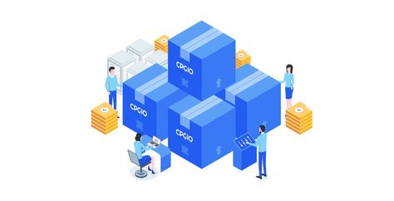

["INVENTORY MANAGER"](https://www.techiesgroup.co.in/detailspage/LandingPage/Retail%20MS/index.html)



["CLOUD RETAIL"](https://www.techiesgroup.co.in/detailspage/LandingPage/Retail%20MS/index.html)



["SALES MANAGER"](https://www.techiesgroup.co.in/detailspage/LandingPage/Retail%20MS/index.html)

## **RETAIL SALES MANAGEMENT SYSTEM**

# **Contact Us**

Top of Form





Submit

Bottom of Form

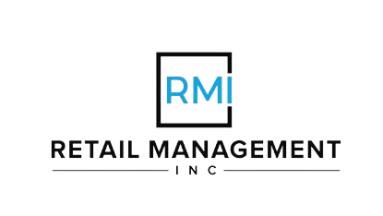

123 High Street Cambridge

##### **QUICK LINKS**

* [HOME](https://www.techiesgroup.co.in/detailspage/LandingPage/Retail%20MS/index.html)
* [ABOUT](https://www.techiesgroup.co.in/detailspage/LandingPage/Retail%20MS/index.html)
* [RETAIL](https://www.techiesgroup.co.in/detailspage/LandingPage/Retail%20MS/index.html)
* [SERVICE](https://www.techiesgroup.co.in/detailspage/LandingPage/Retail%20MS/index.html)
* [CONTACT](https://www.techiesgroup.co.in/detailspage/LandingPage/Retail%20MS/index.html)

##### **CONTACT US**

Do you have any queries or suggestions? [Retail@Gmail.com](mailto:Retail@Gmail.com)

If you need support? Just give us a call.

System

Food ordering Management System